Business Solution Specification for the ClickSchedule-ClickMobile Implementation at GE Healthcare

17th June 2015



The software with this guide is furnished under a license agreement and may be used only according to the terms of that agreement.

Copyright

Copyright © 2013 ClickSoftware, Inc. All rights reserved.

The information contained in this document may not be reproduced, distributed, transmitted, displayed, published or broadcast, in any form or in any medium, in whole or in part, without the prior written permission of ClickSoftware, Inc.

Patent and Trademarks

US Patent Number 6,985,872 B2

ClickAnalyze, ClickMobile, ClickMobile WAP Edition, ClickPlan, ClickRoster, ClickSchedule, and ClickSoftware are trademarks of ClickSoftware, Inc.

Contact Information

Contact information is available from the ClickSoftware web site: [**http://www.clicksoftware.com**](http://www.clicksoftware.com).

For support services, email **support@clicksoftware.com** or see the support page on the ClickSoftware web site.

For general information, email [**sales@clicksoftware.c****om**](mailto:sales@clicksoftware.com).

Publication Notice

This guide has been carefully compiled. The information in this guide does not constitute a warranty of performance. Furthermore, ClickSoftware reserves the right to revise this publication and make changes from time to time in the content thereof, without obligation to notify any person of such revisions or changes. ClickSoftware assumes no liability for losses incurred as a result of out-of-date or incorrect information in this guide.

Confidentiality

This document, and the information contained therein, is issued in confidence, for use and disclosure solely in relation to the purpose or purposes for which it was supplied.  No information as to the content or subject matter of this document or any part thereof arising directly or indirectly there from shall be used or disclosed, orally or in writing, or communicated in any manner whatsoever, to any third party or any employee thereof except under an agreement with, or with the prior written consent of, ClickSoftware, Inc.

World Headquarters

ClickSoftware, Incorporated, 35 Corporate Drive, Suite 400, Burlington, MA 01803

1-781-272-5903

Document Authors

Business Solution Specification for the ClickSchedule and ClickMobile Implementation at GE Healthcare: Prakash Gopal (CKSW), Shai Nahari (CKSW), and Phil Weighill-Smith (CKSW).

ClickSoftware Project Team

Project Manager: John Bardell

Solution Architect: Shai Nahari

Technical Consultants: Phil Weighill-Smith, Duncan Hardie, Anthony Bryan

Quality Assurance: Anna Broitman

Logic Services: CKSW Logic Expert

Business Analyst: Prakash Gopal

**Change History**

|  |  |  |  |
| --- | --- | --- | --- |
| Date | Version | Who | Modification |
| 18th July 2013 | 0.01 | Prakash Gopal | First draft. |
| 19th July 2013 | 0.03 | Prakash Gopal | Including updates for all sections. |
| 19th July 2013 | 0.04 | ClickSoftware | Reviewed and edited. |
| 5th August 2013 | 0.9 | Phil Weighill-Smith | Incorporating review comments from GE. |
| 6th August 2013 | 1.0 | Prakash Gopal/Shai Nahari | Incorporating remaining review comments from GE. |
| 23rd August 2013 | 1.1 | Phil Weighill-Smith | Updates against review comments and agreements in GE and ClickSoftware review call. Additional updates based on the RFP outstanding items document generated by ClickSoftware. |
| 29th August 2013 | 1.2 | Phil Weighill-Smith | Further updates against the review comments, agreements and RFP outstanding items. |
| 2nd September 2013 | 1.3 | Phil Weighill-Smith | Some minor property name changes to add clarity and consistency. Addition of the task reactivation date and macro version properties to align with the data mapping document from GEHC. |
| 3rd September 2013 | 1.4 | Phil Weighill-Smith | Updated the Object Model Overview diagram. |
| 12th September 2013 | 1.5 | Phil Weighill-Smith | Revision based on integration workshop outcome. |
| 23rd September 2013 | 1.6 | Phil Weighill-Smith | Revisions based on final GE review and internal findings (aligning with auditing and correcting some minor mistakes in the BSS). |
| 16th October 2013 | 1.7 | Anthony Bryan/Phil Weighill-Smith | Updates to Audit configuration and Jeopardy Agent List. Correct section numbering in 5.8.x. |
| 25th October 2013 | 1.8 | Phil Weighill-Smith | Various minor updates; FMINumber property type, addition of travel policy property for resources, rule and objective updates, more explanation regarding origin of ClickMobile form content, detail on schedule update triggers, correction of AM/PM appointment slot timings, addition of the “Unable to Update FSE’s Schedule” jeopardy. |
| 29th October 2013 | 1.9 | Anthony Bryan | Minor updates to Task/Resource Property Required Fields. |
| 30th October 2013 | 1.10 | Phil Weighill-Smith | Site language preference default removed. Resource MobileWebClientSettings default removed. NA type list aligned with GE specification. |
| 1st November 2013 | 1.11 | Phil Weighill-Smith | Updates in response to GE review comments, including Due Date handling change, Trainee FSE changes for task, part pickup tasks not necessarily being on the same day as the task itself, changes in the ClickMobile form content and order plus minor clarifications. |
| 4th November 2013 | 1.12 | Anthony Bryan | Updated Task/Engineer Property Requirements as per QA comments. Added “District” to Site Property Requirements. |
| 11th November 2013 | 1.13 | Phil Weighill-Smith | Aligned resource LoginName property with OOTB configuration. Clarified pickup task numberings were examples. Clarified that site addresses may be geocoded when inherited by a task. Removed template BSS example values for high and low task priorities as these do not align with the GE solution. |
| 15th November 2013 | 1.14 | Anthony Bryan | Rewording of Schedule Monitor colour coding section to match OOTB configuration. Updated NA tooltip description.  Updated Task Filters section with new filters and rewording.  For Task Required Fields – Set SkillLevel to hidden, JobSubType property renamed to TaskSubType, Site renamed to SiteID and correct referenced property DisplayID. |
| 15th November 2013 | 1.15 | Phil Weighill-Smith | Updated the geocoding section to mention support for GEHC providing pre-geocoded addresses. Removed defaulting of the resource Active property and change the resource MobileClient property default to reflect the product’s default for ooleans. Updated the description of “training scenario B” to indicate that this has been excluded from the solution due to GE’s concerns. |
| 18th November 2013 | 1.16 | Phil Weighill-Smith | Change to how AllowedTaskTypes is addressed. |
| 12th December 2013 | 1.17 | Shai Nahari | Replace Mobile My View with Engineer View  Adding N/A form description  Adding Country to N/A form  Setting the mobile purge horizon to 7 days |
| 16th December 2013 | 1.18 | Phil Weighill-Smith | Add Site ID to ClickMobile Assignment General form. |
| 10th February 2014 | 1.19 | Shai Nahari | Mobile Map view removed (avoiding GoogleMaps fee)  Aligned mobile NA form to GE requirements |
| 25th February 2014 | 1.20 | Phil Weighill-Smith | Complete removal of Map View reference from the mobile device. Alignment of the name for the engineer details view on the mobile device. |
| 26th February 2014 | 1.21 | Anthony Bryan | Rewording of Schedule Update section to include switching to other FSEs. |
| 28th February 2014 | 1.22 | Anthony Bryan | Update to Dispatch Policy time |
| 3rd June 2015 | 2.0 | Phil Weighill-Smith | Inclusion of the Build 2 and Build 3 Change Requests and some changes applied by GE Healthcare themselves. |
| 24th July 2015 | 2.3.2 | GE Team | Updates as per the inputs received during the Workshop for APAC region between 13 – 15 July 2015. |

**Table of Contents**

Contents

1 Introduction 11

1.1 About this Document 11

1.2 Related Documents 11

1.3 Introduction to ClickSchedule 11

1.4 Terms and Abbreviations 13

2 Project Definition 16

2.1 Project Scope 16

2.1.1 Project Background 16

2.1.2 In Scope 16

2.2 High Level Business Goals 17

3 The Service Operation 18

3.1 GEHC Services Overview 18

3.2 Work Types 18

3.2.1 Work Types Summary –Duration 18

3.2.2 Work Type Details 18

3.2.3 Activity Type 20

3.3 Organizational Structure 21

3.3.1 GEHC Field Navigation Tree 21

3.3.2 Maintaining the Organizational Structure 23

3.4 Time Zones 23

3.5 Key Roles in the Service Operation 23

4 Service Delivery Processes 25

4.1 Processes High Level Overview 25

4.2 Work Status Flow 25

4.2.1 New 26

4.2.2 Tentative 27

4.2.3 Assigned 27

4.2.4 Acknowledged 27

4.2.5 Rejected 27

4.2.6 Rejected by FSE 27

4.2.7 En Route 28

4.2.8 On Site 28

4.2.9 Completed 28

4.2.10 Incomplete 28

4.2.11 Cancelled 29

4.2.12 Suspended 29

4.3 GEHC’s Business Scenarios 30

4.3.1 Business Scenario 1: Schedule a Corrective job 30

4.3.2 Business Scenario 1A: Appointment Booking  37

4.3.3 Business Scenario 1B: Dispatch Work 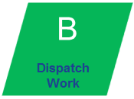 44

4.3.4 Business Scenario 1C: Job Closures -  &  49

4.3.5 Business Scenario 2.0 – Schedule a Preventive Maintenance job 52

4.3.6 Business Scenario 3.0 – Schedule an FMI job 54

4.3.7 Business Scenario 4.0 – Schedule an Installation job 57

4.3.8 Business Scenario 5.0 – Schedule a Training job on a C/P/? job 59

4.3.9 Business Scenario 6.0 – Job Interrupted 61

4.3.10 Business Scenario 10 – Update Job Details 63

4.3.11 Business Scenario 11.0 – Part Pick Up Scenario 65

4.3.12 Business Scenario - Day Tasks 65

5 Solution Data Elements 69

5.1 General Data Considerations 69

5.2 Time 69

5.3 Object Model Overview 70

5.4 Sites 71

5.4.1 Site Property Requirements 71

5.4.1 Site Data Derivation 73

5.4.2 Site Data Management 73

5.5 Systems 73

5.5.1 System Property Requirements 73

5.5.2 System Data Derivation 74

5.5.3 System Data Management 75

5.6 Contracts 75

5.6.1 Coverage 75

5.6.2 Contract Property Requirements 75

5.6.3 Contract Data Management 76

5.7 Resources 76

5.7.1 Districts 76

5.7.2 Resource Type 76

5.7.3 Resource Skills 77

5.7.4 Calendars: Working and Overtime Hours 77

5.7.5 Lunch Breaks 78

5.7.6 Resource Non-Availability (Absences) 78

5.7.7 Home Base 81

5.7.8 Travel Time Calculations 81

5.7.9 Organizational Hierarchy 82

5.7.10 Internal/External indication 82

5.7.11 Resource Languages 82

5.7.12 Resource Property Requirements 82

5.7.13 Resource Data Derivation 86

5.7.14 Resource Data Management 87

5.8 Tasks 87

5.8.1 Job Type 87

5.8.2 Job Sub-Type 87

5.8.3 Required Skills 88

5.8.4 Required Languages 88

5.8.5 Task Organizational Hierarchy 88

5.8.6 Rejection Reasons 88

5.8.7 Incompletion Reasons 88

5.8.8 Job Comments 88

5.8.9 Resource Specifications 89

5.8.10 Task Property Requirements 89

5.8.11 Task Data Derivation 100

5.8.12 Task Data Management 102

6 Geographic Information System Solution (GIS) 103

6.1 Geo-coding 103

6.2 Routing 103

6.3 Mapping 104

7 Scheduling Policies 105

7.1 Standard Policy 105

7.2 Appointment Booking 107

8 Scheduling Methods 109

8.1 Appointment Booking 109

8.2 Background Optimization (BGO) 109

8.2.1 Offline (Night) Optimization 110

8.2.2 Online (In-Day) Optimization 110

8.3 Scheduling Work Immediately (Task Insert) 111

8.4 Schedule Updates 111

8.5 Tools for Manual and Semi-Automatic Scheduling 112

8.5.1 Semi-Automatic Scheduling (a.k.a. ‘Right-Click Schedule’) 112

8.5.2 Manual Scheduling (a.k.a. Drag & Drop) 112

8.5.3 Get Candidates 112

9 Schedule Monitoring and Management 113

9.1 Dispatching of Assignments 113

9.2 Scheduling Monitor 113

9.3 Jeopardies and Task Highlighting 114

9.3.1 Timeline Jeopardies 115

9.3.2 Informational Task Highlighting 115

9.4 Alerts 115

9.5 Purging Policy 116

9.6 Task Presentation 116

10 Access Control and Security 117

10.1 Overview 117

10.2 Access to System Functions 117

11 Integration Overview 119

11.1 Tasks 120

11.2 Resources 120

11.3 Sites, Systems and Contracts 120

11.4 Skills Lookup 120

11.5 Appointment Booking and Task Creation 120

11.6 Task Update 121

12 Audit Trail 122

12.1 Overview 122

12.2 Audited Properties 122

12.3 The Audit Client 124

12.4 Purging 125

13 Click Mobile 126

13.1 Overview 126

13.1.1 Users 126

13.1.2 Devices 126

13.1.3 Connectivity 126

13.1.4 Data Availability 126

13.2 Workflow 126

13.2.1 Tentative 126

13.2.2 Assigned 126

13.2.3 Acknowledged 126

13.2.4 Rejected by FSE 126

13.2.5 En Route 127

13.2.6 On Site 127

13.2.7 Suspended 127

13.2.8 Completed 127

13.2.9 Incomplete 127

13.3 Main Screens 127

13.3.1 Logon 128

13.3.2 Home Page 128

13.3.3 Schedule Main Tasks View 129

13.3.4 Assignment Form 131

13.3.5 Non-Availability Form 136

13.3.6 Messages Form 136

13.4 Alerts 137

13.5 Purging Policy 138

14 Appendix A: Data Structure 139

15 Appendix B: Approvals 140

# Introduction

## About this Document

This document is the Business Solution Specification for the ClickSchedule and ClickMobile implementation at GE Healthcare. In this document we describe our understanding of GE Healthcare’s (GEHC) business requirements associated with Field Service Engineer (FSE) scheduling and propose a solution for the deployment of the Smart Dispatch Tool (ClickSchedule and ClickMobile) as part of the GE Healthcare One Services initiative. The scope of this document addresses the Smart Dispatch tool requirements for the standard model that will be designed, built and piloted for APAC (i.e ASEAN , ANZ and Korea),. During the Requirements workshops, attention was given to regional specific requirements and where these requirements they can be addressed by the OOTB (Out Of The Box) functionality available within ClickSchedule and ClickMobile these requirements have been incorporated into the standard model. Requirements needing customisations outside the scope of the initial ClickSoftware proposal will be subject to further discussion and agreement with GE Healthcare.

Requirements presented in this document are based on the information obtained during Business Requirements Workshop conducted at GE Healthcare during9th to 11th June 2015

This document is presented to GE Healthcare for approval to enable ClickSoftware to proceed with the development and implementation of ClickSoftware products, enabling GE Healthcare to begin realising the benefits and value of its investment at the earliest opportunity. Upon receipt of this document, GE Healthcare is expected to reply, correcting any inconsistencies or requesting further clarification. ClickSoftware and GE Healthcare have already arranged to conduct a workshop to review and amend the content of the BSS. Once both parties have agreed upon the document’s contents, both parties will be required to sign off the Approval form that can be found in Appendix B: Approvals, to move forward with the design and build process.

## Related Documents

* Integration Design Specification (IDS) for information regarding the interaction of ClickSchedule with external GEHC systems, such as SIEBEL. The IDS will be produced following the publication of this BSS and before the “Build” phase of the project.
* Notes collected in the Business Requirements Workshops.
* The GEHC SDT (Smart Dispatch Tool) RFP user requirements documentation.
* The GEHC SDT Data Mapping for Interface, version 1.1.

## Introduction to ClickSchedule

ClickSchedule is an enterprise application that provides a more efficient and effective way of scheduling service personnel and other field resources. ClickSchedule will be integrated with the GE Healthcare SIEBEL CRM system and if required in the future, Enterprise Resource Planning (ERPor legacy systems that may be in use for the creation and management of tasks, orders, jobs, projects or any other types of work. Furthermore, ClickSchedule could be integrated with human resource (HR) systems for maintaining resource profiles, skills, location, availability and other information.

ClickSchedule is designed for organizations that provide a range of different types of service and it schedules service resources based on considerations that are critical to the specific type of service operation. These considerations may include: selecting an appropriately skilled and available resource to complete a task or series of tasks, maximising resource utilisation, minimising response time, minimising the cost of service and many others. ClickSchedule has unique configuration capabilities which include substantial built-in (i.e. out of the box or OOTB) functionality and logic that may be tailored to meet the needs of specific Field Service Engineer operations. ClickSchedule’s flexibility allows changes to the appearance, workflow, scheduling logic and attributes that describe work and resources.

ClickSchedule utilises built-in scheduling criteria to automate much of the scheduling process. Parameters such as resource details, work data and scheduling policies can be created, deleted or modified as needed. The system schedules tasks according to predefined service policies and guides scheduling personnel in making scheduling decisions that comply with or override these policies, as appropriate.

## Terms and Abbreviations

| Term | Explanation |
| --- | --- |
| Activity | A SIEBEL term, representing a given “visit” within a SIEBEL Job. SIEBEL Activities are released to ClickSchedule and are therefore equivalent to Tasks. |
| Service Request (SR) | A SIEBEL term, representing that one SR can have multiple activities. |
| Assignment | The term for a unit of work with an Assigned field resource and Assigned time. |
| BGO | Background Optimizer. Logic that executes “in the background” in order to optimize the schedule. |
| Business Hierarchy | Describes the Navigation Tree that is used in ClickSchedule |
| ClickMobile Touch | The ClickMobile Touch application enables the field force to interact with the ClickSchedule application using an HTML5 capable handheld mobile device. |
| ClickSchedule | The workforce optimization component of the solution being implemented at GE Healthcare. |
| ClickSoftware | ClickSoftware is the supplier of the Service Optimization suite of applications. |
| Configuration | The activities involved in manipulating the Out of the Box applications to ensure they deliver the maximum functionality possible. These activities do not include any modification of or addition to the base code of the products. |
| CS | ClickSchedule. |
| CSC | Customer Service Centre. |
| CSC Agent | A synonym for the Dispatcher. |
| CTC | Customer Technical Centre. Staffed by OLSEs, this centre provides remote diagnostic and fix support. |
| Customization based on existing functionality | The activities involved in manipulating the Out of the Box application while substantially leveraging the existing code base. |
| Customization from scratch | The activities involved in creating additional components, logic or other technical solutions which do not substantially leverage any existing code base. |
| Dispatcher | These personnel are users of the scheduling application; they typically handle customer calls, appointment booking and all scheduling activities (mainly focused on exception cases where manual intervention is required). They are in regular contact with the Resources to assist them in maintaining their schedules. |
| Field Service Engineer | This is an individual to whom tasks may be scheduled. See “Resource”. |
| Gantt | The display of work in a graphical format in the ClickSchedule client |
| GIS | Geographical Information System |
| IDS | Integration Design Specification. |
| ISD | Integrated Service Desktop. An internal GEHC system. |
| Job | A sequence of SIEBEL Activities relating to a specific piece of GEHC equipment. |
| KPI | Key Performance Indicator. This is a measurement that will be used for evaluating the success of the implementation. |
| MDT | Multi-Day Task. A task with a long duration that is split over two or more days. |
| SIEBEL | It’s a CRM system used in APAC region. |
| Named contractors | Contractors’ engineers which are maintained in ClickSchedule as individual resources. |
| Non-Availability (NA) | Denotes a period of time in which a resource cannot be scheduled work. This is also known as an “Indirect Activity” in the SIEBEL world. |
| OLSE | On-Line Service Engineer. |
| OOTB | Out Of The Box; the built-in functionalities of the ClickSoftware products. |
| PM | Preventive Maintenance. |
| PSL | Product Service Leader. |
| Resource | A generic name for an internal engineer, contractor or any other ‘schedulable’ entity in the service process. Resources have specific work availabilities and skills and are assigned tasks that fit with these capabilities. |
| RFS | Request For Service. |
| RSE | Regional Support Expert. |
| Skills | The term for knowledge or capabilities required to perform a task. In this context skills relate directly to GE products. |
| SLA | Service Level Agreement. This is the time within which the service provider has agreed to address some activity related to a task. |
| SLR | Street Level Routing. A process performed by the GIS system to determine a route from one location to another using the road network. This can provide both travel distance and an average travel time. |
| Task | This refers to the call, activity, task, operation or appointment to which the Resource is scheduled.  ClickSchedule uses the term “Task” to represent the work to be scheduled. This term will appear throughout the ClickSchedule client application and solution documentation. |
| TSE | Technical Support Engineer. |
| UDD | User Defined Dictionaries. Additional collections of reference data added through configuration in the Service Optimization solution to help address the list of valid values for certain properties associated with resources and/or jobs. |
| UDP | User Defined Properties. These are custom properties that are added to a business object or a dictionary. Additional properties added through configuration in the Service Optimization solution to help address the characteristics captured and used against the scheduling objects and pick list items. |
| Working Hours | The term used for resource working hours, i.e. the hours that they work as standard each day/week. |

# Project Definition

## Project Scope

### Project Background

GE Healthcare is one of the world's leading manufacturers of Diagnostic imaging equipment, including conventional and digital x-ray, computed tomography (CT), magnetic resonance (MR), ultrasound, positron emission tomography (PET), LCS and nuclear medicine.

GE Healthcare also provides:

* Clinical software
* Diagnostic information management systems
* Diagnostic imaging parts and accessories
* Used and refurbished equipment
* Capital equipment financial services
* An array of services - technical, productivity, and management
* Clinical Services, with over 1.5 million pieces of biomedical equipment being serviced

GE Healthcare (GEHC) is planning to implement a Smart Dispatch Tool to be rolled out in APAC region (ASEAN, ANZ and Korea) covering 4 countries in order to optimize the dispatch of GE Healthcare Field Service Engineers.

GEHC has selected ClickSoftware Ltd to design, build and implement a SaaS (Software as a Service) based Smart Dispatch model, where data owned or controlled by GE Healthcare will be hosted by ClickSoftware.

GEHC has selected and will implement ClickSchedule and ClickMobile from ClickSoftware as the new Smart Dispatch system to be used in GEHC to schedule and manage GEHC Field Service Engineers (FSE).

This BSS describes the requirements to be supported by the ClickSchedule and ClickMobile products of the Smart Dispatch tool standard model, which is to be initially piloted in the UK, Ireland and Northern Ireland regions, and then rolled out into the other GEHC APAC regions outlined below

### In Scope

The following (GE) regions and countries, resources and systems are considered ‘in scope’ of the ClickSchedule and ClickMobile implementation at GEHC. A single “standard model” will be designed, built and piloted in the UKI GE region (UK, Ireland) and then rolled out into the other six regions.

**GE Regions and Countries IN SCOPE:**

| **GE REGIONS** | **COUNTRIES** |
| --- | --- |
| ASEAN | Malaysia |
| ANZ | Australia |
| New Zealand |
| KOREA | Korea |

It should be noted that these GE regions should not be confused with the “region” concept in ClickSchedule. See section 3.3 for further details.

**SYSTEM INTERACTION:**

ClickSchedule will integrate with the following system(s):

* SIEBEL

(Note: integration details will be described in the Integration Design Specification (IDS))

See section 11 for details.

**Work Order Types: [Activity level]**

The types of work included in this implementation are:

* Corrective
* Application *(behaves like Corrective)*
* Other *(behaves like Corrective)*
* FMI
* Preventive Maintenance
* Installation
* On the Job Training

See section 3.2 for further details.

## High Level Business Goals

The high level goals of the implementation of ClickSchedule and ClickMobile at GEHC are to improve the customer experience and improve performance against targets. From previous work by GEHC the following benefits have been observed and are reasonable objectives for the project for following regions: ASEAN, Korea and ANZ

* Reduction in travel distance, time and cost
* Increasing number of FSE jobs per day by between 15% and 20% (i.e. from 1.2 to 1.4 jobs per day, on average)
* Improve customer satisfaction by providing service within agreed and reliable appointment windows  
  resulting in fewer escalations
* Reduced effort for zone managers in exception handling
* Improve compliance with SLAs – providing SLA and appointment constraints to ClickSchedule as parameters, to schedule resources appropriately to conform to these commitments.
* Standardization of work processes across geo-functional lines. There are currently regional differences in working methods as well as a lack of a ‘single view of the world’ to assess capacity.
* Increase visibility of task due dates, thus reducing the amount of planned maintenance tasks that are not completed by their due dates.
* Reduce operating costs – Cost reductions which will result from increased utilisation i.e. minimising travel time and distance, as well as from reducing the need for overtime and the use of contractors by scheduling more work to the internal staff during standard working time.

# The Service Operation

This chapter provides an overview of the GEHC service organization by describing the operation and its components, including territory and work types serviced, the entities requesting work, the form of work itself, and the resources completing the work.

## GEHC Services Overview

The GE Healthcare Field Service organisation provides service to the full range of GEHC.

The GEHC Field Service Engineer (FSE) - performs technical support as well as installation, support, test and commissioning of many various diagnostic imaging platforms. Below are the list of activities performed by field engineers:

* Work on the **Installation** of new equipment at customer sites
* Endeavors to remotely diagnose and fix customer equipment technical problems
* Troubleshoots equipment and technical problems that can happen in the field (**Corrective**) or through routine (**Preventive Maintenance**) inspections.
* Implements **FMI’s** (Field Modification Instruction)
* Accompanies other more experienced engineers as part of their on the job training (**Training** on a Corrective, Preventive Maintenance, Installation and FMI jobs)

## Work Types

### Work Types Summary –Duration

|  |  |
| --- | --- |
| **Work order type** | **Average work time (hours)** |
| Corrective  Application  Other | 3.5 |
| FMI | 2.0 |
| Training | 3.5 |
| Preventive Maintenance | 8.0 |
| Installation | 3.5 to 80 |
| Sales Support | 4 |
| Move Equipment | 90 |

Note: this table is configurable to the extent that new work types added are processed according to one of the process flows described in this document.

### Work Type Details

The types of work that are handled by GEHC and included in this implementation are:

1. **Corrective** – Reactive work, driven by the Customer as a result of an issue with the system. Note that this also covers the Application and Other work types.

This type of work is driven by requests from customers who report a problem with their equipment. A customer can report a problem with their equipment by contacting the GEHC Customer Service Centre (CSC) or reporting the issue using a customer-facing application. In the former case the CSC identifies the system and checks the contract entitlement. The CSC asks the customer for equipment failure information and creates a Request for Service (RFS) job with a job priority set by SIEBEL.

The RFS is placed in the remote queue by the customer-facing application or the CSC based remote capability or is automatically placed in the remote queue by customer facing applications.

An OLSE picks up a RFS and talks to the customer to begin to resolve the problem. If an OLSE is not available, the CSC will endeavour to find an FSE to call back to the customer.

The OLSE begins his remote diagnosis procedure. If needed, the OLSE writes a Quick Note to inform the CSC and anticipate next actions. After diagnosis, the OLSE calls the customer to debrief them on the investigation. Where applicable, the OLSE debriefs the RFS with a new business priority. If the OLSE cannot fix the issue remotely, the RFS is reactivated to the CSC with all the information for dispatch which includes system status, parts impacted, skill level, and number of FSEs, FSE action required and estimated time to resolve the customer issue.

If there is no remote capability the CSC will dispatch an FSE using default information for the task.

For details of follow-on activity please refer to the Corrective work type description.

1. **Installation** – This is work done onsite to install or upgrade a piece of equipment.  It is driven by the sales and installation teams, typically taking one to several weeks.

This type work is created when new equipment has to be installed at a customer site, lasting anything from a few consecutive days to several consecutive weeks. Potentially, this job type would be a MDT (multi day task) carried out by the same lead FSE and supporting engineers. GEHC do a site inspection prior to starting installation using an installation specialist (and in some cases a local FSE). Start and completion dates for installation may change if the site is not ready. GEHC attempts not to change the end date for the installation, e.g. manually changing start dates, adding extra FSE(s) or applying weekend working in order to meet the end date.

1. **Field Modification Instruction** (FMI) – FMI is an upgrade that needs to be carried out for various reasons (which can be software changes, parts changes, modifications, safety etc.). FMI’s are provided free of charge to the customer by GEHC.

*Safety* FMI jobs usually require urgent action to be taken to correct a known issue which could affect patient or operator safety. This type of job is given a high priority due to the safety related nature of the job. The length of this type of job can vary from 30 minutes to 8 hours, but is most commonly about 2 hours. Preferably an FMI should be tagged to a PM job if such a job has already been booked before the date by which the FMI needs to be carried out. There are three types of FMI job: Safety, Mandatory and Optional. Safety has a due date (i.e. latest date the job can be completed) of 60 days, whilst Mandatory has a 90 day due date. Because of the nature of the job, these due dates cannot be missed.

1. **Preventive Maintenance** (PM) - Preventive service work to be carried out on the system is booked on a yearly basis, the number of PM’s per year is driven by the modality and customer contract.

Activities are normally driven by maintenance plans. PM activities are loaded in bulk on a weekly basis (some weeks in advance). Some PM work is booked a year in advance. Typically, two PM services per year are booked, generally equally spaced during the year e.g. one in January and one in July. If a PM booking is not acceptable to the client then a new booking slot has to be placed within 2 weeks (either side) of the original appointment in order to maintain separation between the periodic appointments. A confirmation call is made a day before the PM visit.

* **ASEAN**

The current process for PM in ASEAN region is similar to Field Modification Instruction (FMI) process.

No Scheduling of job is done for preventive maintenance and engineers are dispatched as per the SLA agreed with the customer.

* **ANZ**

Seamless integration between Siebel and SDT / Click tool to ensure there are no additional activities to be performed by CSC agent (For Example upload of PM schedule)

* **KOREA**

1. **Training (On the Job training) -** A job is opened to allow an FSE requiring training on a particular piece of GEHC equipment, to work on a system alongside a colleague.  Typically there will be another job open on that system with an experienced FSE assigned. This other job could be any of the other job types

The primary engineer task and the trainee engineer tasks are linked with a start to start dependency – both tasks need to start at the same time. If the trainee cannot attend the training job, this should not prevent the job being carried out by the primary engineer. In this case, a jeopardy (warning) is raised to the dispatcher.

1. **Sales Support –** When an Organization is ready to buy a system from GEHC, Sales representative with a Field Support Engineer would visit the site location to provide the Pre-Requisites to install the System. Hence during this time this Task Type is used.

**Move Equipment -** This is work done at onsite to move a piece of equipment. This work type is created when existing equipment has to be dismantled at one site and to be reinstalled at new site, lasting anything from a few consecutive days to several consecutive weeks. Potentially, this job type would be a MDT (multi day task) carried out by the same lead FSE and supporting engineers. GEHC do a site inspection prior to starting dismantling and installing using an installation specialist (and in some cases a local FSE). Start and completion dates for Move Equipment may change if the site is not ready. GEHC attempts not to change the end date for the Move Equipment, e.g. manually changing start dates, adding extra FSE(s) or applying weekend working in order to meet the end date.

## Activity Types

**Click to Update**:Please verify if the following Activity Types are existing in the current system as Task Sub Type. Also Is Task Type and Task Sub Type has Parent-Child relationship in the current system?

Activity Type in Siebel should be mapped to Task Sub type in Click Software. Activity Type should be popped up based on the Work Type and hence should consist of a One to Many Mapping.

* Calibration
* Deinstall
* FE Training - Technical
* FE Training OJT
* Field Repair
* Field Support
* Install
* Installation
* PM (Planned Maintenance)
* Phone
* Pre Installation
* Preventive Maintenance
* Sales Support
* Site Survey
* Software Update/Fix
* Software Upgrade/Enhancement
* Tech Support
* Training

## Organizational Structure

The organizational structure provides a hierarchical model for the ClickSchedule solution, and is reflected within the “Navigation Tree”. Internal to ClickSchedule, these “pools” of labour are used to sub-divide the workforce and the workload into smaller units in order to more easily match the demand with an appropriate resource. These divisions are reflected as boundaries that cannot typically be crossed systemically (although it is possible for a Dispatcher to manually schedule work from one labour pool to another using the ClickSchedule Scheduling Tools). Dispatchers are typically given responsibility for one or more units, thereby avoiding an overlap with the scheduling decisions of others.

Adding and removing regions and districts is a simple operation that can be done on a live system. However, changing the depth of the navigation tree of a system in use is a complex operation that requires extensive testing and normally requires the support of ClickSoftware Professional Services.

Adding new personnel to existing groups is a GEHC administrative activity, requiring no support from ClickSoftware.

This structure will be used to group the resources and tasks for viewing within the ClickSchedule web client. The organizational structure is represented by 2 levels of hierarchy:

**Zone**

**(District)**

**Country**

**(Region)**

Figure 1 – Levels of the Organizational Structure

1. **Country (Region)** – the first level in the hierarchy represents a geographical division of the business. (E.g. UK, Ireland etc.)
2. **Zone (District)** – the second level in the hierarchy represents a geographical division of the Business Unit. (e.g. Scotland, Central etc.)

**KOREA**

Korea is looking for 3rd level hierarchy.

### GEHC Field Navigation Tree

Every task inserted into CS, SIEBEL be associated in advance to an organizational zone (achieved via association between the task and an existing System that is situated on a given Site that sits within an organizational zone).

The structure of the organization as it is reflected in CS is called a navigation tree. The GEHC navigation tree for UK and Ireland will use this structure. The other six GEHC European regions will also follow this two level structure.

It is possible for the dispatcher to filter the engineers in his/her view by the various engineer characteristics.

Figure - Example Organizational Countries and Zones

UK  
(Country)

Ireland

Scotland  
(Zone)

UK Central

UK South

Ireland North

Ireland South

The Organization structure for APAC Implementation would consists of following regions and districts

|  |  |
| --- | --- |
| **Region** | **District** |
| Korea | Busan |
| Korea | Daegu |
| Korea | Daejeon |
| Korea | Gwangju |
| Korea | HCIT |
| Korea | Seoul1 |
| Korea | Seoul2 |
| ASEAN | Malaysia |
| ASEAN | Malaysia |
| ANZ | National |
| ANZ | North Zone |
| ANZ | North Zone |
| ANZ | South Zone |
| ANZ | South Zone |
| ANZ | South Zone |
| ANZ | New Zealand |

### Maintaining the Organizational Structure

#### Engineers (Field Service Engineers)

When an engineer is added to the system, he must be associated with an organizational unit (District) to be visible to the dispatcher. An engineer’s affiliation to an organizational unit (District) can be changed by updating the definition, via integration, on a live system.

#### Adding Regions/Districts

This operation can be done by the system administrator, on a live system. (Engineers will then need to be added to the new district and dispatcher(s) assigned to cover the new district when necessary).

#### Removing Regions/District

This operation can be done by the system administrator on a live system, provided there are no tasks, engineers, dispatchers or any other object pointing at the district being removed.

#### Changing the depth of the navigation tree

Is a complex procedure and requires the support of ClickSoftware Professional Services.

#### Changing an Engineer’s Region/District

This operation can be done either by the ClickSchedule administrator using the admin console or by a dispatcher with full write privileges on the engineer form.

This will not affect the engineer’s current assignments but will affect how new assignments will be made (including future tentative assignments).

## Time Zones

It is assumed that times zones will be set at the district level for the optimizer.

## Key Roles in the Service Operation

There are several roles within the task lifecycle that drive GEHC’s process. The various roles are defined in the table below in terms of the scheduling-related activities that they perform. Access to the ClickSchedule client by role is described in section 10.2.

| Role | Role Description |
| --- | --- |
| Customers | The Customer represents the catalyst to the service lifecycle at GEHC. All of the other roles within the lifecycle react to accommodate a Customer’s call, request for service, or acquisition of new equipment. |
| Dispatcher | The Dispatcher acts as the first point of contact for a customer and is responsible for arranging appointments and managing the schedule (especially in cases where human intervention is necessary). Dispatchers are the primary users of the ClickSchedule Client and should be the main point of contact for resources for issues relating to the schedule. Dispatchers also manage properties of various objects in the system. See section 10.2.  Synonymous with CSC Agent. |
| CSC Manager | People with this role manage the operational day to day performance of the business unit. |
| OLSE | On-Line Service Engineer is an engineer who remotely manages a Request for Service (job). |
| Manager (ASM, PSM, PSL, DOS, ML) | Managers and directors who have responsibility for Geographical regions, Field Service Engineers teams, Remote engineer teams, and Service performance. |
| Field Service Engineer (FSE) | FSEs are the schedulable resources assigned to carry out the service work for GEHC. They have no direct access to the ClickSchedule client, but will have access to the ClickMobile client. |
| Regional Support Expert (RSE) | Similar to an FSE, these are schedulable but are more expensive than a TSE. As such, tasks are only scheduled to this resource type when use of a cheaper resource is not feasible. |
| Technical Support Engineer (TSE) | Similar to an FSE, these are schedulable but are more expensive than an FSE. As such, tasks are only scheduled to this resource type when use of a cheaper resource is not feasible. |
| System Administrator | System Administrators are responsible for providing support to the ClickSoftware system and making changes in the ClickSchedule and ClickMobile applications. Examples of their responsibilities include adjusting roles, access, scheduling functionality and modifying interface views.  Although System Administrators have direct, and ‘behind-the-scenes’ access to ClickSchedule, they typically have no ability to make changes to the schedule itself and will not participate in the ‘business’ use of the system.  This role is also responsible for updating reference data in the system, including dictionary management via the standard Click administration tools, and GE object model data via the flat file import. |

# Service Delivery Processes

This chapter describes the processes that will be in place at GEHC following the implementation of ClickSchedule.

## Processes High Level Overview

In the future business environment, ClickSchedule will be the central work scheduling tool.

In ClickSchedule, the Schedulable Tasks are the same as the Work Order Types described in Section 3.2.

## Work Status Flow

The status flow describes the various statuses (or states) that a task goes through from creation to completion and close, including all possible interruptions. The status of a task may be changed in one of the following ways:

* By ClickSchedule automatically (e.g. via automatic scheduling or dispatch).
* By a Dispatcher using the ClickSchedule client user interface (e.g. changing from New to Tentative).
* By a Field Service Engineer in the field updating the status using his or her mobile device.

The following diagram shows the various states and transitions that will be in effect for this project.



Figure 3 – Status Transition Diagram

Note: for integration information regarding this diagram (when integration messages are sent and by whom) please refer to the IDS.

The following section provides additional details about the task status values that will be implemented at GEHC. (Note: the next section outlines the business scenarios and the task status as a result of each scenario, where relevant.)

### New

A task is created in ClickSchedule with status “New”. At this point the task is not yet scheduled and is only in the task list (not on the Gantt).

An outgoing message, to trigger an e-mail notification, will be sent to inform the customer that the activity has been booked. Every change to the appointment window times will also trigger a message (regardless of status).

### Tentative

This status indicates that an assignment has been created for the job and placed on the Gantt. The scheduling is tentative and can be changed based on the on-going updates to the entire area workload. Tentatively scheduled tasks are expected to be re-shuffled many times as the optimizer operates and feedback is received from the field.

Tentatively scheduled assignments in the next 5 working days (configurable) can be sent if required, on a regional basis, to the FSEs’ devices for informational purposes only. Such assignments are read-only on the device.

### Assigned

After a task is tentatively scheduled its status will be changed to “Assigned” either automatically (by the dispatch policy) or manually (by the dispatcher).

This status represents a task that has been sent to the resource for execution.

From this point onward:

1. Data mastery is with the resource’s mobile device.
2. The optimizer is no longer permitted to optimize (i.e. schedule or reschedule) the task.
3. The assigned resource is locked - it is not allowed to reschedule the task to a different resource, be that automatically or manually (rescheduling an assigned job can be achieved via rejection). If needed, the Dispatcher can update the assignment’s start and finish dates (according to the time rules of the job).
4. An outgoing update is queued for SIEBEL.

### Acknowledged

A status indicating that the task assignment has arrived on the mobile device and has been reviewed and accepted by the resource. On opening an assigned job, the tasks form status will automatically be set to Acknowledged on the mobile device for the FSE to submit in order to ease the review and acknowledge process. An outgoing update is queued for SIEBEL.

A dispatcher is able to move a task in this status to the Rejected status, whereas an FSE cannot.

The Acknowledge status can be set by the dispatcher from the ClickSchedule client on behalf of the FSE if required.

### Rejected

This status is reached when a resource notifies a Dispatcher that they cannot perform the job for some particular reason after the job has been assigned or acknowledged.

The resource can use their mobile device, either using the “send message” area of the ClickMobile application or using the mobile phone to call and inform the dispatcher of the reason the job cannot be performed. The dispatcher may then decide whether the job can be rejected and, when appropriate, reject the task (entering the rejection reason – see section 5.8.3 – and other details as part of that activity).

Rejecting a task will cause it to be automatically unscheduled.

A dispatcher SIEBEL manually update the task in order to have it re-scheduled.

### Rejected by FSE

This status is reached when a resource indicates he cannot perform the job assigned to him for some particular reason. This includes a reason and any other required information relating to the rejection. Permission to reject the job will be granted to selected engineers based on their region and administration settings. The rejecting resource is automatically added to the task’s excluded engineers list. A dispatcher is able to perform this status update on the resource’s behalf if necessary.

Rejecting a task will cause it to be automatically unscheduled and raises an alert that is visible to the Dispatchers.

**ASEAN**

* Thisfunctionality needs to be disabled w.r.t mobile technicians.

**KOREA**

* Thisfunctionality needs to be disabled w.r.t mobile technicians.

A dispatcher SIEBEL manually update the task in order to have it re-scheduled.

### En Route

The resource updates the status for the task to ‘En Route’ to confirm that he or she has started travelling to the task’s site.

An outgoing message, to trigger an e-mail notification, will be sent to inform the customer that an FSE is on his way.

The En Route status can be set by the dispatcher from the ClickSchedule client on behalf of the FSE if required.

### On Site

When the resource reaches the task’s site and has parked his vehicle, he or she updates the task status to ‘On Site’. Upon setting the job to On-Site start will be set to “now” to reflect the actual time the FSE starts on site activities. After this point, the assignment start is locked and cannot be updated.

The On Site status can be set by the dispatcher from the ClickSchedule client on behalf of the FSE if required.

### Completed

When the task is completed, the resource changes the task status to ‘Completed’, automatically setting the assignment finish time to “now”. After this point, editing the assignment details is no longer allowed. The task is closed and ready to be purged from the ClickSchedule database when the purge is configured to be activated.

The Completed status can be set by the dispatcher from the ClickSchedule client on behalf of the FSE if required.

### Incomplete

In certain situations, the resource is unable to complete the task (e.g. due to customer equipment not being available to work or missing part). In these cases, the resource will update the task status to ‘Incomplete’ with an incompletion code, automatically setting the assignment finish time to “now”. This raises an alert that is visible to the Dispatchers.

At this point the assignment enters an Incompletion Workflow. The Incompletion Sub-status can be used by Dispatchers to find newly incompleted tasks and to progress the tasks through this workflow (e.g. indicating that a follow-on visit has been booked with the customer or that further detail has been obtained from the FSE) to the point where no further action is necessary. The Incompletion Sub-status is available for use in task lists and filters as required.

After this point, it is no longer possible to change the assignment details. The task is ready to be purged from the ClickSchedule database.

If more work is required to complete the task, the Dispatcher SIEBEL raise a new task via SIEBEL, which can be scheduled in ClickSchedule accordingly. These follow-on tasks may be linked in SIEBEL, but are be separate tasks in ClickSchedule.

The Incomplete status can be set by the dispatcher from the ClickSchedule client on behalf of the FSE if required.

### Cancelled

A task may be cancelled prior to the point when the resource starts travelling to a customer site. A task cannot be cancelled once a resource is travelling, however the resource should report Incomplete with a reason code that would indicate a reason for the cancellation. When the task is cancelled, the task is un-scheduled and editing the assignment details is no longer allowed. The task is ready to be purged from the ClickSchedule database. An outgoing update is queued for SIEBEL, covering all future tasks for the cancelled task’s SIEBEL job ID (*to be validated during IDS authoring*).

### Suspended

When a task is deemed to be an MDT the resource uses their mobile device to update the task to this status when they are breaking the activity over night. This enables the accurate tracking of time spent working and allows subsequent start-of-day travel time to be captured.

## GEHC’s Business Scenarios

The following scheduling workflows were identified (each scenario is detailed in its own sub-section).

### Business Scenario 1: Schedule a Corrective job

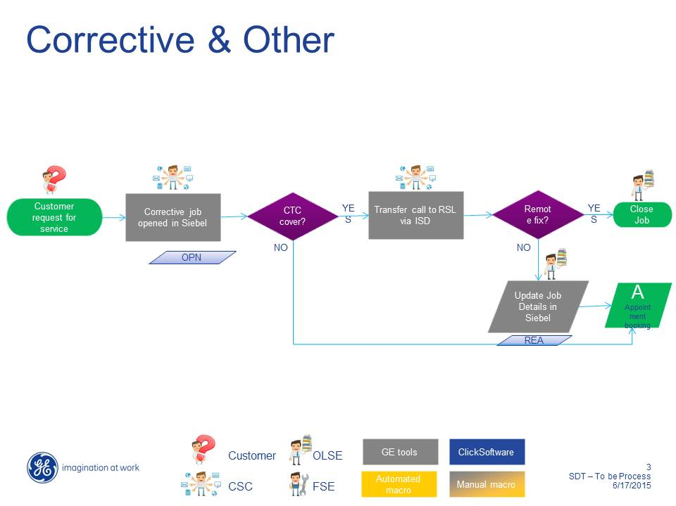

#### Activity: Customer Request for Service

| **Activity Name:** | **Customer Request for Service** |
| --- | --- |
| Action taken by: | Customer |
| Interacting with: | CSC Agent |
| Description | Customer contacts GEHC Customer Service Centre with various queries and requests for work to be performed at customer sites.  The CSC Agent looks up the customer details and inputs the request details into the SIEBEL application.   * Example of a Customer request is to fix or repair GEHC equipment at customer site |
| Task Status | N/A |

#### Activity: Manual process

| **Activity Name:** | **Manual Process** |
| --- | --- |
| Action taken by: | CSC |
| Interacting with: | Customer, OLE (On Line Engineer) |
| Description | * CSC responds to the call and pass the information to OLE. * OLE does the triage and creates the Siebel SR and activity for OLE support. * If the issue can be fixed by OLE he will fix it and close the SR. If not SR Is transferred to CSC. * CSC creates the SR- Activity for field support and order parts if recommended by OLE and get the duration and Field Engineer Skill level if not auto-populated as per local SOP |
| Task Status | N/A |

#### Activity: Activity Creation Process

| **Activity Name:** | **Activity Creation Process** |
| --- | --- |
| Action taken by: | CSC |
| Interacting with: | Customer, SDT Booking Tool, Siebel, Click Software |
| Description | * CSC Agent clicks on the SDT booking button from the Activity Schedule Tab in Siebel. * Siebel launches the SDT Booking Tool passing the 1) SR 2) Activity No 3) Row ID 4) Site ID to the SDT Tool. * SDT Booking Tool fetches all the related information stored at Activity level and SR Level through the Rest API's from Siebel. Also it picks the site and systems information from Click Software and displays all the tasks for selected site for next 45 days. * SDT Booking Tool to understand whether it’s a dependent task or a new task. * CSC agent manually invokes Appointment Booking functionality * Click Sends suitable appointment slots based on Field Engineer availability and parameters selected by the CSC agent in the SDT Booking - Appointment screen * Talk to customer and get the appointment slot fixed |
| Task Status | N/A |

#### Activity: Appointment Booking Process

| **Activity Name:** | **Appointment Booking Process** |
| --- | --- |
| Action taken by: | CSC |
| Interacting with: | Customer, SDT Booking Tool |
| Description | CSC Agent selects the desired appointment slot opted by Customer; For detailed Information please refer to 4.3.2 |
| Task Status | N/A |

#### Activity: Visit Creation Process

| **Activity Name:** | **Visit Creation Process** |
| --- | --- |
| Action taken by: | System |
| Interacting with: | SDT Booking Tool, Click Software |
| Description | * Visit(Task) created in Click Schedule by SDT Booking Tool based on the appointment slot chosen by Customer * Once the visit is created the Assignment Start, Finish and Assigned Engineer would be sent back to SDT Booking Tool by Click Software |
| Task Status | Tentative |

#### Activity: Job Assign Process

| **Activity Name:** | **Job Assign Process** |
| --- | --- |
| Action taken by: | Automatic |
| Interacting with: | Click Schedule, Click Mobile, SDT Assign |
| Description | * Task moved to Assigned Status by Click Software * XML files to be placed in the New GE FTP folder for APAC (all engineer/job assignment data would be part of this) (As implemented for Europe) * Engineer gets job assigned in Click Mobile * SDT Assign updates Assignment Start date, Assignment End date and Field Engineer Name to the activity of the Siebel SR |
| Task Status | Assigned |

#### Activity: Siebel Activity Status Update Process

| **Activity Name:** | **Siebel Activity Status Update Process** |
| --- | --- |
| Action taken by: | Automatic |
| Interacting with: | Siebel |
| Description | Following statuses are updated in Siebel  Activity Status: Open  Activity Sub status : Scheduled |
| Task Status | Assigned |

#### Activity: Job Acknowledgement Process

| **Activity Name:** | **Job Acknowledgement Process** |
| --- | --- |
| Action taken by: | Field Engineer |
| Interacting with: | Click Schedule, Click Mobile, SDT Assign |
| Description | * Engineer Acknowledges the job in Click Mobile and changes the status to Acknowledged * XML files to be placed in the GE FTP folder (all engineer/job assignment data would be part of this) by Click Software * Task Details are updated in the activity of the Siebel SR by SDT Assign |
| Task Status | Acknowledged |

#### Activity: Siebel Activity Status Update Process

| **Activity Name:** | **Siebel Activity Status Update Process** |
| --- | --- |
| Action taken by: | Automatic |
| Interacting with: | Siebel |
| Description | Following statuses are updated in Siebel  Activity Status: Scheduled  Activity Sub status : NULL |
| Task Status | Acknowledged |

#### Activity: Engineer Enroute to Job Process

| **Activity Name:** | **Enroute to Job Process** |
| --- | --- |
| Action taken by: | Engineer |
| Interacting with: | Click Mobile |
| Description | Engineer is Enroute for the Job and changes the status to Enroute |
| Task Status | En-route |

#### Activity: Engineer Onsite Job Process

| **Activity Name:** | **Onsite at Job Process** |
| --- | --- |
| Action taken by: | Engineer |
| Interacting with: | Click Mobile |
| Description | Engineer is at Onsite for the Job and changes the status to Onsite |
| Task Status | Onsite |

#### Activity: Engineer Completes the Job Process

| **Activity Name:** | **Completes the Job Process** |
| --- | --- |
| Action taken by: | Engineer |
| Interacting with: | Click Mobile, Click Software, SDT Assign |
| Description | * Engineer completes the Job and changes the status to Completed * XML files to be placed in the GE FTP folder (all engineer/job assignment data would be part of this) by Click Software * Task Details are updated in the activity of the Siebel SR by SDT Assign |
| Task Status | Completed |

#### Activity: Siebel Activity Status Update Process

| **Activity Name:** | **Siebel Activity Status Update Process** |
| --- | --- |
| Action taken by: | Automatic |
| Interacting with: | Siebel |
| Description | Following statuses are updated in Siebel  Activity Status: Open  Activity Sub status : SDT-Completed |
| Task Status | Completed |

#### Activity: Engineer InCompletes the Job Process

| **Activity Name:** | **InCompletes the Job Process** |
| --- | --- |
| Action taken by: | Engineer |
| Interacting with: | Click Mobile, Click Software, SDT Assign |
| Description | * Engineer Incompletes the Job and changes the status to InComplete * XML files to be placed in the GE FTP folder (all engineer/job assignment data would be part of this) by Click Software * Task Details are updated in the activity of the Siebel SR by SDT Assign |
| Task Status | InComplete |

#### Activity: Siebel Activity Status Update Process

| **Activity Name:** | **Siebel Activity Status Update Process** |
| --- | --- |
| Action taken by: | Automatic |
| Interacting with: | Siebel |
| Description | Following statuses are updated in Siebel  Activity Status: Open  Activity Sub status : SDT-InComplete |
| Task Status | InComplete |

#### Activity: Follow up Task Creation Process

| **Activity Name:** | Follow up Task Creation |
| --- | --- |
| Action taken by: | CSC |
| Interacting with: | Siebel |
| Description | CSC Agent would create a follow-up task and follows same process from 4.3.1.4  This would be the new Activity in Siebel under same SR |
| Task Status | New |

#### Activity: Engineer rejects the Job

| **Activity Name:** | **Rejects the Job Process** |
| --- | --- |
| Action taken by: | Engineer |
| Interacting with: | CSC Agent, Click Mobile, Click Software, SDT Assign |
| Description | * Engineer calls CSC Agent and Rejects the Job by changing the status to Reject * Task moves to New Status * XML files to be placed in the GE FTP folder (all engineer/job assignment data would be part of this) by Click Software * Task Details are updated in the activity of the Siebel SR by SDT Assign |
| Task Status | New |

#### Activity: Siebel Activity Status Update Process

| **Activity Name:** | **Siebel Activity Status Update Process** |
| --- | --- |
| Action taken by: | Automatic |
| Interacting with: | Siebel |
| Description | Following statuses are updated in Siebel  Activity Status: Open  Activity Sub status : SDT- Rejected |
| Task Status | New |

#### Activity: Reassigning post rejection of the primary activity

| **Activity Name:** | **Reassigning post rejection of the primary activity** |
| --- | --- |
| Action taken by: | CSC |
| Interacting with: | Click Mobile, Click Software |
| Description | * CSC Agent Manually assigns the task to Field Engineer * Flow repeated from Job Status Assigned till Complete |
| Task Status | Assigned |

#### Activity: Cancel the Job

| **Activity Name:** | **Cancel the Job Process** |
| --- | --- |
| Action taken by: | CSC |
| Interacting with: | Click Software, SDT Assign |
| Description | * CSC Agent cancels the task in Click and changes the status to Cancelled * XML files to be placed in the GE FTP folder (all engineer/job assignment data would be part of this) by Click Software * Task Details are updated in the activity of the Siebel SR by SDT Assign |
| Task Status | Cancelled |

#### Activity: Siebel Activity Status Update Process

| **Activity Name:** | **Siebel Activity Status Update Process** |
| --- | --- |
| Action taken by: | Automatic |
| Interacting with: | Siebel |
| Description | Following statuses are updated in Siebel  Activity Status: Open  Activity Sub status : SDT- Cancelled |
| Task Status | Cancelled |

#### Activity: Exception Handling

| **Activity Name:** | **Part Picked and Task Cancelled** |
| --- | --- |
| Action taken by: | TBD |
| Interacting with: | TBD |
| Description | TBD |
| Task Status | N/A |























### Business Scenario 1A: Appointment Booking

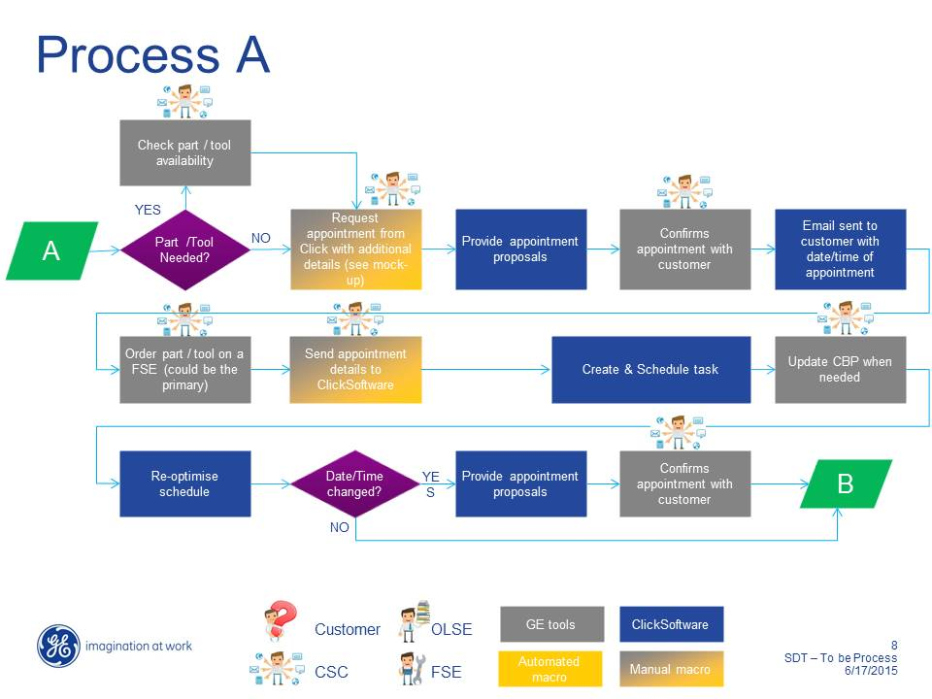

#### Activity: Part/Tool Needed?

| **Activity Name:** | **Part/Tool Needed?** |
| --- | --- |
| Action taken by: | Dispatcher |
| Interacting with: | SIEBEL |
| Description | The Dispatcher interrogates SIEBEL to find out if parts or tools are required to the job. |
| Task Status | N/A |

#### Activity: Check Part/Tool Availability

| **Activity Name:** | **Check Part/Tool Availability** |
| --- | --- |
| Action taken by: | Dispatcher |
| Interacting with: | SIEBEL  GE Part Ordering System |
| Description | If parts or tools are required to perform the work, then the dispatcher interrogates the GE Part Ordering System to see if the parts/tools are available. Note that part ordering is handled later in the process flow. Delivery timescales SIEBEL be checked with the local courier services during this activity.  The parts can either be sent to the Customer location address or a designated drop box or other location where FSE can pick-up parts prior to the appointment start time. Selection of the location SIEBEL drive the optional creation of a Part Pickup task in ClickSchedule, to be associated with the main task for the SIEBEL activity. As such this information SIEBEL be included when submitting a booking request for the planned activity. |
| Task Status | N/A |

#### Activity: Request Appointment from Click with Additional Details

| **Activity Name:** | **Request Appointment from Click with Additional Details** |
| --- | --- |
| Action taken by: | Dispatcher |
| Interacting with: | 1. Customer 2. SIEBEL 3. ClickSoftware |
| Description | 1. The SDT Booking tool will be used with Siebel to send the appointment booking request to SDT / click interface with following details :    1. Length of job / Duration – Can be sent null or with some value.    2. Job type    3. Other details are detailed in SDT - Interface - v1.3.pptx document produced by GEHC    4. Alternative scheduling policy selection in order to adjust or relax certain scheduling constraints. 2. Early and late start values are derived from the associated contract and district calendar as covered in section 5.8.6. 3. Determines the priority and work type based on the customer’s input. (SIEBEL will determine the SLA based on the details entered above). 4. Offers the customer the choice between the following appointment profiles:    1. ‘AM / PM’    2. ‘1 hour slots’    3. ‘2 hour slots’ 5. Enter appointment search time window of two weeks based on customer input and the job priority. In order to control appointment search response times, the interval within which ClickSchedule is to search for an appointment should not be longer than two weeks, although the start and end dates may be changed.    1. If the Dispatcher would like to search for an appointment in a time window wider than two weeks, then instead of doing so they should look further using multiple requests. Here, they will need to perform a number of iterative searches, each with an interval of two weeks. E.g. if the Dispatcher would like to search for all the available appointment slots within the next 4 weeks, they should first search for appointments in the first two weeks, then the following two weeks (3rd and 4th) and so on. Note: Each search is a separate one, so the Dispatcher would have to search again to get an earlier set of results back. Also, it may not return exactly the same list twice, especially if someone else has taken a slot in the meantime.   It should be noted that if *n* FSEs are required for the activity then the integration SIEBEL request an appointment for *n* primary tasks and up to *n* associated part pickup tasks, all with appropriate dependencies. |
| Task Status | N/A |

#### Activity: Provide Appointment Proposals

| **Activity Name:** | **Provide Appointment Proposal** |
| --- | --- |
| Action taken by: | Dispatcher |
| Interacting with: | 1. Customer 2. Manual Macro |
| Description | 1. ClickSchedule receives request for an appointment. 2. ClickSchedule searches for appointment options within the defined search period and using the specified appointment profile.    1. ClickSchedule searches for available appointments based on capacity, geography, and availability. While searching for possible appointment slots, ClickSchedule will take into consideration the resources’ availability, skills, (SLR) travel to and from other tasks or appointments, SLA compliance, priority, alternative scheduling policy selection and many other factors to fulfil GEHC’s scheduling objectives (please refer to section 7 for more details).    2. ClickSchedule uses the appointment’s priority to determine whether it can unschedule less important work to allow scheduling at a specific slot.    3. ClickSchedule limits the number of returned options to avoid a long search and response time for the Dispatcher. *The threshold will be determined during the “Build” and “Test” phases of implementation*.    4. Based on the selected appointment profile.    5. Once the search is completed, ClickSchedule sends to the Manual Macro interface a list of available appointments. For each available appointment, ClickSchedule provides the start and finish date and time.   If the search for an optional appointment results in no appointments being found, the Dispatcher should initiate a new search with a different appointment search window using the Manual Macro interface.  If, after performing searches for an appointment, no appointment slots can be found the Dispatcher is expected to create the task without a fixed appointment in ClickSchedule to enable further manual search, potentially updating the schedule so that there are rule violations. An example may be to allow a FSE from a different region to attend the task (thereby breaking the match region and maximum travel rules). |
| Task Status | N/A |

#### Activity: Confirms Appointment with Customer

| **Activity Name:** | **Confirms Appointment with Customer** |
| --- | --- |
| Action taken by: | Dispatcher |
| Interacting with: | 1. Customer 2. SDT Booking tool |
| Description | The Dispatcher (CSC agent) communicates to the customer the options for appointments offered by ClickSchedule.  If any of the options suit the customer, they can request it and the Dispatcher will select the appropriate slot.  If none of the options suit the customer, the Dispatcher should initiate another search for appointment options, modifying one or more of the search parameters:   * The date range in which to search – e.g. if the customer is not available within the search period offered, the CSC can search at a later date. * The appointment profile.   Customer accepts commitment provided by the CSC.  Confirm Commitment: the customer agrees to the commitment offered, triggering the Dispatcher to retain the task in SIEBEL with the appointment details that have been agreed on.  Note: At this stage ClickSchedule has not yet received the task and therefore the slot is not secured; only upon task creation in the next activity is the slot actually consumed**.** The next activity of creating and scheduling the task therefore needs to follow immediately after the booking and before the call is completed, otherwise, the time window may be given to another customer. |
| Task Status | N/A |

#### Activity: Email Sent to Customer with Date/Time of Appointment

| **Activity Name:** | **Email Sent to Customer with Date/Time of Appointment** |
| --- | --- |
| Action taken by: | ClickSchedule |
| Interacting with: | E-Mail Integration |
| Description | On receiving confirmation of the appointment from the SIEBEL ClickSchedule will create the contents of a confirmation email to the customer site with the appointment details (date and time). This requires ClickSchedule to be (indirectly) integrated with the GEHC email system in some way. The following parameters will be included (some values may be blank):   * Customer Contact Name * Customer E-mail Address * System Name * System ID * Job Number * Job Type * Site Languages * Appointment Start/Finish * Status (for when messages are sent at a later point) * Message Type (identifies the context of the message) * FSE Name |
| Task Status | N/A |

#### Activity: Order Part/Tool on a FSE (Field Service Engineer)

| **Activity Name:** | **Order Part/Tool on a FSE (Field Service Engineer)** |
| --- | --- |
| Action taken by: | Dispatcher |
| Interacting with: | GE Part Ordering System  Manual Macro |
| Description | 1. Parts required for the appointment will be ordered using the GE Part Ordering System. 2. Based on the parts collection method as set in the Check Part/Tool Availability step for appointment booking, this information SIEBEL be included when submitting the task creation request to ClickSchedule. |
| Task Status | N/A |

#### Activity: Send Appointment Details to ClickSoftware (ClickSchedule)

| **Activity Name:** | **Send Appointment Details to ClickSoftware (ClickSchedule)** |
| --- | --- |
| Action taken by: | Dispatcher |
| Interacting with: | 1. SDT booking and Assign tool 2. ClickSchedule |
| Description | 1. The Dispatcher initiates sending of the Customer activity and appointment details, using the SDT tool, to ClickSchedule in order to create a task in ClickSchedule for that customer appointment (and optionally a related part pickup task). All of the non-derived task details SIEBEL be submitted to ClickSchedule at this point. |
| Task Status | N/A |

#### Activity: Create and Schedule Task

| **Activity Name:** | **Create and Schedule Task** |
| --- | --- |
| Action taken by: | Dispatcher using SDT booking / assign tool |
| **Interacting with:** | **ClickSchedule** |
| Description | 1. ClickSchedule receives a system message with task details, including time constraints (and optional associated part pickup task) as committed to the customer. 2. ClickSchedule immediately attempts to tentatively schedule the task(s) and insert it (them) into the current schedule. ClickSchedule continues to optimize and reschedule the task, taking into account the different constraints (E.g. SLA, appointment window, etc.). If ClickSchedule fails to schedule the task immediately, it continues to try and schedule it via background optimization. In case ClickSchedule fails to schedule and there is a risk that the customer commitment or SLA will be violated, ClickSchedule flags the task as ‘In Jeopardy’ (this only happens when the commitment is in imminent danger of being missed).    1. The Dispatcher responsible for the customer’s area attempts to schedule the task using the ClickSchedule semi-automatic tools available from the ClickSchedule application. If no suitable resource and time can be found using the semi-automatic tools, the Dispatcher can manually drag the task to the time and resource of their choosing.    2. This process may also be accompanied by a phone call to the customer, or other manual actions based on the specific circumstances of the scenario.   Note: Prior to this activity the task had not yet been created in ClickSchedule, and therefore the appointment to the customer was not confirmed. It is crucial that the time between the selection of the appointment and the creation of the task in ClickSchedule is minimised to significantly reduce the chance of the slot being filled by a concurrent appointment booking.  It should be noted that if *n* FSEs are required for the activity then the integration SIEBEL request creation for *n* primary tasks and up to *n* associated part pickup tasks, all with appropriate dependencies. |
| Task Status | 1. If the task is scheduled, its status is Tentative. 2. If the task could not be scheduled, its status is New. |

#### Activity: Update back SIEBEL with a dummy FE assignment for 1 minute

This activity is now included as part of step 8.

#### Activity: Update CBP When Needed

This is an internal logic process within the GEHC flow.

#### Activity: Re-optimize Schedule

| **Activity Name:** | **Re-Optimize Schedule** |
| --- | --- |
| Action taken by: | ClickSchedule  Dispatcher |
| Interacting with: | ClickSchedule |
| Description | As the name of this activity implies, a task is generally scheduled within the context of re-optimizing other parts of the existing schedule. Even during exception handling, “no [task] is an island” (unless it has been manually locked in some way or has progressed passed the “Assigned” status).  The task is rescheduled by one of the following processes:   * Continuous Re-optimization (via ClickSchedule Background Optimizer). ClickSchedule is continuously reviewing parts of the schedule to seek local improvements to the existing schedule. Refer to section 8.2 for further details regarding the Background Optimization (BGO). * Triggered Re-optimization (via ClickSchedule Task Insert or Schedule Update).  As a result of other changes in the schedule (e.g. new tasks with variations in priority or updates from the field), parts of the schedule are automatically rescheduled. Please refer to Section 8.3 - Scheduling Work Immediately (Task Insert)and 8.4 - Schedule Updates. * If ClickSchedule fails to schedule a task and there is a risk that the customer commitment or SLA (as embodied by the appointment window and early/late start details) will be violated, ClickSchedule flags the task as ‘In Jeopardy’.  For more information about Jeopardy Alerts please refer to section 9.3. * The Dispatcher responsible for the customer’s area attempts to schedule the task using the ClickSchedule semi-automatic tools available from the ClickSchedule client. For more information please refer to section 8.5 * If no suitable resource and time can be found using the semi-automatic tools, the Dispatcher can manually drag the task to the time and resource of his or her choosing (see section 8.5.2). * This process may also be accompanied by a phone call, or other manual actions based on the specific circumstances of the scenario. |
| Task Status | Varies based on timing of re-optimization vs. dispatch timeframe. |

### Business Scenario 1B: Dispatch Work

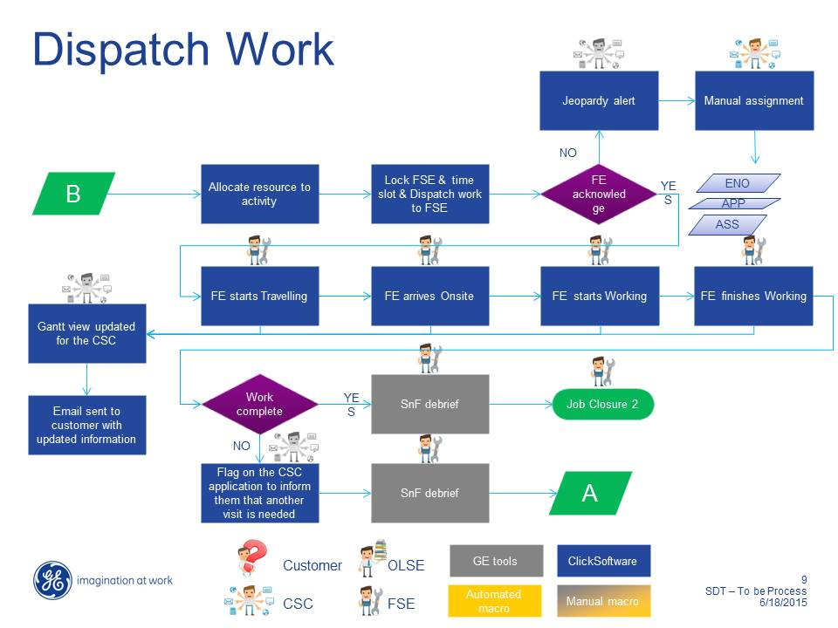

#### Activity: Allocate Resource to Activity

| **Activity Name:** | **Allocate Resource to Activity** |
| --- | --- |
| Action taken by: | ClickSchedule |
| Interacting with: | ClickSchedule  ClickMobile |
| Description | ClickSchedule (tentatively) allocates the currently optimum FSE (given the location, availability and skill of the FSE along with other considerations) to the activity to be performed. Depending on the regional configuration, such tentative assignments may be sent to the mobile device for the FSE. |
| Task Status | Varies based on timing of re-optimization vs. dispatch timeframe. |

#### Activity: Lock FSE & Slot & Dispatch Work to a FSE

| **Activity Name:** | **Lock FSE & Time Slot & Dispatch Work to a FSE** |
| --- | --- |
| Action taken by: | 1. ClickSchedule Dispatch Agent (automatic dispatching) 2. Dispatcher (for manual dispatch) |
| Interacting with: | ClickSchedule  ClickMobile |
| Description | ClickSchedule dispatches the work to the FSE.   1. **Automatic dispatching**: The configured dispatch policy identifies when specific tasks should be dispatched, i.e. status changed to Assigned, and sent to the FSEs’ mobile devices. Note that this leverages a “next working day” facility to ensure that policies that dispatch tasks on subsequent days allow for weekends, bank holidays and other non-working days as defined in the individual FSEs’ calendars. Different policies are applied in different regions and sometimes apply different handling of different task types. 2. **Manual Dispatching**: On an ad hoc and as needed basis, Dispatchers can change the status of tentatively scheduled tasks to Assigned. This is expected for cases in which the Dispatcher manually updates the schedule (e.g. for immediate, high priority tasks). |
| Task Status | Assigned |

#### Activity: FSE Accept?

| **Activity Name:** | **FSE Accepts?** |
| --- | --- |
| Action taken by: | FSE |
| Interacting with: | ClickMobile  Dispatcher |
| Description | FSE reviews assigned job details and can reject the job if needed. This step is available on the mobile device depending on the regional configuration. If not available then the rejection must be communicated by the FSE contacting their dispatcher. |
| Task Status | Acknowledged or Rejected by FSE/Rejected |

* + **KOREA**
    - Disable Reject this functionality for Korea implementation

#### Activity: Jeopardy Alert

| **Activity Name:** | **Jeopardy Alert** |
| --- | --- |
| Action taken by: | FSE |
| Interacting with: | ClickMobile |
| Description | If the FSE rejects the assigned job with a rejection reason, then a rejection alert is sent to the dispatcher’s ClickSchedule client. The dispatcher can then contact the FSE to fully understand the reason for the job rejection. This can trigger an email alert to the FSE’s manager.  Note that dispatchers can use a jeopardy workflow to track where they are in the process of resolving the jeopardy. The assignment will remain in jeopardy until the workflow is complete or the task’s status is changed. |
| Task Status | Rejected by FSE |

#### Activity: Manual Assignment

| **Activity Name:** | **Manual Assignment** |
| --- | --- |
| Action taken by: | Dispatcher |
| Interacting with: | ClickSchedule |
| Description | The rejected job is manually assigned to another FSE by the Dispatcher using ClickSchedule. This activity has an implied iteration back through 4.3.3.3 and is assumed to finally exit when an alternative FSE accepts the assignment. |
| Task Status | Acknowledged |

#### Activity: Assignments loaded in SIEBEL for 1 min

| **Activity Name:** | **Assignments loaded in SIEBEL for 1 min** |
| --- | --- |
| Action taken by: | ClickSchedule |
| Interacting with: | Siebel |
| Description | A one minute assignment is created in SIEBEL to avoid overlapping jobs. This generates an outgoing message that SIEBEL include all of the (future) tasks for the given SIEBEL job ID to allow SIEBEL to keep a clean list of non-overlapping jobs. |
| Task Status | Acknowledged |

#### Activity: FSE Starts Travelling

| **Activity Name:** | **FSE Starts Travelling** |
| --- | --- |
| Action taken by: | FSE |
| Interacting with: | ClickMobile |
| Description | The FSE starts to travel to the assignment and sets the status of the job to En Route on his/her mobile device. |
| Task Status | En Route |

#### Activity: FSE Arrives On-Site

| **Activity Name:** | **FSE Arrives On-Site** |
| --- | --- |
| Action taken by: | FSE |
| Interacting with: | ClickMobile |
| Description | On parking at the customer site the FSE uses their mobile device to update the job status to On Site, setting the assignment start time to “now”. |
| Task Status | On Site |

**KOREA**

* + Korea wanted this implementation to change the status as Onsite automatically when engineer’s reaches the site and clicksoftware system should be able to update the same by checking Engineer’s coordinate on field and Task site coordinates on GIS.

#### Activity: FSE Starts Working

| **Activity Name:** | **FSE Starts Working** |
| --- | --- |
| Action taken by: | FSE |
| Interacting with: | ClickMobile |
| Description | The FSE begins to start work on the customer equipment. This does not include a status update within the ClickMobile app. |
| Task Status | On Site |

#### Activity: FSE Finishes Working

| **Activity Name:** | **FSE Finishes Working** |
| --- | --- |
| Action taken by: | FSE |
| Interacting with: | ClickMobile |
| Description | The FSE finishes working on the customer equipment, and prepares for the debrief process. Note that completion of the work may or may not have successfully resolved the customer’s issue. On success, the FSE updates the status to Completed. In other cases the status is updated to Incomplete and additional information is entered into the task by the FSE (such as incomplete reason, whether a follow-on visit is required etc.). In both cases, closing the activity will automatically set the assignment finish to “now”. |
| Task Status | Completed/Incomplete |

#### Activity: Gantt View Updated for the CSC

| **Activity Name:** | **Gantt View Updated for the CSC** |
| --- | --- |
| Action taken by: | ClickMobile |
| Interacting with: | ClickSchedule |
| Description | The Gantt view on ClickSchedule is continually updated with the task status, status change timings, feedback data (such as incompletion reasons etc.) caused by the FSE’s updates entered via ClickMobile (at the various stages of the process), with any corresponding jeopardy warnings and alerts being automatically added by ClickSchedule as required. |
| Task Status | Acknowledged, En Route, Rejected, On Site, Completed, Incomplete, Cancelled |

#### Activity: Work Complete?

| **Activity Name:** | **Work Complete?** |
| --- | --- |
| Action taken by: | FSE |
| Interacting with: | ClickMobile |
| Description | If the work was incomplete, as per the output of 4.3.3.10, then different processing is required compared with a successful completion. This is handled by the dispatchers leveraging an “incompletion workflow”. Incomplete assignments have a sub-status that can be set by the dispatcher and are retained until the workflow is complete. |
| Task Status | Completed/Incomplete |

#### Activity: SnF Debrief

| **Activity Name:** | **SnF Debrief** |
| --- | --- |
| Action taken by: | FSE |
| Interacting with: | GE Toolset on FSE Personal Computer  ClickMobile |
| Description | If the job is completed (without a need for a follow-on customer visit), the FSE debriefs the completed job on his PC. |
| Task Status | Completed |

#### Activity: Job Closure 2

| **Activity Name:** | **Job Closure 2** |
| --- | --- |
| Action taken by: | FSE and CSC |
| Interacting with: | ClickMobile |
| Description | See the Job Closure 2 process description in section 4.3.4. |
| Task Status | Completed |

#### Activity: Flag on the CSC Application to inform them that another Visit is needed

| **Activity Name:** | **Flag on the CSC Application to inform them that another visit is needed** |
| --- | --- |
| Action taken by: | Dispatcher |
| Interacting with: | ClickSchedule |
| Description | If the job is not complete and the FSE believes that a follow-on customer visit is needed to complete the work, then the FSE indicates this as part of their feedback in 4.3.3.10. This is viewable using the ClickSchedule client against the incomplete task’s details and service alert allowing the information required to drive manual creation of the follow-on activity in SIEBEL (along with the required appointment) – see 4.3.3.13. This process leverages the incompletion sub-status mechanism described in 4.3.3.12. |
| Task Status | Incomplete |

#### Activity: SnF Debrief

| **Activity Name:** | **SnF Debrief** |
| --- | --- |
| Action taken by: | FSE |
| Interacting with: | GE Toolset on FSE Personal Computer  ClickMobile |
| Description | The FSE debriefs the completed job on his PC. The job status is changed to Completed on his Mobile device. Since the job requires a further visit to be arranged before it can be completed, this activity invokes the Appointment Booking process , section 4.3.2 above, enabling the CSC Agent to arrange a follow-up visit at the customer site to complete the job. |
| Task Status | Completed |

### Business Scenario 1C: Job Closures - &

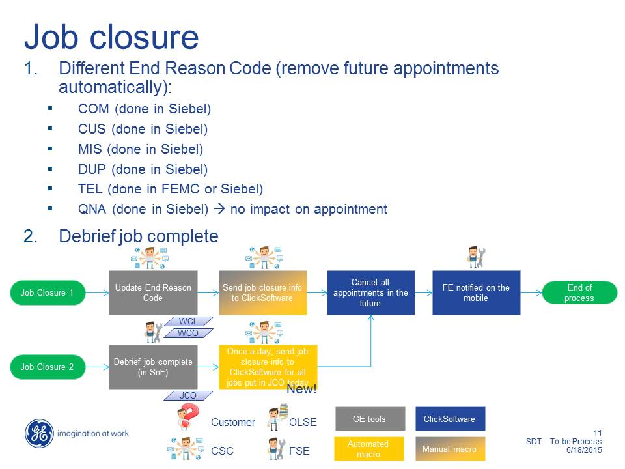

#### Job Closure 1 Process

##### Activity: Update End Reason Code

| **Activity Name:** | **Update End Reason Code** |
| --- | --- |
| Action taken by: | Dispatcher |
| Interacting with: | GE Tools |
| Description | The Dispatcher updates the end reason code. Valid codes are:   * COM (done in SIEBEL) - Competitor manages the product * CUS (done in SIEBEL) - Customer fixes product themselves e.g Reboot etc. * MIS (done in SIEBEL) - Mistake * DUP (done in SIEBEL) - Duplicate Job * TEL (done in FEMC or SIEBEL) – Fixed via Telephone * QNA (done in SIEBEL) 🡪 no impact on appointment |
| Task Status | N/A |

##### Activity: Send Job Closure info to ClickSchedule

| **Activity Name:** | **Send Job Closure Info to ClickSchedule** |
| --- | --- |
| Action taken by: | CSC Agent ( Dispatcher) |
| Interacting with: | Siebel - ClickSoftware |
| Description | Send ClickSchedule information required to cancel all future appointments connected with the job. |
| Task Status | New, Tentative, Assigned, Acknowledged (Those tasks related to the SIEBEL job that are cancelled end in the Cancelled status) |

##### Activity: Cancel All Appointments in the Future

| **Activity Name:** | **Cancel All Appointments in the Future** |
| --- | --- |
| Action taken by: | Automated via integration in the Manual Macro |
| Interacting with: | ClickSchedule |
| Description | Cancel all appointments in the future related to this job. This relies on receiving the SIEBEL job ID from the invoking manual macro. |
| Task Status | New, Tentative, Assigned, Acknowledged (Those tasks related to the SIEBEL job that are cancelled end in the Cancelled status) |

##### Activity: FSE Notified on the mobile

| **Activity Name:** | **FSE Notified on the mobile** |
| --- | --- |
| Action taken by: | ClickSchedule |
| Interacting with: | ClickMobile |
| Description | If the FSE has any assigned or acknowledged tasks related to the SIEBEL job on their device they will receive a notification that these tasks have been removed. |
| Task Status | Assigned, Acknowledged |

#### Job Closure 2 Process

##### Activity: Debrief Job Complete (SnF)

| **Activity Name:** | **Debrief Job Complete (SnF)** |
| --- | --- |
| Action taken by: | FSE |
| Interacting with: | GE Toolset on FSE Personal Computer (SnF) |
| Description | The FSE debriefs the completed job on his PC. |
| Task Status | Completed |

##### Activity: Once a Day send Job Closure Info to CS for all jobs put in JCO today – *ClickSoftware believe this activity is now redundant, as the job is already closed in ClickSchedule. If GE believes that additional information is required for completed activities, then GE need to provide the data content and time horizon of this information to the ClickSoftware team.*

| **Activity Name:** | **Once a Day send Job Closure Info to CS for all Jobs put in JCO today** |
| --- | --- |
| Action taken by: | CSC Agent |
| Interacting with: | Manual Macro |
| Description | Once a day it is necessary to send Job Closure Info to CS for all jobs put in JCO that day. |
| Task Status | N/A |

##### Activity: Cancel All Appointments in the Future

See section 4.3.4.1.3.

##### Activity: FSE Notified on the mobile

See section 4.3.4.1.4.

### Business Scenario 2.0 – Schedule a Preventive Maintenance job

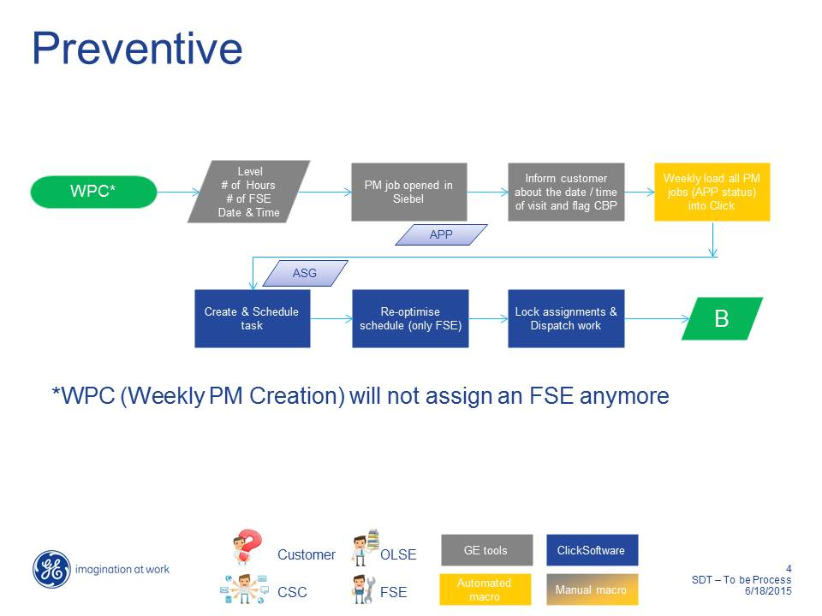

#### Activity: Contract Creation Process

| **Activity Name:** | **Contract Creation Process** |
| --- | --- |
| Action taken by: | Contract Team |
| Interacting with: | Siebel |
| Description | * Once the System is installed at Site, Siebel Contract will generate the number of Maintenance tasks to be performed as per SLA. * PM Scheduling/PM Plan in Siebel will be created based on the inputs received from Siebel Contract. |
| Task Status | N/A |

#### Activity: Bulk PM Creation Process

| **Activity Name:** | **Bulk PM Creation** |
| --- | --- |
| Action taken by: | Automatic, CSC |
| Interacting with: | Siebel, SDT Booking Tool, Click Software |
| Description | * Siebel opens the PM SR Jobs 90 days in advance * CSC Agent does the Reconciliation of PM Plan - Check that for PM's which are due In next 90 days, all the associated information is correct (Field Engineer Skill level, and Duration and Schedule Date is appropriate) manually. * Scheduled Windows service in SDT Booking Tool would pull the Activity Information from Siebel based on   + Scheduled date   + Activity Type = PM   + Activity Status = Open   + Last update date   + Modality   + Operating Unit * Jobs created in Click without appointment details (These activities wouldn’t be shown on Gantt and no BGO should be run on these until Appointment Details are mentioned and thus shown in a different Tab in Click Schedule) |
| Task Status | N/A |

#### Activity: Individual PM Appointment Process

| **Activity Name:** | **Individual PM Appointment** |
| --- | --- |
| Action taken by: | Automatic, CSC |
| Interacting with: | Siebel, SDT Booking Tool, Click Software |
| Description | * CSC Agent gets a list of tasks within Click which are unscheduled (either through a report or a task list). * CSC selects the SR and Activity for the Task which is unscheduled in Click based on the list (Manual step). * CSC checks if there are any parts required for fulfilling this PM activity or if any OJT required manually. * CSC Agent clicks on the SDT booking button from the Activity Schedule Tab in Siebel. * Siebel launches the application passing the 1) SR 2) Activity No 3) Row ID 4) Site ID to the SDT Booking application * If parts are required please follow the steps mentioned in 4.3.11 * SDT Booking application fetches all the related information stored at Activity level and SR Level through the Rest API's from Siebel * From Here on it's the same flow as corrective repair mentioned in 4.3.1 |
| Task Status | N/A |































### Business Scenario 3.0 – Schedule an FMI job

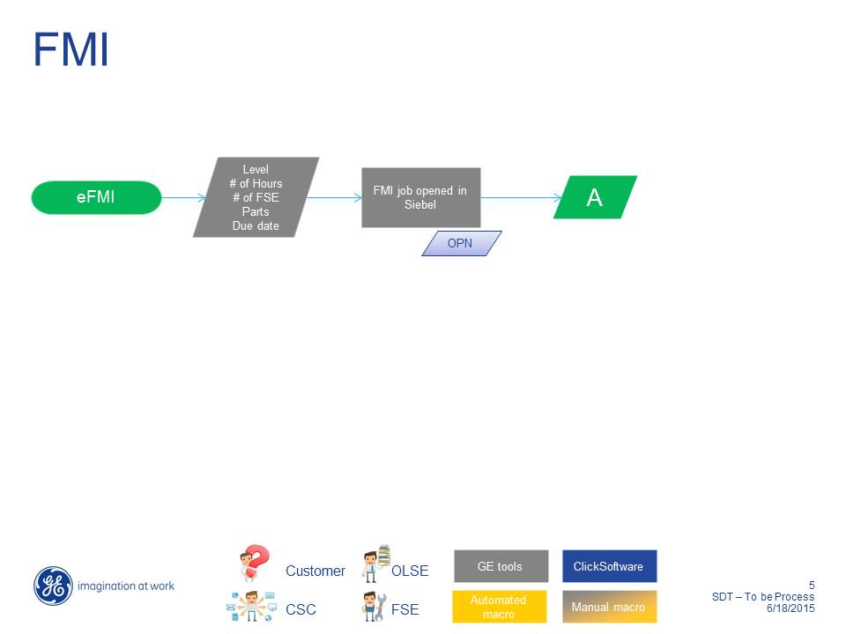

#### Activity: Bulk FMI Creation Process

| **Activity Name:** | **Bulk FMI Creation Process** |
| --- | --- |
| Action taken by: | Automatic |
| Interacting with: | SDT booking Tool, Siebel, Click Software |
| Description | * Scheduled Windows service would pull the Activity Information for next 90 days from Siebel based on   1. Activity = Open   2. Activity Open Date > 1st Jul   3. Activity Type = FMI   4. Last update date > yesterday-1 * Jobs created in Click without appointment details (These activities wouldn’t be shown on Gantt and no BGO should be run on these) * BGO further optimizes the task once the appointment details are available. |
| Task Status | N/A |

#### Activity: Individual FMI Appointment Process

| **Activity Name:** | **Individual FMI Appointment Process** |
| --- | --- |
| Action taken by: | CSC |
| Interacting with: | SDT booking Tool, Siebel, Click Software |
| Description | * Get a list of tasks within Click which are unscheduled (either through a report or a task list) * When the FMI Kit is ready in Siebel then select the SR and Activity (Manual step) * CSC Agent clicks on the SDT booking button from the Activity Schedule Tab. * Siebel launches the application passing the 1) SR 2) Activity No 3) Row ID 4) Site ID to the SDT Booking application |
| Task Status | New |

#### Activity: Manual Process

| **Activity Name:** | **Manual Process** |
| --- | --- |
| Action taken by: | CSC |
| Interacting with: | N/A |
| Description | * Check if the FMI Kit is locally available for fulfilling this FMI activity * Check if any OJT required |
| Task Status | N/A |

#### Activity: Part Pick Scenario

| **Activity Name:** | **Part Pick Scenario** |
| --- | --- |
| Action taken by: | Engineer |
| Interacting with: | N/A |
| Description | If parts are required please follow the process mentioned at Section 4.3.12. |
| Task Status | N/A |

#### Activity: On Job training

| **Activity Name:** | **On Job training** |
| --- | --- |
| Action taken by: | Engineer |
| Interacting with: | N/A |
| Description | If OJT is required please follow the process mentioned at Section 4.3.8. |
| Task Status | N/A |

#### Activity: Individual FMI Appointment Process

| **Activity Name:** | **Individual FMI Appointment Process** |
| --- | --- |
| Action taken by: | System |
| Interacting with: | SDT booking Tool, Siebel, Click Software |
| Description | * SDT Booking application fetches all the related information stored at Activity level and SR Level through the Rest API's from Siebel * From here on it's the same flow as corrective repair at section 4.3.1 |
| Task Status | Tentative |







### Business Scenario 4.0 – Schedule an Installation job

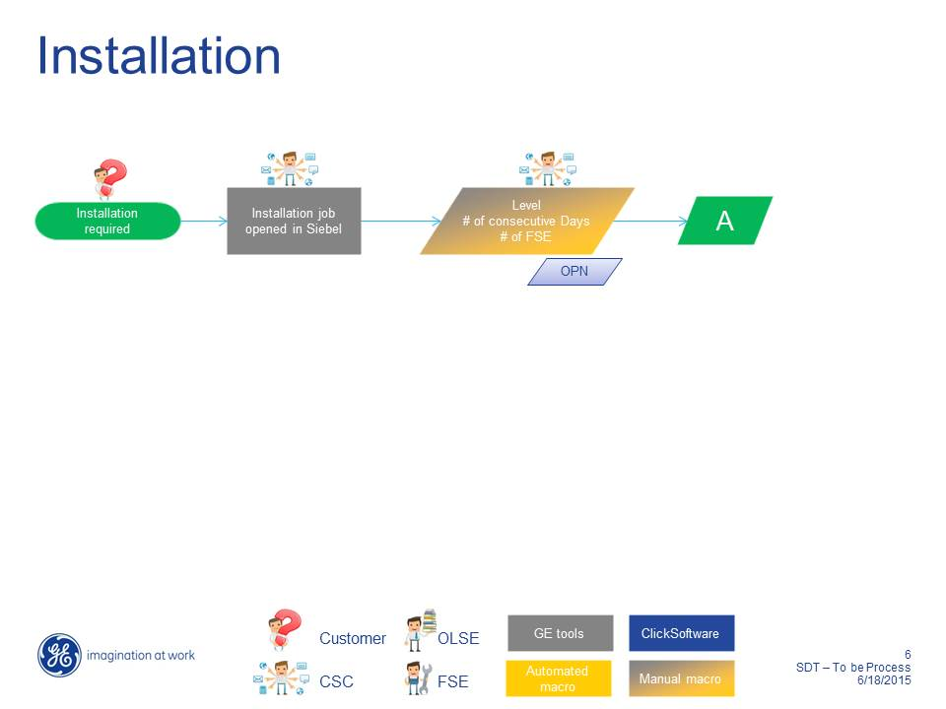

#### Activity: Manual process

| **Activity Name:** | **Manual Process** |
| --- | --- |
| Action taken by: | Project Manager for Installation (PMI), RSE- ASM (Regional Support Engineer- Area Service Manager), CSC |
| Interacting with: | CSC, Salesforce.com (Eagle) |
| Description | * Request for Installation from PMI Team * RSE-ASM assigns the Primary Engineer and passes the information to CSC and sales force.com team (Eagle) * CSC Agent block assigned Field Engineer with right skills on planned dates |
| Task Status | N/A |

#### Activity: Activity Creation Process

| **Activity Name:** | **Activity Creation Process** |
| --- | --- |
| Action taken by: | CSC Agent |
| Interacting with: | Siebel, SDT Booking Tool, Click Software |
| Description | * CSC Agent creates installation activity with 1-2 weeks of window (duration) and specific dates and for the required Field Engineer * CSC Agent clicks on the SDT booking button from the Activity Schedule Tab * Siebel launches the application passing the 1) SR & 2) Activity no 3) Row ID 4) Site ID to the SDT Booking application * SDT Booking application fetches all the related information stored at Activity level and SR Level through the Rest API's from Siebel * CSC agent creates visit without appointment (as the dates of installation are determined beforehand by sales folks) * Task created in ClickSchedule (Not on the GANTT) * CSC Agent manually assign task to the Field Engineer on the desired date - Manual Scheduling in Click Software * Dispatch policy runs every day and task would be assigned to the Field Engineer * CSC communicates with Field Engineer to pick the required installation tools manually * From here on it's the same flow as corrective repair at section 4.3.1 |
| Task Status | New/Tentative |







### Business Scenario 5.0 – Schedule a Training job on a C/P/? job

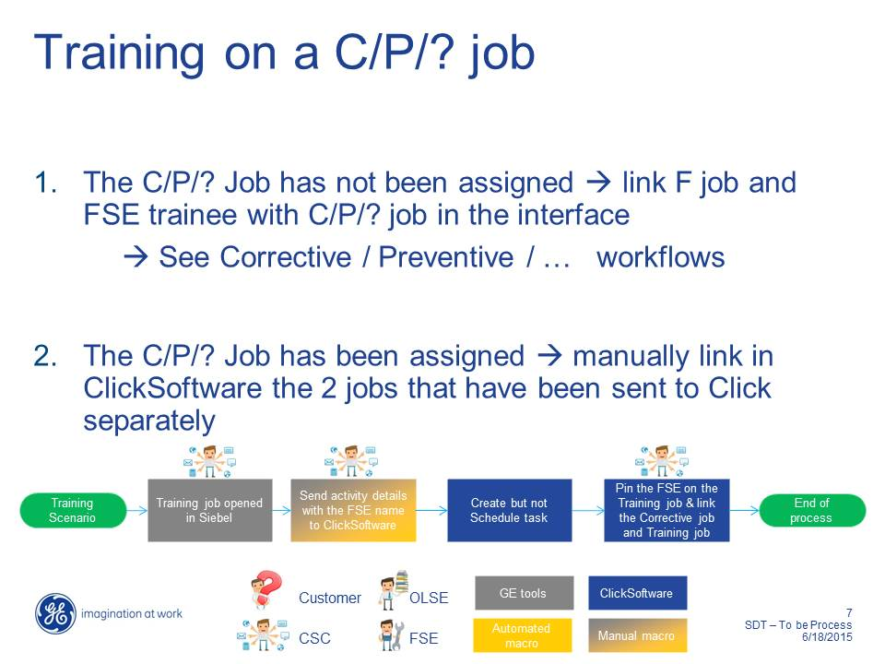

**Training Scenario A**

In this scenario, a C/P/? Training job (Corrective, Preventive Maintenance/Other work types) has not been assigned (linked) to an existing job. The integration between SIEBEL and ClickSchedule is used to create the training job and link it to an existing task. It is assumed the CSC Agent creating the activity in SIEBEL can link it to the existing one, using the Task ID of it as communicated to ClickSchedule. SDT Booking will manage all the OJT and Part Pick up jobs and create dependency jobs in Click Software as required.

**Training Scenario B**

In this scenario a training job has been created as free standing and the Dispatcher SIEBEL join it to the relevant “primary” task using the ClickSchedule client facilities.

NB: Since GE have indicated that it is unlikely to be used due to the complexity of this activity and the raised potential for human error this scenario has been excluded from the solution.

#### Activity: On Job Training Initiation Process

| **Activity Name:** | On Job Training Initiation |
| --- | --- |
| Action taken by: | CSC Agent |
| Interacting with: | Siebel, SDT Booking Tool, Click Software |
| Description | * Create the OJT Activity in Siebel * Enter the Training details (OJT) (SDT booking tool adds a dependency task against the Primary task with a Start to Start dependency) * CSC agent manually invokes Appointment Booking functionality |
| Task Status | N/A |

#### Activity: On Job Training Scheduling Process

| **Activity Name:** | On Job Training Scheduling Process |
| --- | --- |
| Action taken by: | CSC Agent |
| Interacting with: | Siebel, SDT Booking Tool, Click Software |
| Description | * Click Sends suitable appointment slots based on Field Engineer availability and parameters selected by the CSC agent in the SDT Booking - Appointment screen * CSC Agent selects the desired appointment slot and clicks on Create Visit Button in SDT Booking Tool. * 2 Tasks created (Original task and Training Task) in ClickSchedule for different Field Engineer's -> One main and one trainee with Start to Start dependency. * From here on it's the same flow as corrective repair at section 4.3.1. |
| Task Status | N/A |















### Business Scenario 6.0 – Job Interrupted

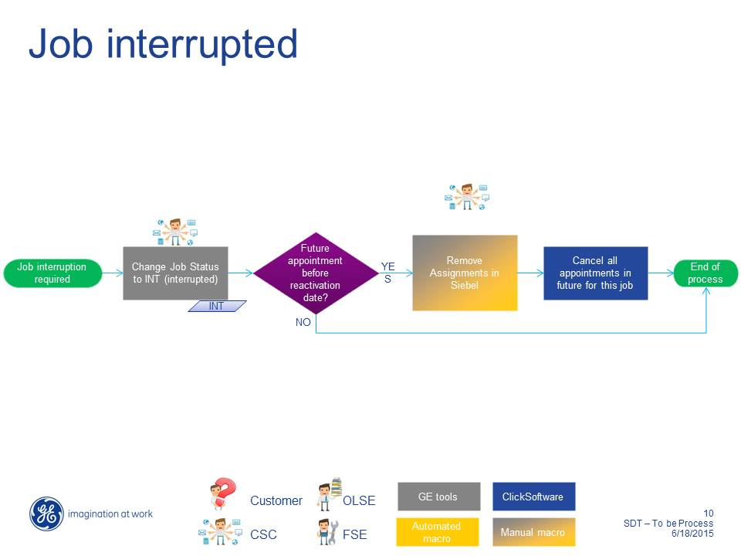

#### Activity: Change Job Status to INT (interrupted)

| **Activity Name:** | **Change Job Status to INT (interrupted)** |
| --- | --- |
| Action taken by: | CSC Agent |
| Interacting with: | GE Tools |
| Description | The Change Job Status to INT (interrupted) in SIEBEL. A job cannot be interrupted whilst an activity is in progress, so if there are such activities the CSC Agent SIEBEL tell the FSE to incomplete the task first. |
| Task Status | All statuses prior to On Site |

#### Activity: Future Appointment?

| **Activity Name:** | **Future Appointment?** |
| --- | --- |
| Action taken by: | CSC Agent |
| Interacting with: | GE Tools |
| Description | The CSC Agent determines whether the interrupted job has future appointment dates related to this job. |
| Task Status | N/A |

#### Activity: Remove Assignments in SIEBEL

| **Activity Name:** | **Remove Assignments in SIEBEL** |
| --- | --- |
| Action taken by: | CSC Agent |
| Interacting with: | Manual Macro/SIEBEL |
| Description | If future appointments for this job then remove these assignments from SIEBEL. |
| Task Status | N/A |

#### Activity: Cancel all Appointments in the Future related to this Job

| **Activity Name:** | Cancel all Appointments in the Future related to this job |
| --- | --- |
| Action taken by: | Automatic |
| Interacting with: | ClickSchedule |
| Description | Cancel all the future tasks related to this job, using the SIEBEL Job ID to search for them. The CSC Agent will use the FSE job debriefs to submit any necessary follow-up jobs required into the schedule, though that is outside the scope of this activity |
| Task Status | Cancelled (for all identified future tasks) |

### Business Scenario 10 – Update Job Details

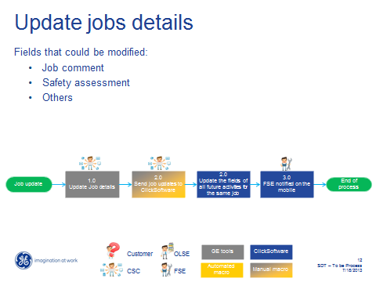

#### Activity: Update Job Details

| **Activity Name:** | **Update Job Details** |
| --- | --- |
| Action taken by: | CSC Agent |
| Interacting with: | GE Tools |
| Description | The CSC Agent updates various details associated with the Job. Fields that can be modified include the Job Comment and Safety Assessment. *GE SIEBEL provides an exhaustive list to ClickSoftware during the Design stage of the implementation*. |
| Task Status | N/A |

#### Activity: Send Job Updates to ClickSoftware

| **Activity Name:** | **Send Job Updates to ClickSoftware** |
| --- | --- |
| Action taken by: | CSC Agent |
| Interacting with: | Manual Macro |
| Description | The CSC Agent triggers the sending of the Job updates to ClickSoftware. |
| Task Status | N/A |

#### Activity: Update the Fields of all Future Activities for the same Job

| **Activity Name:** | **Update the Fields of all Future Activities for the same Job** |
| --- | --- |
| Action taken by: | Automatic |
| Interacting with: | ClickSchedule |
| Description | On receipt of a system message including the SIEBEL Job ID and the properties to be updated, ClickSchedule identifies all future activities (tasks) related to the job and updates all required properties to the given values. Note that it is not appropriate to attempt to update the task status property since there are specific restrictions on which transitions are supported/allowed. |
| Task Status | Can be in any valid Status. If an impacted task has already been dispatched then an update is sent to the mobile device. |

#### Activity: FSE Notified on the Mobile

| **Activity Name:** | **FSE Notified on the Mobile** |
| --- | --- |
| Action taken by: | Automatic |
| Interacting with: | ClickMobile |
| Description | The FSE is sent alerts to warn them that the impacted task(s) have been updated on his mobile device. If the FSE has an impacted task open at this time they must close and re-open it, potentially having to discard pending updates (which will have to be re-entered). |
| Task Status | Any scheduled status at or after Assigned. |

### Business Scenario 11.0 – Part Pick Up Scenario

#### Activity: Part Pick Up Process

| **Activity Name:** | **FSE Notified on the Mobile** |
| --- | --- |
| Action taken by: | CSC |
| Interacting with: | Siebel, SDT Booking Tool |
| Description | * OLE recommends Part for fulfilling a SR. * CSC Agent orders part through Siebel (and eventually fulfilled by Oracle GPRS Solution) * Enter the Part details including Drop Box information in SDT Booking Tool(SDT booking adds a dependency task against the Primary task with Finish to Start dependency) |
| Task Status | N/A |

#### Activity: Part Pick Up Task Scheduling

| **Activity Name:** | **FSE Notified on the Mobile** |
| --- | --- |
| Action taken by: | CSC |
| Interacting with: | Siebel, SDT Booking Tool, Click Software |
| Description | * CSC agent manually invokes Appointment Booking functionality * Click Software sends suitable appointment slots based on Field Engineer availability and parameters selected by the CSC agent in the SDT Booking - Appointment screen * CSC Agent selects the desired appointment slot and click on create visit button in SDT Appointment Booking Tool * 2 Tasks created (Original task and Part Task) in ClickSchedule and from here the actions from Field Engineer would be similar as for job mentioned at section 4.3.1 |
| Task Status | N/A |

### Business Scenario - Day Tasks

Multi-day tasks (MDTs) have a planned duration of more than a resource’s typical working day. Scheduling multi-day tasks requires special consideration, as the planned duration can overlap non-working time and weekends.

With the Suspend status, tasks with duration longer than 8 hours will be considered candidates as MDTs. If necessary the optimizer will automatically consider the task to be split into consecutive ‘sections’ spread over several working hour segments. This is shown on the Gantt as one long task bar. Use of Suspend permits the correct tracking of working and (if required) travel time for audit purposes. A minimum segment duration of 2 hours will be applied; this means that the optimizer is able to “truncate” a final segment that would be less than 2 hours in the assumption that this is squeezed into the previous day.

#### Part Pickup Tasks

The following dependency types for Multi-Stage Tasks (MSTs) with time dependencies were identified at GEHC in order to address the situation where the resource SIEBEL first collect a part from a different location and then transit to the primary task to perform their work.

Whenever a separate part pickup is required a task with a special type SIEBEL be created.

| Scenario 1 | Description |
| --- | --- |
| "One Parts Pick-up" | In this scenario, to perform a specific task (Site B), the engineer requires a special part that is not part of his van stock and should be picked up from another location (Site A).  The resource has to pick up the parts at any time during the day of the execution of the Corrective task, not necessarily immediately prior to the execution.  The pick-up itself only lasts 5-10 minutes (excluding travel to and from the pick-up location).    SIEBEL would create 2 different tasks. SIEBEL will specify for the second task (corrective task) the following dependencies:   * Start after Task#1 (Part pick-up) finishes with a critical relationship (i.e. there’s no point in scheduling the actual job if the pick-up task cannot be scheduled) * Task#2 (e.g. Corrective) should have the same resource as Task#1 * Task#2 may not necessarily be scheduled on the Same Day as Task#1, yet the relationship would be critical (i.e. there’s no point in performing one task without the other) * Both tasks SIEBEL share the same Task ID but with different numbers, e.g. the pickup task could be numbered 1 (Task.Number = 1) and the actual task numbered 2. |

| Scenario 2 | Description |
| --- | --- |
| "Two Part Pick-ups at the same location" | In this scenario, an engineer has to perform two specific Corrective 1 and Corrective 2 both at different sites during the day, each requiring the engineer to do a parts pick-up and these parts (parts pick up 1 and 2 below) need to be picked up from same location (Site A) for each of the two Corrective tasks. See fig B below :  Fig B.    As for scenario 1 above, SIEBEL creates 2 separate tasks for each corrective job above, a parts pick-up job and the corrective job. SIEBEL will specify for the second task (Corrective job) the following dependencies:   * Start after Task#1 (pick-up 1 ) finishes with a critical relationship (i.e. there’s no point in scheduling the actual job if the pick-up task cannot be scheduled) * Task#2 (e.g. Corrective) should have the same resource as Task#1 * Task#2 should be scheduled on the Same Day as Task#1, the relationship would be critical (i.e. there’s no point in performing one task without the other) * Each pair of task and pickup task SIEBEL share the same Task ID, while the pickup task will be numbered 1 (Task.Number= 1) and the actual task will be number 2.   Since in this scenario there are two parts pick-up tasks to be performed at the same parts pick-up site A for two different customer sites, it is more efficient to have the engineer pick up parts for both jobs in the morning and then continue to perform correction job 1 and corrective 2.  Using the ClickSoftware Same Site Booster objective, Minimise Travel objectives and others, ClickSchedule would then schedule the two corrective jobs above with their parts pick-up (pick-up 1 and pick-up 2) tasks done as one task so that the schedule would look like Fig C below.  Fig C |

| Scenario 3 | Description |
| --- | --- |
| Two "Part Pick-ups at different locations" | In this scenario, an engineer has to perform two specific jobs during the day at different customer sites (Site C and Site D), each requiring the engineer to do a parts pick-up and these parts (parts pick up 1 and 2 below) need to be picked up from different locations for each of the tasks. See fig D below :  Fig D.    SIEBEL creates 2 separate tasks for each corrective task above, a parts pick-up task and the corrective task. SIEBEL will specify for the second task (corrective task) the following dependencies:   * Start after Task#1 (pick-up 1 ) finishes with a critical relationship (i.e. there’s no point in scheduling the actual job if the pick-up task cannot be scheduled) * Task#2 (e.g. Corrective) should have the same resource as Task#1 * Task#2 should be scheduled on the Same Day as Task#1, the relationship would be critical (i.e. there’s no point in performing one task without the other) * Each pair of task and pickup task SIEBEL share the same Task ID, while the pickup task will be numbered 1 (Task.Number= 1) and the actual task will be number 2.   Since in this scenario there are two parts pick-up tasks to be performed at the different parts pick-up sites (Site A and Site B) for two different customer sites. In this scenario, unlike scenario 2 above, because the two parts pick-up tasks are at different sites, ClickSoftware will use the Minimise Travel objective to have a schedule as show below in Fig E.  Fig E |

# Solution Data Elements

This section contains information regarding the data considerations that will be relevant to the scheduling requirements, as well as the expected information that will be used for representing Contracts, Sites, Systems, Engineers and Tasks. The data and other considerations included in this section are required to support the solution described in this BSS.

## General Data Considerations

GE Healthcare understands the importance of accurate, standardised and consistent data to be held within the ClickSchedule solution. The required data should be supplied to, and validated by the ClickSoftware Project Team, as early within the project time frame as possible. ClickSoftware’s assumption is that GEHC will be responsible for providing the described data, extracting it from its existing business systems and transforming it ready to be input into ClickSoftware.

## Time

Time is the most critical aspect of the scheduling problem because it drives all of the activities in the service task lifecycle. Time SIEBEL be defined in whole minutes.

1. **Open Date** – Specifies the date and time when the service request is first made.
2. **Early Start Date** – Specifies the earliest date and time after which an engineer should arrive to begin a task.
3. **Late Start Date** – Identifies the latest possible date and time at which the task may be started in order for it to be completed (based on expected assignment duration) before the Due Date and therefore remain within the service level agreement (SLA).
4. **Due Date** – Specifies the date and time by which the task should be completed, and is typically used where SLAs require that the work be completed (not started) within a specified time period.
5. **Appointment Start Date** – Defines the start of the appointment window – it specifies the earliest date and time after which an engineer can arrive to begin a task as agreed with the customer. This is only relevant for tasks where a commitment has been made to a customer in a time window different from the SLA window. This is also known as the “Earliest Arrival on Site Date”.
6. **Appointment Finish Date** – Defines the appointment window – it specifies the latest date and time by which an engineer can arrive to begin a task as agreed with the customer. This is only relevant for tasks where a commitment has been made to a customer in a time window different from the SLA window. This is also known as the “Latest Arrival on Site Date”.

The diagram below illustrates these dates in further detail:

Appointment Window

SLA Window

**Time Description**

**Appointment Finish Date**

Assignment Start

Assignment Finish

**Open Date**: Indicates when the customer has first made contact to request service. A task may not be scheduled before this date.

**Early Start Date**: Indicates the earliest time that a task should, ideally, be scheduled. It is often the same as the Open Date but may also be set later than the Open Date.

**Appointment Start Date**

**Due Date**: Indicates the completion SLA requirement for the task. It is the target date before which the work should be completed. This is the Late Start Date plus the assignment Duration.

Appointment Start and Finish dates make up an Appointment Window. This window is determined by ClickSoftware as available before the commitment is given to the customer. The assignment for a task will be created to start somewhere within this time window. Note: The task only has to start and not finish within this window. The difference between Assignment Start and Finish is the assignment Duration.

**Late Start Date**: Indicates the latest time that a task can be scheduled to start whilst still meeting the SLA.

Figure 4- Time Description

An important point to note is that the Early Start Date is not always an absolute restriction in this solution. It is a rule for Part Pickup (see section 4.3.11.1) and Customer Expectation B tasks and an objective for all other tasks. See section 7.1 for details related to objectives.

## Object Model Overview

ClickSchedule uses a configurable object model to hold data pertinent to the scheduling problem. The objects themselves are retained until no longer required and are then purged from the database.

In this solution there are two distinct sets of objects:

* Those provided by GEHC via a periodic data synchronization mechanism and which are used as sources of information used in data derivation. These have no direct visual representation within the various ClickSchedule and ClickMobile clients used in the solution; only the derived data does, where required.
* Those provided by GEHC via a periodic or on demand data synchronization mechanism that represent core components of scheduling: tasks and resources. These have explicit visual representation within the various clients used in the solution.

The object model for the solution is illustrated in the following high level diagram. See Appendix A for details of the all the data properties included in the data structure.

FSE SSO

**FSE Skills**

FSE SSO

**FSE List and Address**

System ID

**Task**

Contract ID  
System ID

**Contact**

Site ID

**Site**

System ID

Site ID

**System**

Figure 5 - High-level Object Model with Relationships

The types of object shown are covered in more detail in the following sections.

## Sites

The following sections describe the supporting data required to describe sites, these being the locations at which GE Healthcare systems have been installed. Note that certain “sites” are actually mobile, where the system has been installed in a truck. Special case handling is applied to these “mobile” sites as described in section 5.8.6.

For clarity and consistency this is represented as a business object type called GEHCSite within ClickSchedule.

### Site Property Requirements

The following table describes the site properties/attributes that will be used in this solution. It is possible that, during later stages of the implementation (e.g. design or testing), additional required properties will be identified. Therefore, this list should be considered as an initial list only.

Sites are not visible in the ClickSchedule user interface and exist in order to provide values for properties related to tasks.

For each property appearing in the table, the following information is provided:

* **Property** – The internal name of property.
* **Description** – A description of the usage of the property.
* **Type** – the type of the property (number, string, dictionary, etc.).
* **Mandatory** – indicates whether this property is mandatory or not in ClickSchedule**.**

| Property | Description | Type | Mandatory? |
| --- | --- | --- | --- |
| ID | An internal and unique identifier used to identify a specific site. This value is useful for creating references between other objects and the site. This is the SIEBEL Site ID combined with a database number. | String (64) | Yes |
| DisplayID | An identifier for the site that is for external use. It is the value used by the FSEs to identify the site. This is the SIEBEL Site ID. | String (64) | Yes |
| Name | Human readable short description of the site. | String (64) | No |
| CRMSystemName | Identification as to which CRM system covers the site. Not currently used. | Dictionary (CRMSystem) | No |
| District | Specifies the district in which the site resides. This is used to derive the district for tasks associated with systems within the site when the task district is not otherwise specified. | Dictionary (District) | Yes |
| Comments | A comment providing further details about the site, such as how to access the system(s) at the site. | String (256) | No |
| PreferredLanguage | The language to be used in e-mail correspondence with the Site contact(s). Should ideally be one of the Languages defined for the Site. Defaults to no specific preference. | Dictionary (Language) | No |
| SiteLanguages | A sequence of semi-colon separated language names. | String (1024) | No |
| Languages | The language(s) acceptable at the Site. If unspecified no resource language restrictions are applied at the site. This is derived from the SiteLanguages. | Dictionary (Language, Multi-value) | N/A |
| Street[1] | The various address components. These are used in geo-coding. Enough detail is required in order to successfully geo-code the location for the address. | String (64) | Yes, enough to support geo-coding. |
| City | String (64) |
| State | String (64) |
| Postcode | String (64) |
| CountryID | The country in which the address exists. | Dictionary (Country) |
| Latitude | The geo-coding location for the site. These can be provided on creation or update of the site’s address if available. | Number | N/A |
| Longitude | Number | N/A |

### Site Data Derivation

When a site is created not all the required data is provided by the work order system (SIEBEL) in a form usable directly by ClickSchedule. The additional data needed will have to be automatically derived, according to the following mappings.

1. Languages

There is a requirement to derive the Languages list from a formatted string (SiteLanguages) containing a semi-colon separated sequence of language names. (Korea & Thailand needs local language support)

### Site Data Management

Sites are always created and updated via periodic synchronization from GEHC’s infrastructure.

## Systems

The following sections describe the supporting data required to describe systems, these being the GE Healthcare systems that have been installed at customer sites.

For clarity and consistency this is represented as a business object type called GEHCSystem within ClickSchedule.

### System Property Requirements

The following table describes the system properties/attributes that will be used in this solution. It is possible that, during later stages of the implementation (e.g. design or testing), additional required properties will be identified. Therefore, this list should be considered as an initial list only.

Systems are not visible in the ClickSchedule user interface and exist in order to provide values for properties related to tasks.

For each property appearing in the table, the following information is provided:

* **Property** – The internal name of property.
* **Description** – A description of the usage of the property.
* **Type** – the type of the property (number, string, dictionary, etc.).
* **Mandatory** – indicates whether this property is mandatory or not in ClickSchedule**.**

Note: It assume that all data will be synchronized from GEHC’s infrastructure on a periodic basis.

| Property | Description | Type | Mandatory? |
| --- | --- | --- | --- |
| ID | An internal and unique identifier used to identify a specific system. This value is useful for creating references between other objects and the system. This is the SIEBEL System ID plus a database number. | String (64) | Yes |
| DisplayID | An identifier for the system that is for external use. It is the value used by the FSEs to identify the system. This is the SIEBEL System ID. | String (64) | Yes |
| SiteID | A reference to the site at which the system is installed. | Reference to Site | Yes |
| Name | Human readable short description of the system. | String (64) | No |
| CRMSystemName | Identification as to which CRM system covers the system. Not currently used. | Dictionary (CRMSystem) | No |
| Comments | A comment providing further details about the system. | String (256) | No |
| Modality | The system’s modality. | String (256) | Yes |
| ProductID | Identifies the system’s product identity. This is critical for identifying the skills required by a resource when working on the system. | Dictionary (Skill) | Yes |
| ProductName | A human readable identity for the product. | String (256) | Yes |
| PreferredFSEs | A sequence of semi-colon separated IDs used to identify the preferred resources. | String (256) | No |
| PreferredEngineers | A list of the resources who are preferred when working on this system. | Reference to Engineer (Multi-value) | No |
| ExcludedFSEs | A sequence of semi-colon separated IDs used to identify the excluded resources (aka “blacklisted”). | String (256) | No |
| ExcludedEngineers | A list of the resources who are excluded from working on this system. Derived from ExcludedFSEs. | Reference to Engineer (Multi-value) | No |
| RequiredFSEs | A sequence of semi-colon separated IDs used to identify the required resources (i.e. a “whitelist” defining the only resources permitted to work on this system). | String (256) | No |
| RequiredEngineers | A list of the resources permitted to work on this system. Derived from RequiredFSEs. | Reference to Engineer (Multi-value) | No |
| VIP | An indication as to whether the system has VIP status. Not currently used. | Yes/No (Boolean) | No |

### System Data Derivation

When a system is created not all the required data is provided by the work order system (SIEBEL) in a form usable directly by ClickSchedule. The additional data needed will have to be automatically derived, according to the following mappings.

1. PreferredEngineers, ExcludedEngineers and RequiredEngineers

There is a requirement to derive the Preferred, Excluded and Required Engineers lists from formatted strings containing semi-colon separated sequences of FSE IDs. Note that this derivation requires the FSEs to already exist within the ClickSchedule database and will otherwise fail to retain the unknown FSE reference(s).

### System Data Management

System data is created and updated via periodic synchronization from GEHC’s infrastructure.

## Contracts

The following sections describe the supporting data required to describe contracts covering GE Healthcare systems.

For clarity and consistency this is represented as a business object type called GEHCContract within ClickSchedule.

### Coverage

Contracts cover specific date ranges. There can only be a single contract covering a specified system for a given date.

The Early and Late Start properties in the contract are used to derive the Early and Late Start properties for a task.

### Contract Property Requirements

The following table describes the contract properties/attributes that will be used in this solution. It is possible that, during later stages of the implementation (e.g. design or testing) additional required properties will be identified. Therefore, this list should be considered as an initial list only.

Contracts are not visible in the ClickSchedule user interface and exist in order to provide values for properties related to tasks.

For each property appearing in the table, the following information is provided:

* **Property** – The internal name of property.
* **Description** – A description of the usage of the property.
* **Type** – the type of the property (number, string, dictionary, etc.).
* **Mandatory** – indicates whether this property is mandatory or not in ClickSchedule**.**

| Property | Description | Type | Mandatory? |
| --- | --- | --- | --- |
| **Identity** | | | |
| ID | An internal and unique identifier used to identify a specific contract. This value is useful for creating references between other objects and the contract. This is the SIEBEL Contract ID plus database number. | String (64) | Yes |
| DisplayID | An identifier for the contract that is for external use. This is the SIEBEL Contract ID. | String (64) | Yes |
| SystemID | References the system covered by the contract. | Reference to System | Yes |
| OfferingFamily | Identifies the offering family covered by the contract. | String (64) | Yes |
| Name | Human readable short description of the contract. | String (64) | No |
| ContractStart | The date/time at which the contract comes into force. | Date | Yes |
| ContractFinish | The date/time at which the contract expires. | Date | Yes |
| EarlyStartOffset | Used when computing the “early start” for a task related to the contract. Measured in seconds. | Duration | Yes.  LateStart SIEBEL be greater than EarlyStart for appropriate functioning. |
| LateStartOffset | Used when computing the “late start” for a task related to the contract. Measured in seconds. | Duration |
| Warranty | Indicates whether the contract includes a warranty. Not currently used. | Yes/No (Boolean) | No |
| Status | The contract’s status. Not currently used. | String (16) | No |

### Contract Data Management

Contracts are always created and updated via periodic synchronization from GEHC’s infrastructure.

## Resources

The following sections describe the supporting data required to describe resources. The implementation only uses named resources; there is no use of mega resources.

### Districts

The District dictionary enumerates the various available districts, these representing the lowest level in the organizational hierarchy. This solution includes an extended version of the OOTB District dictionary in order to support certain custom facilities.

**Additional District Dictionary Properties**

|  |  |  |
| --- | --- | --- |
| Property Name | Data Type | Description |
| Calendar | Reference to Calendar | Identifies the calendar to be used when performing appointment booking. |

### Resource Type

There are currently the following types of resource, listed from “least expensive” to “most expensive” for GE to schedule activities to:

* “Field Service Engineer”
* “Technical Support Engineer”
* “Product Service Leader”
* “Regional Support Engineer”

It should be noted that “Field Service Engineer” covers both GEHC employees and their named contractors.

**Resource Type Dictionary Properties**

|  |  |  |
| --- | --- | --- |
| Property Name | Data Type | Description |
| Name | String | Indicates the name of the Type. |
| BaseCostPerTask | Double | A (relative) cost per task for the type of resource. Note that this value defaults to zero when a new resource type is added; it is therefore necessary for the admin to appropriately and explicitly set this value during creation of the new type. |

### Resource Skills

Each resource has an assigned set of graded skills, selected from the list of skills that are defined in the ClickSchedule system, defining their competencies. Skills are based on GEHC product identities.

A task relates to a given system which in turn has a specific product ID. The task requires a specific level of competency against the product. This is then comparable with the resources’ skills to identify those resources capable of undertaking the task. Each resource skill is also accompanied by an efficiency coefficient. The latter is used to scale the estimated task duration when assigning a task requiring a given skill and level.

**Skills Dictionary Properties**

|  |  |  |
| --- | --- | --- |
| Property Name | Data Type | Description |
| Name | String | Indicates the name of the skill, i.e. the product ID. |

### Calendars: Working and Overtime Hours

Resource absences, attendance and availability information is a significant factor in scheduling. Ensuring that this information is accurate and up-to-date will now take on greater importance.

Resource calendar definitions include working hours, overtime (a.k.a. “optional” and “standby”) hours and non-working hours.

Base (i.e. shared) calendars need to be created and maintained by the Dispatchers on an on-going basis to account for working hours, overtime agreements and shift changes. The assignment of calendars to individual resources is expected to be addressed either in the data that is periodically synchronized from the GEHC infrastructure or via a property edited in the ClickSchedule client against the resource. The management of base calendars is to be performed by dispatchers (or administrators) using the ClickSchedule client.

ClickSchedule’s calendar system includes an inheritance capability whereby one calendar can inherit the working, non-working and optional hours from another. The recommended configuration includes the following levels of calendars:

1. **District Calendars** – Each district will be assigned a calendar. This calendar will be used to specify the bank holiday and weekly hour definitions applicable at this level. Note that a single calendar instance can be assigned to multiple districts, thereby allowing districts to share a common calendar.
2. **Personal Calendar** – Inheriting from the relevant district calendar, this defines the variations for regular working and overtime hours applicable to a given resource. It is this level of calendar that is expected to be associated with a given resource.

It is a matter for GE to choose which calendars they will create and use.

**Visibility:** The working hours, overtime hours and non-working hours are indicated on the Gantt chart for all resources, individually.

It is assumed that the calendar data will be supplied for a minimum of six months ahead in order to allow for PM and non-availability booking.

### Lunch Breaks

Until the more complex lunch break requirements applicable in certain regions are addressed, a simple policy will be applied to begin with. A defined length (the resource’s LunchBreakDuration) lunch break will be taken by each resource, starting as soon as possible after, but no earlier than, a defined time of day or offset from start of day (LunchStartsFrom and LunchStartsAfter respectively, one or other selected per region) and allowed for in the schedule usually between two assignments for the resource**.**

The two defined properties’ values may either be provided in the data that is periodically synchronized from the GEHC infrastructure or via editing the resource in the ClickSchedule client.

Lunch breaks are represented by a gap in the day (except when considering a Multi-Day Task) and are excluded from the schedule monitoring utilization figures.

This gap will have UI representation on the ClickSchedule client.

The FSE will have the option to include lunch in their current task.

### Resource Non-Availability (Absences)

Non-Availability Assignments (NAs) are used to block out a specific resource (or group of resources) for a specific period of time. This mechanism is used to represent personal vacations, absences or other professional tasks (e.g. training, meetings) that are not represented as standard tasks in the system.

It is the resource’s responsibility to notify their Dispatcher (potentially via their Manager) of the applicable non-availability time. The Dispatcher can create, modify and delete different types of non-availability using the ClickSchedule client using the Gantt.

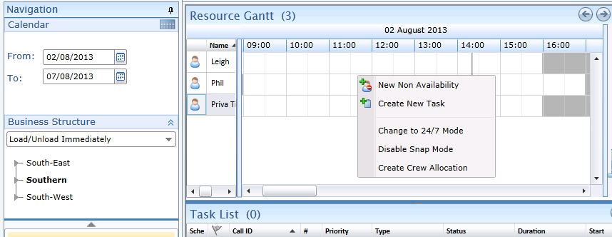

A non-availability is an assignment with no task and is edited in its own form, as shown below.

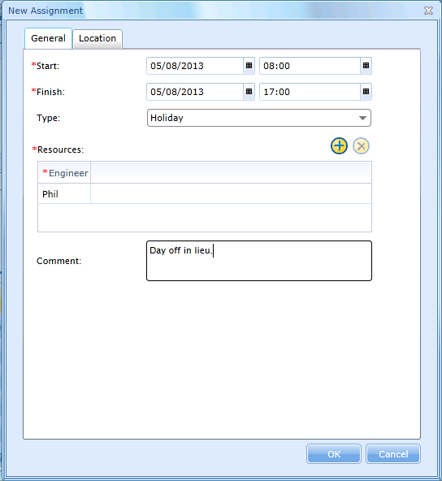

Once created, with the appropriate type, timing and location, the non-availability is shown on the Gantt. The label defaults to the comment value but is updated to be the type in this implementation.

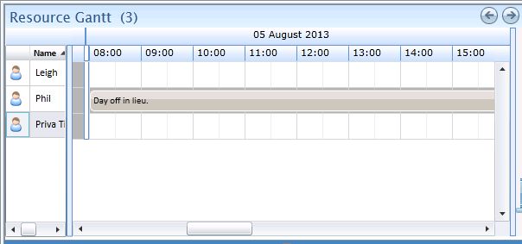

Resources are, on trust, able to enter non-availabilities (types defined below) directly into ClickSchedule via their mobile device – see section 13 for details.

When creating a non-availability assignment it is possible to set the non-availability’s type from the following options:

* **Admin(*)(+)**
* **Personal (*)(+)**
* **Hotel (*)(+)**
* **Meeting**
* **Off Site Training**
* **Sickness (+)**
* **Holidays (+)**
* **Compensation Time (+)**
* **LCS Activities**
* **Hub**
* **Standby (+)**
* **System not in SDT**
* **Union (+)**
* **Other (*)(+)**

(*): A resource may create this type of non-availability from their device. See section 13.3.3.

(+): An e-mail is automatically sent to the resource’s manager (regardless as to whether this is created by the FSE or the dispatcher).

If a location is not assigned to the non-availability ClickSchedule will assume its location to be that of the associated resource’s home base. Thus, it will calculate the travel time to the resource’s next assignment from the home base. If the NA is located somewhere other than the home base the resource should create (or the Dispatcher create or update) the NA with an appropriate location. See section 5.7.7 for more information about home bases.

**Non-Availability Properties**

The following table describes the Non-Availability properties/attributes that will be used in this solution.

For each property appearing in the table, the following information is required:

* **Property** – The internal name of property as defined in ClickSchedule.
* **Visible name** – The visible name of the property, as will appear throughout the application.
* **Description** – A description of the usage of the property.
* **Type** – the property’s type (number, string, dictionary, etc.)
* **Access** – The access that users[2] will have to the property in ClickSchedule. This can be: Read Only, Editable or Hidden: Not visible and thus not editable.
* **Mandatory** – Indicates whether this property is mandatory or not in ClickSchedule.

| Property | Visible Name | Description | Type | Access | Owner | Mandatory? |
| --- | --- | --- | --- | --- | --- | --- |
| **General** | | | | | | |
| Start | Start | Time at which the non-availability is scheduled to start. | Date | Editable | CS | Yes |
| Finish | Finish | Time at which the non-availability is scheduled to finish. | Date | Editable | CS | Yes |
| NonAvailabilityType | Type | The type of the non-availability. | Dictionary (NonAvailabilityType) | Editable | CS | No |
| Comment | Comment | Free text for more information about the non-availability. | String (256) | Editable | CS | No |
| Engineers | Resources | The name of the resource affected. Should only reference a single resource. | Reference to Engineer (Multi-value) | Editable | CS | Yes |
| **Location** | | | | | | |
| Street1 | Street | The address at which the non-availability occurs. This enables travel time to be considered when scheduling around the NA. | String (64) | Editable | CS | No |
| City | City | String (64) | Editable |
| State | County | String (64) | Editable |
| Postcode | Postcode | String (64) | Editable |
| CountryID | Country | The country in which the address exists. | Dictionary (Country) | Editable | CS | No |
| Longitude | Longitude | The geo-coded location for the non-availability. These are derived on creation or update of the NA’s address and may be derived from the resource’s home base. | Number | Hidden | CS | No |
| Latitude | Latitude | Number | Hidden | CS | No |

The non-availability is shown as a labelled bar on the Gantt, using the type for the label. The Gantt tooltip for non-availabilities includes the type, assigned engineers and start / finish times.

The Hotel non-availability is a special case provided to permit a resource to be temporarily re-located to a hotel. It should be scheduled to start at the end of the working day on which they will be using the hotel and end at the start of the following day’s working time. Doing so will ensure that the non-availability location will be used instead of the resource’s home base.

### Home Base

The resource’s contractual base is the location where they are expected to start and end each working day.

A resource’s home base is defined as their home address. The address for each resource SIEBEL be provided by GEHC as part of the resource data synchronization with enough detail to enable GIS geo-coding.

Scheduling is restricted to have the resource normally travel no longer than a defined time from their home base. The maximum travel time rule is included in the Standard Policy covered in section 7.1.

### Travel Time Calculations

ClickSchedule calculates travel time for both manual and automated scheduling assignment. In the case of manual scheduling, the Dispatcher needs to explicitly move the task to the point where the start of travel is the moment of completion of the previous task.

Resources start and end their day at their home base unless this is explicitly overridden using a non-availability. For the initial rollout to UK and Ireland, when traveling to the first assignment of the day and from the last assignment of the day, all of the travel is to be undertaken during working hours. Where different countries require different rules, such as Northern Europe’s requirement for 30 minutes of travel on own time at the start of day or France’s requirement for 30 minutes travel on own time at start and end of day, it is necessary to have Region-specific logic domains with differently configured “gap rules”.

Note that a maximum travel rule is applied against travel from and to the home base in order to avoid long journeys at the start and end of the day.

### Organizational Hierarchy

Each resource (individual engineer or named contractor) is a member of one Region and one District in the Hierarchy (for details about the organization hierarchy please refer to section 3.3). The resource will only be automatically scheduled to tasks for the same region.

A resource’s Region and District are mainly static and are not likely to change. Temporary relocation can be modelled using Hotel non-availabilities (section 5.7.6) and manual scheduling (where the resource needs to work in a different Region or SIEBEL work a long way from home base).

### Internal/External indication

The ‘Internal’ indication for a resource is to enable ClickSchedule to differentiate between internal resources (i.e. employees of GEHC) and external resources (i.e. named contractors that are employees of sub-contractors of GEHC).

### Resource Languages

A resource may be able to communicate in multiple languages. The set of languages for the resource is defined as part of the resource definition and are used to match against the languages required for a given task. Languages are enumerated in the Language dictionary and are referenced via their culture code in resources and tasks.

**Language Dictionary Properties**

|  |  |  |
| --- | --- | --- |
| Property Name | Data Type | Description |
| Name | String | Indicates the name language, in human readable form. This is the key value and therefore should be included in any resource, site or task definition. |
| Culture | String | The .NET code for the language. |

### Resource Property Requirements

The following table describes the engineer properties/attributes that will be used in this solution. It is possible, that during later stages of the implementation (e.g. design or testing) additional required properties will be identified. Therefore, this list should be considered as an initial list only.

The properties in the table are divided into tabs, as they would be in the Engineer Forms.

For each property appearing in the table, the following information is provided:

* **Property** – The internal name of property.
* **Visible name** – The visible name of the property, as will appear throughout the application.
* **Description** – A description of the usage of the property.
* **Type** – the property’s type (number, string, dictionary, etc.)
* **Access** – The access that users[3] will have to the property in ClickSchedule. This can be: Read Only, Editable or Hidden: Not visible and thus not editable.
* **Mandatory** – Indicates whether this property is mandatory or not in ClickSchedule.

| Property | Visible Name | Description | Type | Access | Owner | Mandatory? |
| --- | --- | --- | --- | --- | --- | --- |
| **Personal** | | | | | | |
| Name[4] | Name | The resource’s name, for display purposes only. | String (256) | Non-Editable | GEHC | Yes |
| ID | ID | Unique identifier of the resource. The GEHC SSO identity or (prefixed) SIEBEL ID depending on whether the engineer is in SIEBEL or Siebel. | String (64) | Non-Editable | GEHC | Yes |
| MUSTID | MUST ID | The resource’s unique identifier within MUST (with any necessary prefix). | String (64) | Non-Editable | GEHC | Yes[5] |
| SSO | SSO | The resource’s unique SSO identifier. This is used when logging into the ClickMobile client. | String (64) | Non-Editable | GEHC | Yes |
| EngineerType | Type | The resource’s type. Defaults to “Field Service Engineer”. | Dictionary (ResourceType) | Non-Editable | GEHC | No |
| Characteristic | Characteristic | A formatted string, typically used to hold key SIEBEL characteristics such as modalities, SAV#, flattened skills list etc. allowing searching and filtering of the resources against these characteristics. | String (500) | Non-Editable | GEHC | No |
| ServiceArea | Service Area | The name of the service area in which the resource operates.( Siebel Service Area) | String (100) | Non-Editable | GEHC | No |
| MobilePhone | Mobile Phone | The resource’s mobile phone number. Enables the Dispatcher to call the resource if needed. | String (64) | Non- Editable | GEHC | No |
| Calendar | Calendar | The (name/ID of the) calendar that defines the resource’s working time. Defaults to the District’s calendar. | Reference to Calendar | Editable | GEHC /CS | No |
| Active | Active | An active Resource is one to which work can be assigned. A Resource that is unavailable for a long period of time (e.g. maternity leave) will be marked as inactive. | Yes/No (Boolean) | Editable | CS | Yes |
| Internal[6] | Internal | Internal resources are employees of GEHC. External resources are employees of sub-contractors of GEHC. | Yes/No (Boolean) | Non- Editable | GEHC | Yes |
| TravelPolicy | Travel Policy | Engineers may either travel to and from their home base in company time (i.e. working hours) or their own time, as controlled by this setting. | Dictionary (TravelProfile) | Non-Editable | GEHC | Yes |
| LunchBreakDuration | Lunch Break Duration | Specifies how long the resource’s lunch break should be. | Duration | Non-Editable | GEHC | Yes |
| LunchBreakType | Lunch Break Type | Specifies how the Lunch break should be included. Based on “After Time” or “After Duration” values. | Reference to LunchBreakType | Non- Editable | GEHC | Yes |
| LunchStartsFrom | Lunch Starts No Earlier Than | When applicable in the resource’s region, this specifies the earliest time of day when the resource may start their lunch. | Date | Editable when Lunch BreakType is “Break After Time” | GEHC | When LunchBreakType is “Break After Time” |
| LunchStartsAfter | Lunch Starts After Working At Least | When applicable in the resource’s region, this specifies the duration after a resource starts work for the day that SIEBEL pass before they may start their lunch. | Duration | Editable when Lunch BreakType is “Break After Duration” | GEHC | When LunchBreakType is “Break After Duration” |
| FSELanguages | Languages | A sequence of semi-colon separated language names. | String (1024) | Hidden | GEHC | No |
| Languages | Languages | The set of languages spoken by the resource. This is used to limit the tasks that the resource is automatically scheduled to. If unspecified the resource is assumed to speak all languages. Derived from the FSELanguages. | Dictionary (Language, Multi-value) | Non-Editable | CS | No |
| MobileClient | Has Mobile Client | Indicates if the resource is using ClickMobile. Defaults to No. | Yes/No (Boolean) | Editable | CS | No |
| LoginName | Mobile Login | Specifies the username associated to the CM Touch login | String (128) | Editable when MobileClient is Yes | CS | When MobileClient is Yes |
| MobileWebClientSettings | Mobile Template | Mobile settings template name. This needs to be set to a valid selection when the MobileClient property is set true otherwise an error will occur during dispatch to this resource. | Reference to UserSettings | Editable when MobileClient is Yes | CS | When MobileClient is Yes |
| MaxTimeFromHB | Maximum Travel Time From HB | The maximum time that the resource can travel between their home base and a task. Use of this parameter ensures that regional level automatic scheduling does not result in unnecessarily large amounts of travel. | Duration | Editable | CS | No |
| **Location** | | | | | | |
| Region | Country (Region) | The highest level in the organizational hierarchy. | Dictionary (Region) | Non-Editable | GEHC | Yes |
| District | Zone (District) | The second level in the organizational hierarchy. | Dictionary (District) | Non-Editable | GEHC | Yes |
| Street1 | Street | The resource's home base address, i.e. the location of where the resource normally starts and finishes their working day. | String (64) | Non- Editable | GEHC | Yes, enough to enable geo-coding. |
| City | City | String (64) | Non-Editable | GEHC |
| State | County | String (64) | Non-Editable | GEHC |
| Postcode | Postcode | String (64) | Non- Editable | GEHC |
| Country ID | Country | The country in which the address exists. | Dictionary (Country) | Non- Editable | GEHC |
| Longitude | Longitude | The geo-coded location for the resource’s home base. These are derived on creation or update of the resource’s address. | Number | Hidden | CS | No |
| Latitude | Latitude | Number | Hidden | CS | No |
| **Professional** | | | | | | |
| FSEAllowedTaskTypes | Allowed Job Types | The types of task that the resource is permitted to undertake. This is used to limit the tasks that are automatically scheduled to the resource. When unspecified a resource can perform all types of task. | String (1024) | Hidden | GEHC | No |
| AllowedTaskTypes | Allowed Job Types | The types of task that the resource is permitted to undertake. This is used to limit the tasks that are automatically scheduled to the resource. When unspecified a resource can perform all types of task. Derived from FSEAllowedTaskTypes. | Dictionary (TaskType, Multi-value) | Non-Editable | CS | No |
| Skills | Skills | The set of skills, by level, that the resource has. This is used to limit the tasks that are automatically scheduled to the resource. | Graded Skills  (Multi-value) | Non-Editable | GEHC | No |
| ManagerID | Manager ID | The resource’s manager’s GEHC SSO identity. Not currently used. | String (64) | Hidden | GEHC | Yes |
| ManagerName[7] | Manager Name | The resource’s manager’s name. For display purposes only. | String (256) | Non-Editable | GEHC | Yes |
| ManagerContactNumber[8] | Manager Contact Number | The phone number via which the resource may contact their manager. For display purposes only. | String (64) | Non-Editable | GEHC | No |
| ManagerEmail | Manager E-mail Address | The e-mail address for the manager. For use when automated e-mails are to be sent. | String (256) | Non-Editable | GEHC | Yes |

### Resource Data Derivation

When a resource is created not all the required data is provided by the work order system (SIEBEL). The additional data needed would have to be automatically derived, according to the following mappings.

1. Languages

The resource has a formatted string, FSELanguages, within which the resource’s languages are listed. There is a requirement to use this string to create the required languages multi-value definition.

1. AllowedTaskTypes

The resource has a formatted string, FSEAllowedTaskTypes, within which the resource’s permitted task types are listed. There is a requirement to use this string to create the allowed task types multi-value definition.

### Resource Data Management

Resources are always created (and generally updated) via periodic (and ad hoc) synchronization from GEHC’s infrastructure. Additional data may be set manually by the administrator or dispatcher, in order to be able to better use the resource for scheduling:

1. Calendar – each resource SIEBEL be assigned to an appropriate calendar, representing their working hours.
2. Active – allows control of whether the resource should be included in, or excluded from, scheduling.
3. Mobile Template – each resource can be assigned the relevant pre-defined template for their mobile experience.

## Tasks

Tasks represent the SIEBEL Activities that are to be performed by the various GEHC resources. The following sections describe the supporting data required to describe tasks. This data will be referenced by the task record in ClickSchedule and used for display purposes, as criteria for scheduling decisions, or both.

### Job Type

Job Types are a list of names that represent the types of service jobs performed by GEHC (e.g. Preventive Maintenance, Corrective, Field Modification Instructions, Installation and Training). Each task has one job type.

Note that there is an additional job type required in order to support Part Pickup. See section 4.3.11.1 for further details.

**Job Type Dictionary Properties**

|  |  |  |
| --- | --- | --- |
| Property Name | Data Type | Description |
| Name | String | Indicates the name of the job type. |

### Job Sub-Type

Job Sub-Types are a list of names that represents the sub-type of the job. Each task has one job sub-type. This replaces both Activity Types and FMI Types and achieves this by being hierarchical. There is a single list of sub-types, but each is related to the parent type. Every job type has a separate set of sub-types defined in this list – none of them are common across all job types.

**Activity Type Dictionary Properties**

|  |  |  |
| --- | --- | --- |
| Property Name | Data Type | Description |
| Name | String | Indicates the name of the sub-type. |
| JobTypeParent | Dictionary (JobType) | Defines the “parent” type for the sub-type. |

### Required Skills

In terms of determining valid resource candidates, each task is linked to a single system and through that to a single product identity. The task also has a required skill level. These two pieces of information are used to derive the list of (one) required skills that are mandatory for the assignment of a resource.

The skill efficiency associated with the resource causes the estimated duration to be increased or decreased accordingly.

### Required Languages

Each task has a set of languages (derived from the associated Site). In order to be assigned to the task a resource must be able to speak at least one of these languages.

### Task Organizational Hierarchy

Each task is attributed to one Region and District. ClickSchedule will use this as part of the decision making process when determining an assigned resource (see section 3.3). It is also used during appointment booking.

### Rejection Reasons

Rejection reasons are assumed to be common across all regions.

|  |  |  |
| --- | --- | --- |
| Property Name | Data Type | Description |
| Name | Text | Indicates the name of the rejection reason. |

### Incompletion Reasons

There is a specified set of incompletion reasons from which the FSE may select. This is assumed to be common across all regions.

|  |  |  |
| --- | --- | --- |
| Property Name | Data Type | Description |
| Name | Text | Indicates the name of the incompletion reason. |

*GE to provide the full list of options during the Design phase.*

### Job Comments

GE requires that the full job comments related to the job be accessible from the web client and the mobile device. These are held in a separate object, for reference from the task(s) to which they relate, in order to maximize efficiency in management of this potentially large amount of data.

For clarity and consistency this is represented as a business object type called GEHCJobComments within ClickSchedule.

| Property | Visible Name | Description | Type | Access | Owner | Mandatory? |
| --- | --- | --- | --- | --- | --- | --- |
| SIEBELJobNumber | SIEBEL Job Number | The ID that uniquely identifies the associated job in SIEBEL. | String (64) | Non-Editable | GEHC | Yes |
| Text | Full Job Comments | The full job comment extracted from SIEBEL. | String (unlimited) | Non-Editable | GEHC | No |

### Resource Specifications

It is possible to specify, for each task, several lists of resources that affect how an assignment is created.

|  |  |
| --- | --- |
| Property Name | Description |
| Preferred Resources | One of the specified resources is preferred to be assigned to the task.  NB: Preferences may also be included in the task’s associated System; these preferences are also considered (by being added, as necessary, to this list when the task is created or updated).  Note that scheduling a task to a resource that is not on this list is not a rule violation. |
| Required Resources | One of the specified resources must be assigned to the task.  Note that scheduling a task to a resource that is not on this list is a rule violation. |
| Excluded Resources | None of the specified resources can be assigned to the task.  Note that scheduling a task to a resource on this list is a rule violation. |

### Task Property Requirements

The following table describes the task properties/attributes that will be used in this solution. It is possible that during later stages of the implementation (e.g. design or testing) additional properties required will be identified. Therefore, this list should be considered as an initial list. The properties in the table are divided into tabs, as they would be in the Task Forms.

For each property appearing in the table, the following information is provided:

* **Property** – The internal name of property.
* **Visible name** – The visible name of the property, as will appear throughout the application.
* **Description** – A description of the usage of the property.
* **Type** – the property’s type (number, string, dictionary, etc.)
* **Access** – The access that users[9] will have to the property in ClickSchedule. This can be: Read Only, Editable or Hidden: Not visible and thus not editable.
* **Mandatory** – Indicates whether this property is mandatory or not in ClickSchedule.

*N.B. properties that are invisible or not in use for all profiles or logic such as Job System Status are not included in this table as they are outside of the ClickSchedule data structure scope.*

| Property | Visible Name | | Description | Type | Access | Owner | Mandatory? | |
| --- | --- | --- | --- | --- | --- | --- | --- | --- |
| **General** | | | | | | | | |
| CallID | Call ID | | These values form the unique identifier for the task in ClickSchedule. The CallID is defaulted to the SIEBEL Job Number, while the Number is defaulted to 1, but can be different (e.g. when creating dependencies between “primary” and associated “training” or pickup tasks). The TaskID is created initially by SIEBEL and subsequently managed and synchronized between both systems in order to define a value that can be consistently derived over time by SIEBEL in order to identify a unique visit. | String (64) | Editable | GEHC | Yes | |
| Number | Number | | Number | Editable | GEHC |
| TaskID | Task ID | | String (64) | Non-Editable | GEHC |
| MUSTJobNumber | MUST Job Number | | The ID that uniquely identifies the associated job in MUST. | String (64) | Non-Editable | GEHC | Yes | |
| SystemID | System ID | | The DisplayID of the related System. This is derived from the task’s associated System.  References the system against which the task is to be carried out. | Reference to System | Non- Editable | GEHC | Yes | |
| CRMSystemName | CRM System Name | | The name of the CRM system that created the task. Not currently used. | Dictionary (CRMSystem) | Non-Editable | GEHC | Yes | |
| IsSafety | Safety? | | Identifies whether the task is a safety activity. Defaults to No. | Yes/No (Boolean) | Non-Editable | GEHC | No | |
| Priority | Priority | | The priority (importance) of the task. The higher the number the higher the priority.  This is a computed priority value provided by GEHC. | Number | Non-Editable | GEHC | Yes | |
| TaskType | Job Type | | The type of job the task is a part of, or the type of activity the task represents. | Dictionary (TaskType) | Non-Editable | GEHC | Yes | |
| TaskSubType | Job Sub-Type | | The sub-type of the task. | Dictionary (TaskSubType) | Non-Editable | GEHC | Yes | |
| Contract | Contract | | The currently active contract for the target system. Derived from the Open Date and the Contract instances associated with the task’s System. | Reference to Contract | Non-Editable | CS | Yes | |
| CustomerExpectation | Customer Expectation | | The customer’s expectations. For display purposes only. | String (256) | Non-Editable | GEHC | No | |
| Status | Status | | Current status of the task. | Dictionary (TaskStatus) | Editable | CS | Yes | |
| InJeopardy | In Jeopardy | | This flag is automatically set by ClickSchedule when the task goes into jeopardy. The Dispatcher is responsible for clearing the jeopardy. | Yes/No (Boolean) | Editable | CS | No | |
| JeopardyState | Jeopardy State | | Indicates the type of jeopardy situation the task is in, e.g. not scheduled and approaching due date, late to travel etc. | Dictionary (JeopardyState) | Non-Editable | CS | No | |
| JeopardySubstatus | Jeopardy Sub-status | | Tracks the jeopardy workflow status, only relevant when the task is in jeopardy. When explicitly set to “Action Completed” the task’s jeopardy is cleared. Note that if the jeopardy hasn’t actually been resolved then the task will be put back in jeopardy the next time the jeopardy agent processes it. | Dictionary (JeopardySubstatus) | Editable when InJeopardy is true | CS | No | |
| SchedulingPolicy |  | | Used when creating the task to select alternative rules to be applied within the optimizer. SIEBEL | String | Hidden | GEHC | No | |
| **Time** | | | | | | | | |
| OpenDate | Open Date | | The date on which the task was initially logged. If customer-initiated, this is the date and time at which the customer made the initial call. | Date and Time | Non- Editable | GEHC | Yes | |
| EarlyStartOffset | Early Start Offset | | This is an interval, in seconds, after the Open Date after which the task can be booked. May be derived from the associated Contract. | Duration | Non-Editable | GEHC/CS | No | |
| LateStartOffset | Late Start Offset | | This is an interval, in seconds, after the Open Date before which the task can be booked. May be derived from the associated Contract. | Duration | Non-Editable | GEHC/CS | No | |
| EarlyStart | Early Start | | The earliest time the work on the task should ideally start. This is used as an objective rather than applied as a rule and may be derived from the task’s early start offset details. | Date and Time | Non-Editable | GEHC | Yes | |
| Duration | Duration | | The estimated duration for performing the work (excluding any necessary travel). | Duration | Non-Editable | GEHC | Yes | |
| LateStart | Late Start | | The latest time that work on the task SIEBEL start in order to meet the SLA. This may be derived from the task’s late start offset details. | Date and Time | Non-Editable | GEHC | Yes | |
| DueDate | Due Date | | The latest time on which the work should finish. This is derived from the LateStart and Duration. | Date and Time | Hidden | CS | Yes | |
| ReactivationDate | Reactivation Date | | The time at which the task is set to reactivate. | Date and Time | Hidden | GEHC | No | |
| AppointmentStart | Earliest Arrival On Site | | The start time of the appointment window provided to the customer. | Date and Time | Non-Editable | GEHC | No | |
| Appointmen Finish | Latest Arrival On Site | | The end time of the appointment window provided to the customer. | Date and Time | Non-Editable | GEHC | No | |
| UseDistrictCalendar | Early/Late Used District Calendar | | Indicates whether the Early and Late Start derivations are expected to use the district’s calendar. When omitted or set false the early/late start values are simple offsets from “now” and do not take non-working time into consideration. | Yes/No (Boolean) | Non-Editable | GEHC | No | |
| **Customer** | | | | | | | | |
| ContactName | Contact‌ Name | | The name of the customer’s contact. | String (128) | Non-Editable | GEHC | No | |
| ContactPhone‌Number | Contact‌ Phone‌ Number | | The phone number for the customer’s contact. | String (64) | Non- Editable | GEHC | No | |
| Customer‌Email | Contact E-mail Address | | The customer contact e-mail address. | String (128) | Non- Editable | GEHC | No | |
| ContractOfferingFamily | Contract Offering Family | | If not provided at the task creation, the offering family is derived from the task’s Contract details. | String (64) | Non-Editable | GEHC | No | |
| TaskLanguages | Languages | | A sequence of semi-colon separated language names. | String (1024) | Hidden | GEHC | No | |
| Languages | Languages | | The language(s) accepted at the customer site for this task. This is derived from the TaskLanguages or, when that is unspecified, the task’s Site details. | Dictionary (Language, Multi-value) | Non-Editable | CS | No | |
| **Location** | | | | | | | | |
| Region | Organization Country | | The first level in the hierarchy. Derived automatically from the District. | Dictionary (Region) | Non- Editable | CS | | Yes |
| District | Organization Zone | | The second level in the hierarchy. | Dictionary (District) | Non- Editable | GEHC | | Yes |
| SiteID | Site | | The DisplayID of the related Site. This is derived from the task’s associated Site. | Reference to Site | Non- Editable | CS | | Yes |
| IsMobileSystem | Is Mobile System? | | Indicates whether the system is part of a mobile site. | Yes/No (Boolean) | Non-Editable | GEHC | | Yes |
| Street1 | Street | | The work site address.  When not specified this is derived from the task’s System’s Site address. | String (64) | Non- Editable | GEHC/ CS | | No |
| City | City | | String (64) | Non-Editable | GEHC/ CS | |
| State | County | | String (64) | Non-Editable | GEHC/ CS | |
| Postcode | Postcode | | String (64) | Non- Editable | GEHC/ CS | |
| CountryID | Country | | The country in which the address exists. | Dictionary (Country) | Non-Editable | GEHC/ CS | |
| Latitude | Latitude | | The geo-coded location for the task. These are derived on creation or update of the task’s derived (or specified) address. | Number | Hidden | CS | | No |
| Longitude | Longitude | | Number | Hidden | CS | | No |
| **Resource** | | | | | | | | |
| PreferredFSEs | Preferred FSEs | | A sequence of semi-colon separated IDs used to identify the preferred resources. | String (1024) | Hidden | GEHC | No | |
| PreferredEngineers | Preferred Resources | | The resources to one of which it is preferred to schedule the task if possible/sensible. Derived from the PreferredFSEs. | Reference to Engineer  (Multi-value) | Non-Editable | CS | No | |
| ExcludedFSEs | Excluded FSEs | | A sequence of semi-colon separated IDs used to identify the excluded resources. | String (1024) | Hidden | GEHC | No | |
| ExcludedEngineers | Excluded Resources | | The optional set of resources to whom the task cannot be automatically scheduled. This is typically used after a given resource rejects a task on some grounds in order to prevent the task being re-assigned to them. Initially derived from ExcludedFSEs and the associated System’s excluded engineers. | Reference to Engineer  (Multi-value) | Editable | CS | No | |
| RequiredFSEs | Required FSEs | | A sequence of semi-colon separated IDs used to identify the required resources. | String (1024) | Hidden | GEHC | No | |
| RequiredEngineers | Required Resources | | The set of resources from which the scheduler may select a single resource to schedule the task to. Initially derived from RequiredFSEs. | Reference to Engineer  (Multi-value) | Editable | GEHC/ CS | No | |
| **Requirements** | | | | | | | | |
| SkillLevel | Level | | The skill level associated with the task. | Number | Hidden | GEHC | Yes | |
| RequiredSkills1 | Required Skills | | The skills that a resource must have to be able to perform the work. This is automatically derived from the task’s associated system’s product ID and the task’s skill level. | List of Skills  (Multi-value) | Non - Editable | CS | No | |
| **Dependencies** | | | | | | | | |
| TimeDependancies | | Time Dependencies | Defines time relationships between tasks that are part of a multi-staged chain. | List of time dependencies  (Multi-value) | Non - Editable | GEHC | No | |
| EngineerDependancies | | Resource Dependencies | Defines Field Engineer relationships between tasks that are part of a multi-staged tasks chain. | List of Field Engineer dependencies  (Multi-value) | Non - Editable | GEHC | No | |
| Critical | | Critical | Defines if this task cannot be scheduled, others in the MST chain will also not be scheduled. | Boolean | Non - Editable | GEHC | No | |
| **Assignment** (this tab is only relevant for scheduled tasks) | | | | | | | | |
| Start | Assignment Start | | The time at which the resource is scheduled to start work on site. | Date and Time | Editable | CS | Yes | |
| Finish | Assignment Finish | | Time at which the resource is scheduled to finish work on site. | Date and Time | Editable | CS | Yes | |
| Engineers | Resource | | The (single) resource scheduled to perform the task. | Reference to Engineer  (Multi-value) | Non-Editable | CS | Yes | |
| **Details** | | | | | | | | |
| OwnerName | Owner Name | | The name of the Dispatcher who created the task via the SIEBEL integration. | String (64) | Non-Editable | GEHC | No | |
| OwnerSSO | Owner SSO | | The SSO identity for the Dispatcher who created the task. | String (64) | Non-Editable | GEHC | Yes[10] | |
| CTCDebrief | CTC Debrief | | The CTC debrief. | String (4000) | Non- Editable | GEHC | Yes | |
| Notes | Task Note | | A note combining the mobile and part comment. Where required, the part pickup location may be included here (when the part is to be obtained from a location related to the site address and when there is no separate part pickup task). | String (4000) | Non-Editable | GEHC | No | |
| JobComments | Job Comments | | The full job comments. | Linked GEHCJobComments | Non-Editable | GEHC | No | |
| FMIDueDate | FMI Due Date | | The date at which the FMI is due. Only relevant for FMI type jobs. For display purposes only. | Date and Time | Non-Editable | GEHC | No | |
| FMINumber | FMI Number | | The FMI number. Only relevant for FMI type jobs. | String (64) | Non-Editable | GEHC | No | |
| FMIRecall | FMI Recall? | | Indicates whether the FMI is a recall. Only relevant for FMI type jobs. | Yes/No (Boolean) | Non-Editable | GEHC | No | |
| PMSchedule | PM Schedule | | Identifies the PM schedule code. Only relevant for PM type jobs. | String (2) | Non-Editable | GEHC | No | |
| MacroVersion | Macro Version | | An identifier for the version of the macro through which the task instance was created. | String (64) | Hidden | GEHC | No | |
| SuperPowerTaskFlag | Able to Unschedule Other Task? | | Controls whether a task can unschedule other scheduled tasks on the Gantt. Note that safety and other super power tasks cannot be unscheduled by one of these tasks.  Default is “No”. | Yes/No (Boolean) | Non-Editable | GEHC | No | |
| IsMDT | Is MDT? | | Automatically derived based on the task’s duration, this is set true when the task is deemed an MDT candidate. | Yes/No (Boolean) | Non-Editable | CS | No | |
| TrainingJobNumber | Training Job Number | | The associated on-the-job training task SIEBEL job number. | String (64) | Non-Editable | GEHC | No | |
| TraineeFSEs | Trainee FSEs | | A sequence of semi-colon separated IDs used to identify the associated on-the-job training resources. | String (1024) | Hidden | GEHC | No | |
| TraineeEngineers | Trainee Resources | | The set of associated on-the-job training resources. Derived from TraineeFSEs. | Reference to Engineer (Multi-value) | Non-Editable | CS | No | |
| **Parts** | | | | | | | | |
| PartEstimatedDeliveryDate | Estimated Delivery Date | | The date at which the parts should have been delivered. When specified this limits the earliest time at which the task can be automatically scheduled. | Date and Time | Non-Editable | GEHC | No | |
| PartDeliveryType | Delivery Type | | The method of delivery. | String (64) | Non-Editable | GEHC | No | |
| **Closure** (shown when the task can be or is cancelled, rejected, completed or incompleted)  The tab will be shown in the following statuses: Tentative, Rejected, Rejected By FSE, New, Cancelled, Acknowledged, Completed, Incompleted) | | | | | | | | |
| Status | Status | | Current status of the task. Repeated on this tab for ease of use. | Dictionary (TaskStatus) | Editable | CS | Yes | |
| RejectionReason | Rejection Reason | | The reason stated when a resource has rejected the task. | Dictionary (RejectionReason) | Editable when status is Rejected | CS | Yes when the Status is Rejected (or Rejected by FSE) | |
| RejectionComment | Rejection Comment | | A free text comment accompanying the rejection reason. | String (256) | Editable when status is Rejected | CS |
| IncompleteReason | Incomplete Reason | | The reason stated when a resource closes the task as incomplete. | Dictionary (IncompletionReason) | Editable when status is Incomplete | CS/CM | Yes when the Status is Incomplete | |
| IncompletionSubstatus | Incompletion Sub-status | | The sub-status set by Dispatchers during the Incompletion Workflow. Incomplete tasks are only purged when this is set to “Action Completed”. | Dictionary (IncompletionSubstatus) | Editable when status is Incomplete | CS |
| IncompletionComment | Incomplete Comment | | A free text comment accompanying the incompletion reason. | String (256) | Editable when Status is incomplete | CS/CM |
| FollowOnWIthMe | Prefer Original Resource for Follow-on | | Indicates that the resource would like to complete the task in a follow-on activity. | Yes/No (Boolean) | Editable when Status is incomplete | CM |
| FollowOnDuration | Proposed Follow-on Duration | | The amount of time estimated by the original resource as needed in order to complete the follow-on. | Duration | Editable when Status is incomplete | CM |
| SystemStatus | System Status | | The System Status when leaving the site on incomplete status | Dictionary (System Status) | Editable when Status is incomplete | CM |
| CancellationReason | Cancellation Reason | | The reason stated when the task is cancelled. | Dictionary (CancellationReason) | Editable when status is cancelled | CS | Yes when the Status is Cancelled | |

*Additional Notes: The following points are to be addressed by ClickSoftware in further detail during the Design phase:*

*On the Job Training/Pickup task parameters - the CallID needs to be the same in both in order to create an MST.*

*Contract Offering Family.*

*Click Time Window profile – is erroneously listed as a task property.*

### Task Data Derivation

When a task is created not all the required data is provided by the work order system (SIEBEL). The additional data needed would have to be automatically derived, according to the following mappings.

1. Skills

The task has a SkillLevel plus a reference to a System that in turn has a ProductID. There is a requirement to use these two values to create the required skill definition. Note that, if the SkillLevel is 0 then no derivation is performed – this represents the case where man-power is required but skills are irrelevant.

1. Region

Task’s Region is derived from the specified District. A request was made to derive the District from the task’s associated Site. *Whether this is possible will be confirmed during the Design phase.*

1. Site

There is a requirement to derive the task’s Site from the task’s associated System. This is then used in other derivations.

1. Address

When the task does not include a pre-specified address (the latter is expected to be included for tasks against mobile sites and all Part Pickup tasks) there is a requirement to obtain the task’s address from the task’s derived Site. It is not expected that existing tasks will be updated when their associated Site’s address is changed.

1. Languages

The task’s associated languages are required to be derived from the given TaskLanguages formatted string or, if that is unspecified, from the task’s derived Site. It is not expected that existing tasks will be updated when their associated Site’s languages are changed.

1. Contract

There is a requirement to derive the current Contract associated with the System referenced by the task. It is suggested that, since Contracts are time bound, the OpenDate for the task is used to identify the active Contract. This is then used in the following derivations.

1. Early Start, Late Start and Due Date

There is a requirement to derive the Early and Late Start values using values in the Contract associated with the task. This derivation is required to optionally permit notice to be taken of non-working time, as specified in the associated District’s calendar.

If the early and late start values are already included on the task no derivation is required. Otherwise, if the task does not include values for the early and late start offsets these are derived from the associated contract.

The Due Date is then to be calculated from the (derived) Late Start and the specified Duration on creation and/or update of the task (any specified Due Date is always overwritten).

1. Offering Family

There is a requirement to derive the Contract Offering Family from the Contract associated with the task.

1. Preferred Engineers

There is a requirement to derive the Preferred Engineers list from a formatted string containing a semi-colon separated sequence of FSE IDs. Additionally, the FSEs preferred on the task’s associated System SIEBEL be incorporated into the Preferred Engineers list.

1. Required Engineers

There is a requirement to derive the Required Engineers list from the task’s associated System and a formatted string containing a semi-colon separated sequence of FSE IDs.

1. Excluded Engineers

There is a requirement to derive the Excluded Engineers list from the task’s associated System and a formatted string containing a semi-colon separated sequence of FSE IDs.

1. Trainee Engineers

There is a requirement to derive the Trainee Engineers list from the a formatted string containing a semi-colon separated sequence of FSE IDs.

### Task Data Management

Tasks are always created and updated via incoming integration messages from GEHC’s SIEBEL work order management system. Various updates are also possible via:

* The automated scheduling processes.
* The ClickSchedule client used by the dispatchers.
* The ClickMobile client used by the resources when executing the tasks in the field.

# Geographic Information System Solution (GIS)

Question to Click: Dataset is not finalized for APAC, PTV cannot be used as discussed with Phil. PitneyBowes Dataset was recommended by him. Please update this section accordingly.

In order to achieve the efficient scheduling of resources, ClickSchedule needs to be able to estimate travel times between various points, such as between resource start-of-day locations and customer sites, and between different task locations.

**PTV** is the GIS provider solution that is to be installed onto one or more GIS server(s) used by GEHC in order to provide the following functionality.

## Geo-coding

Geo-coding means determining the location of an address. The location is defined as the latitude and longitude coordinates of the address.

ClickSchedule needs the location coordinates for each task and for the home base of each resource. It uses these coordinates, for example, to estimate the distance between two tasks or between a resource and a task, and to display tasks and resources locations on a map.

GEHC will provide the addresses for all sites[11], non-availabilities, resource home bases and tasks and ClickSchedule will calculate (geo-code) the longitude and latitude values using PTV unless GEHC explicitly supplies appropriate lat/long values.

A report will be made available to find objects that have failed to geo-code correctly. Additionally, the Integration API will include a web service operation that can be invoked to validate an address as being capable of geo-coding.

## Routing

Routing is defined as estimating the travel distance or travel time between two locations. The geo-coding service is a prerequisite for routing. This is because if the task location is unknown, it is not possible to estimate its distance from other tasks or the engineer’s home base.

The ClickSchedule logic services use the routing service to help minimise the resource travel time that is required by a schedule. The distance estimation can be at two levels:

* As-the-crow-flies (a.k.a. Aerial routing) - The system computes the shortest distance between two locations, along a straight line (or more precisely, along a great circle). The travel time is computed from the distance by assuming an average travel speed which is the same for all engineers.
* Street-level routing (SLR) - The system computes the distance along roads or transportation routes. The system determines the best route between two locations and it estimates the length of the route. The travel time is calculated, within PTV, using a speed profile per road type. Street-level routing is much more precise than aerial routing. Consider, for example, two tasks that are located on opposite banks of a river. The aerial distance between the tasks may be 1 mile, but the street-level distance may be 10 miles.

Street Level Routing is to be the main routing method used to calculate travel in the GEHC implementation.

Street-level routing calculations are very time consuming. In order to improve the system performance, the following methods are available:

1. Caching – Previous routing results are saved to the database/in memory
2. Routing grid – Routing is calculated for centre of grid location instead of accurate location. The grid size is normally set to 100 metres (configurable). Use of this method may compromise accuracy.

## Mapping

In the *map* service, the locations of tasks or resources are displayed on a map. Dispatchers can use the map to help monitor the service schedule. The dispatcher can display the recommended street-level route between resources’ home bases and their assigned tasks in the order calculated by ClickSchedule. This may facilitate the selection of a resource for the handling of a task, simply by viewing their scheduled routes.

The map in the ClickSchedule client can be configured, as part of the users’ administrative settings, to be “undocked” from the main application window and placed in a separate window. This allows it to be displayed, if desired, on another screen.

# Scheduling Policies

This section describes the Scheduling Policies used daily by the dispatchers and after hours by an automatic scheduling process, for applying different scheduling operations.

Scheduling policies consist of time constraints (e.g. task SIEBEL be scheduled to start before or after a specific time), personal constraints on the resource (e.g. the resource SIEBEL have certain skills), availability, and geography.

Associated with scheduling policies are appointments booking profiles which support appointment booking integration between SIEBEL (GEHC’s work order management system) and ClickSchedule.

## Standard Policy

*The standard policy may vary between the regions e.g. Travel time restrictions and overtime objective weights.*

The following constraints (also known as “rules”) are part of the ‘Standard Policy’ to support the dispatchers’ daily work. These are “yes/no” conditions that govern which assignments are permitted and which are disallowed. These are never violated during automated scheduling.

| # | Restriction on | Constraint |
| --- | --- | --- |
|  | One task - one resource relationship | * A resource can only be assigned to one task at any given time. * A task can only be assigned to one resource at any given time (manually or automatically). |
|  | SLA | A task can only be scheduled during its SLA period – i.e. it can only be scheduled to be started by the Late Start date. The task’s Early Start date is not included here. |
|  | Appointment slot | If the task has an appointment then it can only be scheduled within the appointment slot – i.e. to start on or after the Appointment Start and before the Appointment Finish. |
|  | Task start time | * Tasks can only be scheduled for later than the current time. * If the task has an Early Start date the task cannot be scheduled before this date. This rule will be initially de-activated. * If the task has a Parts Availability date the task cannot be scheduled before this date. |
|  | Organizational structure coverage | Tasks can only be scheduled to resources from the task’s Region. Note that application of restriction 10 avoids unnecessarily long travel times. |
|  | Resource selection | * A task can only be scheduled to a resource during their regular working and overtime hours, as defined in their calendars. * A task cannot be scheduled to a resource during any time marked with a non-availability (e.g. sick leave). * A task can only be scheduled to “active” resources. * A task cannot be scheduled to an excluded resource. * A task can only be scheduled to a required resource, if there are any. |
|  | Resource capabilities | * A task can only be scheduled to a resource that has the minimum required skills to perform it. * A task can only be scheduled to a resource that can speak (or otherwise use) at least one of the languages required by the task’s Site. If either the resource or the site has no languages specified then no restriction is applied. * A task can only be scheduled to a resource that is permitted to undertake that type of task[12]. |
|  | Task dependencies | Time dependencies between tasks SIEBEL be honoured. |
|  | Lunch break | Resources are reserved a gap for lunch between two assignments, no earlier than a specified time of day (configurable) and that is a specified duration (configurable). |
|  | Travel | * Resources have a maximum travel time between their home base and assignments (start and end of day). * The required travel is created and reserved between assignments based on SLR. * The technician’s travel to the first appointment of the day and back home from the last appointment is according to rules outlined in section 5.7.8. |

**Note**: Although it is not recommended, any of the above constraints (with the exception of scheduling a task to more than one resource at any given time) may be violated, or overridden, by a dispatcher as required during manual scheduling or schedule update. In such a case a violation message is shown warning the user that they are violating the specific listed constraint(s) – i.e. the message lists those constraints that are no longer met.

An attempt to schedule a Safety task may cause a previously scheduled task to be unscheduled.

The policy also includes definition of various objectives. These represent the goals of scheduling, rather than absolute requirements, and are used to select the “best option” from various (valid) potential assignment choices. Each objective has a given importance (represented, when implemented, as an appropriate “weighting”) which is reflected in this document by the order in the list, with the most important appearing first. The specific weightings to be applied will be identified during the detailed design and testing phases.

| # | Objective | Description |
| --- | --- | --- |
|  | Give safety tasks precedence | A task marked as a safety job takes precedence over any other form of job. |
|  | Prefer higher priority tasks | A task with higher priority is given preference. |
|  | Minimize resource travel between assignments | Minimizes the travel time between consecutive assignments for a specific resource. |
|  | Prefer same site | If possible, two consecutive tasks at the same location (within a defined radius) should be scheduled to the same resource.  A same site boost will also be applied. |
|  | Prefer employees | It is preferred to use a GE employee over a named contractor. |
|  | Minimize the use of resource overtime | It is preferred that use of overtime be minimized. |
|  | Use preferred resource | If possible a preferred engineer should be used. |
|  | Use cheapest resource type available | When selecting a resource, cheaper resources are preferred. |
|  | Prefer FSE for PM | Assignment of a Preventive Maintenance task should be to a preferred Field Service Engineer. However, other types of resource may be assigned if a better schedule can be created. |
|  | Prefer scheduling after the early start | Unless found necessary it is preferable that a task be scheduled after its early start. Whilst there is also a rule for early start, that rule may be de-activated in specific regions at which point this objective takes effect. |
|  | Schedule as soon as possible | Tasks should be scheduled earlier rather than later. This minimizes the likelihood of missing the task’s SLA due to the task being bumped by a higher priority task. |

These objectives are also used by the automated scheduling processes to evaluate how effective entire schedules are, and therefore permit “better” over-all schedules to be selected and “worse” ones to be rejected.

*A relaxed set of rules can optionally be provided during later phases of the implementation if deemed useful. These would be defined as a new logic domain and can applied by additionally specifying the alternative logic domain as part of an appointment booking request, for example.*

## Appointment Booking

The following profiles are available for appointment booking purposes.

| # | Profile Name | Description |
| --- | --- | --- |
|  | ONE HOUR | Provides one hour appointment slots throughout the day in one hour steps (i.e. 00:00-01:00, 01:00-02:00, …, 08:00-09:00, 09:00-10:00, …, 23:00-00:00). |
|  | TWO HOURS | Provides two hour appointment slots. Throughout the day in one hour steps (i.e. 00:00-02:00, 01:00-03:00, …, 08:00-10:00, 09:00-11:00, …, 22:00-00:00). |
|  | AM/PM | Provides two appointment slots for nominal morning and afternoon appointments (i.e. 08:30-13:00 and 12:00-17:00).  Note that alternative definitions of the two slots may be required in certain regions. |

*For some regions, for example Spain, AM/PM is defined differently compared with the above specification and may require additional profiles.*

Appointment booking is customized in this solution such that the integration permits indication as to whether non-working time (identified by the District’s calendar) should be accounted for when calculating the derived times for the task.

# Scheduling Methods

This section describes the different scheduling components that will be part of the solution provided to GEHC. The intention of this chapter is not to describe the functional components of ClickSchedule, but rather to demonstrate how the specific scheduling components will be used for supporting GEHC’s business events and the business decisions that will need to be made.

## Appointment Booking

An Appointment (time window) commitment will be offered to customers who require a specific time window for the FSE arrival. The available appointment options will be presented as a set of timeslots from which the required appointment may be chosen. Available time windows will be returned using ClickSchedule’s Appointment Booking search, which will use time windows profiles as described in section 7.2.

The ClickSchedule Appointment Booking mechanism will search for all time slots which are available within the Response Period. The Response Period is the time span between the earliest point at which the work can start and the latest point at which the work can start and still be within the contractually agreed response time as illustrated in the following diagram.

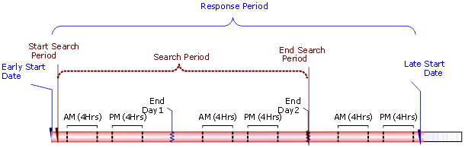

Figure 6 – Determining an “Appointment Commitment”

Where necessary the appointment booking request can include multiple, related tasks (e.g. part pickup and primary job tasks). Doing this ensures that the appointment slots returned are appropriate for the entire sequence of tasks.

## Background Optimization (BGO)

The ClickSoftware background optimizer (BGO) further refines the schedule by continually re-evaluating the overall schedule throughout the day and night. The background optimizer uses the scheduling logic described in the Scheduling Policies chapter to achieve a well optimized schedule, by improving the efficiency of the currently scheduled tasks and ‘fitting’ additional (unscheduled) tasks into gaps in the schedule.

The background optimization process functions by examining sections of the schedule, formulating new potential schedules and compares its potential schedule to the existing schedule. The optimization process will commit its changes whenever the following two criteria are met:

1. The proposed schedule has a higher “business value” than the existing schedule.
2. The tasks, resources, and assignments within the section which the optimizer is processing have not been modified by any other user or process.

The optimization process will be configured to use the standard business policy for the generation of proposed schedule changes. As this process functions within a system where schedule data is also modified by end users, it is likely that the optimizer will encounter scenarios where users have created assignments that break the policies that the optimizer must follow. However, the optimization process will not violate any business policies. These situations will limit the capability of the optimizer to make improvements to the schedule, and thus should be minimized through in-depth user training. Additionally, user modifications to tasks currently being analysed by the BGO will cause any proposed changes from the BGO to not commit. The BGO assumes that an end user has the additional information to make a more informed decision about a specific task, and such intervention would therefore override BGO calculations.

Optimization can only further modify tasks that are not yet locked and there are also some tasks for which only certain things can be changed. These include:

* Optimization cannot modify tasks which were already assigned to FSEs (resources). This also includes tasks that are at a more advanced stage in their lifecycle (Acknowledged, En Route, On Site, Suspended, Completed and Incomplete).
* Optimization cannot modify cancelled tasks.
* Optimization cannot modify tasks that were pinned/including lunch by the Dispatcher.
* Optimization cannot modify tasks that were scheduled while violating the standard policy.

The amount of time required for the optimization process to examine the entire business scope (i.e. all territories and/or lines of business) is dependent on the ability to break the problem down into multiple sub-sections, and on the amount of computer hardware processing power available to the optimization process.

### Offline (Night) Optimization

The main purpose of night optimization is to optimize the schedule for the short term. As there is typically little other activity in the system at that time it allows the optimizer to operate over a longer time frame with little or no interruptions, which results in highly optimized schedules.

#### Scheduling Horizon

Night optimization will operate within a scheduling horizon of 14 days. This horizon defines the period of time for which the optimizer will optimize the schedule.

**Relevant Tasks:**

The offline BGO will try to optimize the schedule for tasks that are unscheduled or have a scheduled date within the next 14 days. As mentioned above, the optimizer will not be able to reschedule any tasks that are considered to be locked.

#### Frequency

Night Optimization would run sometime during non-working hours or periods of low activity volume hours (i.e. after 10:00 pm and before 5:00 am local time).

#### Scheduling Policy

The night BGO will use the Standard Policy. It will optimize the work within each region and will not allow the scheduling of resources during overtime hours. Usage of overtime is a manual process.

### Online (In-Day) Optimization

The main purpose of in-day optimization is to continuously re-optimize today’s schedule in order to react to in-day events such as the arrival of new tasks, delays, cancellations, non-availability of engineers, etc., and thus keep the schedule optimized at all times. In addition to the Day BGO, there is also a process which will insert urgent tasks immediately on an ad hoc basis, potentially removing less urgent tasks in the process - see section 8.4-Scheduling Work Immediately (Task Insert) for further details.

#### Scheduling Horizon

In-day optimization will operate within a scheduling horizon of 1-3 days. This horizon defines the period of time for which the optimizer will optimize the schedule.

**Relevant Resources and Business Units**:

* In-day optimization is relevant only for FSEs that have an in-day dispatching policy – i.e. only internal resources.
* The day BGO will optimize one region at a time (in the initial deployment).

#### Frequency

* The Day BGO runs every 30 minutes (configurable).
* In-day optimization is configured to run throughout the day (Monday-Sunday from 6 AM to 5 PM configurable) with visibility into the schedule for the current day plus the following day (days 1-2). This enables the filling of any in-day gaps in the schedule with work that is due within the upcoming 2 days.

#### Relevant Tasks

The Day BGO will try to schedule tasks that are scheduled or have a due date within the next 2 days. As mentioned above, the optimizer will not be able to reschedule any tasks that are considered to be locked.

#### Scheduling Policy

The day BGO will use the Standard Policy.

## Scheduling Work Immediately (Task Insert)

Click to Update: For APAC, This section should be updated for CR and Installation Jobs. These jobs are emergency for GE APAC and once the task is created in Click Software, Engineer should be fixed for this activity within “Creation time + 4 Hours”.

For PM and FMI Jobs, Task is already there in Click Software, the appointment would be booked later by CSC Agent using SDT Appointment Booking Tool later. These tasks can be optimized once the Appointment details are present. Otherwise these tasks should not be scheduled to any Engineer it should remain in New Task Status

When looking to schedule a task when a schedule already exists, it is not enough to just try and fit the task into an existing empty slot in the schedule. This is because the newly arriving task may be of higher priority than the tasks already scheduled. In addition, any new task, if put together with the previously scheduled tasks, creates a slightly different “picture” (e.g. the new task may be closer to an existing task than another already scheduled task) and may therefore result in a different schedule which is more optimal.

For this purpose, the Schedule Workflow service may push tasks into the schedule at the expense of delaying or pushing other tasks that are already scheduled. This ensures, for example, that high priority tasks are given precedence over lower priority ones and that travel distances between tasks are optimized.

The Task Insert Schedule Workflow optimizes based on the Standard Policy (as defined in section 7.1).

If the insertion of a task into the schedule fails, it is left unassigned, in status New. Tasks in this status are considered as exceptions, for further handling by the Dispatcher. However, the Background Optimization process will attempt to fit them into the schedule during its next execution.

The Task Insert functionality will only be used for tasks with short SLA’s that have to be completed today or tomorrow.

## Schedule Updates

The in-day schedule is dynamic, incorporating constant updates to the schedule resulting from updates received from FSEs in the field. The Schedule Update service ensures that upon receiving an update to an FSE’s schedule the rest of his or her schedule will be updated accordingly, rescheduling any further (typically yet to be dispatched) tasks assigned to the resource for the day.

The Schedule Update operation optimizes based on the “Standard Policy” scheduling policy and is only relevant for FSEs (resources) that send updates from the field throughout the day. Using pre-defined configuration options, ClickSchedule will update the rest of the schedule for the FSE (resource), applying the relevant scheduling policy.

If Schedule Update fails to reschedule any of the FSE’s (resource’s) tasks to a different time (or different FSE in the case that tasks are still ‘Tentative’), it will flag it as a task in jeopardy (jeopardy status ‘Unable to update FSE's Schedule’) for the Dispatcher to handle by intervention. These updates are described in more detail below. Schedule Update will consider pinned tasks, assignments that include lunch, tasks with status Acknowledged/En Route/On Site/Suspended/Complete/Incomplete and tasks that violate the scheduling policy as unmoveable and will not try to reschedule them; consequently these tasks will be flagged as In Jeopardy.

**Note:** After an in jeopardy task is dealt with, the dispatcher will need to manually remove the jeopardy state and flag.

## Tools for Manual and Semi-Automatic Scheduling

### Semi-Automatic Scheduling (a.k.a. ‘Right-Click Schedule’)

Semi-automatic Scheduling is the process of selecting and scheduling tasks in the ClickSchedule Client application. A Dispatcher can use it to schedule a single task or multiple tasks. This functionality is referred to as ‘right-click and schedule’, since this is how the process is invoked. The ‘right-click schedule’ will:

* Attempt to schedule the task(s) only to the resources viewed on the client based on the Schedule Policy that is selected by the user (only the Standard Policy will initially be available in this solution) and the time period currently selected in the ClickSchedule client. Tasks that cannot be scheduled in compliance with the constraints in Schedule Policy will remain unscheduled.
* Not change (move or unschedule) any existing assignments on the Gantt while trying to schedule the selected tasks.

At the end of the process, a confirmation window is displayed, listing information for each of the tasks that can be scheduled. The Dispatcher can either confirm the scheduling, or cancel the scheduling process. If none of the tasks can be scheduled, a message would appear indicating so.

### Manual Scheduling (a.k.a. Drag & Drop)

The user may schedule an unscheduled task by dragging it from the task list and dropping it on the Gantt or reschedule an assigned task by dragging and dropping it from one place on the Gantt to another. If a proposed assignment for a task violates any constraints the Dispatcher is warned via a dialogue box. The Dispatcher can then choose to override the rule violations by accepting the proposed assignment, or cancel the scheduling of the task to the selected resource. Manual scheduling with rule violation is not recommended when automatic scheduling is available, and it is important that the use of manual scheduling is minimized. It should be used only on an exceptional basis.

### Get Candidates

The Get Candidate option is available when displaying the context-menu of an unscheduled task. This option highlights in the Gantt the resources that have the required skills necessary to complete the task. It does not take into account whether they have availability that day. It is up to the dispatcher to manually drag and drop the task on their preferred engineer (typically one of the candidates who has availability).

# Schedule Monitoring and Management

## Dispatching of Assignments

Scheduling tasks does not make them visible to the resource in the field: they need to be sent out explicitly. Sending a task to a resource in ClickSchedule is called “Dispatching”. In GEHC this results in the status being changed to Assigned. The Dispatcher decides when to assign (dispatch) tasks to resources, balancing between two often-conflicting objectives:

1. Provide the resource visibility of their planned work **as far ahead as possible**;
2. Commit to specific assignments **as late as possible**, thereby enabling flexibility for rescheduling.

According to ClickSchedule best practices, once a task has been assigned (dispatched) it should not be moved to another resource. The rejection of a task (by the dispatcher or FSE) allows the task to be re-scheduled to a different resource.

The dispatch policy applied to jobs released from Siebel may vary by region and/or by the job type.

For the initial UKI region roll-out , in order to allow the resource to prepare for and plan their mornings, including collection of any necessary parts, the policy includes dispatch, at 16:30 the previous working day, of all assignments due to start during the next working day (this being configurable by region). The remaining task(s) for the day are dispatched two hours before their travel is expected to commence.

The time of 16:30 is not fixed and will be varied by region, as is the cut-off horizon (“whole next working day” in this case). It is a GEHC working practice to notify FSE’s of their full set of jobs for the next working day by approx. 16:30 of the previous day. It could just as easily be 16:00 or any other time which is required by GEHC.

Different cut-off horizons and execution times may be applied by region and/or job type at GEHC’s discretion though it must be understood that dispatching assignments too early reduces the ability for the scheduler to optimize the schedule as already mentioned.In this context working days are determined from the FSE’s associated calendars, looking ahead up to 5 days from now.

Note that, in order to provide greater visibility of planned work whilst still committing assignments as late as possible, the system will permit tentative assignments to be sent to the mobile device for the next 7 days (configurable), with this option being enabled on a per-region basis. FSEs must understand that tentative assignments may be moved in, removed from or added to their schedule at any time prior to them becoming assigned.

## Scheduling Monitor

The Scheduling Monitor provides a high level view of overall schedule quality for the domain selected in the ClickSchedule client. It enables dispatchers and managers to focus on the most critical business factors reflected in the schedule, for example, business measures such as number of tasks in jeopardy.

For each defined metric, the Scheduling Monitor displays a colour-coded bar containing the current value for the loaded district(s) in the navigation tree for the current and following days. A green bar indicates a value that falls below the predefined thresholds, while a red bar indicates a value that falls above the predefined thresholds thereby indicating a scheduling problem that requires further investigation. Yellow will show a value within nominal limits.

The following metrics have been identified as the key business factors that can provide an indication in regards to the status of the schedule, in GE’s business environment:

| # | Measurement | Description | Below Lower Limit | Within limits | Above upper limit |
| --- | --- | --- | --- | --- | --- |
|  | Tasks in jeopardy | The number of tasks that were flagged as in jeopardy based on the “timeline jeopardy” definitions in section 9.3.1. | 0 | 1-19 | 20+ |
|  | Missed appointments | The number of tasks that missed their Latest Arrival On Site time. | 0-2 | 3-19 | 20+ |
|  | Late arrivals | The number of tasks that missed their Assignment Start by more than 30 minutes. | 0-2 | 3-19 | 20+ |
|  | Incompleted tasks | The number of tasks that have been set incomplete. | 0-9 | 10-19 | 20+ |
|  | Rejected tasks | The number of tasks that have been rejected directly by dispatchers and have yet to be re-assigned. | 0-9 | 10-19 | 20+ |
|  | Rejected by FSE tasks | The number of tasks rejected by an FSE that have yet to be re-assigned. | 0-9 | 10-19 | 20+ |
|  | Resource utilization | The overall resource utilization as a percentage. | 70%+ | 30-69% | 0-29% |

**Note**: Each metric is calculated per day, per district.

The Metrics will be recalculated every 60 minutes; therefore there might be a delay before the metric is updated to reflect the changes in the schedule.

## Jeopardies and Task Highlighting

The Jeopardy mechanism highlights specific defined situations that exist within the schedule to the ClickSchedule client users, such as dispatchers and managers.

ClickSchedule automatically sets a task’s “Jeopardy” flag along with an appropriate “JeopardyState” when certain conditions are detected. These conditions typically put the successful completion of the task within the timelines in jeopardy. There are, however, some “informational jeopardies” simply used to draw the dispatchers’ attention.

The Jeopardy State will be re-evaluated every 15 minutes (configurable). Therefore there might be a few minutes delay until ClickSchedule updates the jeopardy state to reflect the changes in the schedule.

Note:

* A task can only have one jeopardy state associated with it at any one time.
* If an assignment is in jeopardy, the task is highlighted by a colour change on the Gantt. The specific colour used depends on the jeopardy.
* After a jeopardy task is dealt with by a dispatcher, they SIEBEL manually remove the jeopardy flag from the task.

Note: A status change will automatically remove the Jeopardy flag and state of a Task.

The following sections list the scenarios where a task will be considered to be ‘in jeopardy’ or otherwise require highlighting in some manner.

### Timeline Jeopardies

Click to Update: Verify the below Jeopardy alerts from the Europe Production Environment except 9.3.1.7 (New)

#### Unscheduled Task

The task is considered In Jeopardy if it is not scheduled at least 72 (configurable) hours before its late start OR appointment start.

#### Late to Travel

A task is considered In Jeopardy if it is still Acknowledged and the assignment’s start of travel time has been missed by at least 15 minutes.

#### Late to Complete

A task is considered In Jeopardy if it is still On Site and the assignment’s finish time has been missed by at least 15 minutes.

It should be noted that, unless the task is the last task of the day, it is quite likely that the resource’s subsequent task will also be in jeopardy (Late to Travel).

#### Appointment Missed

The task is considered In Jeopardy if On Site is not reported with an Assignment Start date prior to the Appointment Finish Date.

#### Late to Arrive

The task is considered In Jeopardy if it dispatched and the Appointment Start date was missed by more than 30 minutes.

#### Unable to Update FSE’s Schedule

A task is considered In Jeopardy if it cannot be re-scheduled when it or something else in the FSE’s schedule has changed, requiring this tentatively scheduled task to be re-scheduled.

#### Appointment not fixed

A Task is considered in Jeopardy if the Appointment details are not fixed with the Customer even before 4 hours of Late Start of the task. i.e., Jeopardy flag to be set for “Late Start - 4 Hours”. This should be applicable only for PM and FMI Jobs.

### Informational Task Highlighting

#### Consider Combining

When there is another task on the same site and scheduled for the same day or the following days (within a pre-defined time window) as the current task, both the current task and the same site matching task are considered to require highlighting. This is designed to allow the dispatcher to consider whether the tasks could be undertaken in parallel by a resource, thereby saving some over-all effort.

This highlighting is only applied when the current task’s assignment is scheduled within the next 96 hours, has not yet been assigned (i.e. sent to the FSE’s mobile device) and the two tasks have different call ID values (i.e. they are not part of a pre-defined MST chain).

The highlighting can be seen via the use of the “Consider Combining” filter (see section 9.6). Note that the dispatcher is able to explicitly remove assignments from the “Consider Combining” filter by setting the assignment’s “Consider Combining Sub-status” to “Action Completed”.

## Alerts

ClickSchedule includes the ability to present alerts to the client user. No alerts will currently be provided.

## Purging Policy

The Purge Agent is a process that will be scheduled to run on a periodic basis to remove old data (including tasks, assignments, and integration messages) from the ClickSchedule database that is no longer relevant for scheduling. As ClickSchedule is not a record repository and all the data it uses is for scheduling purposes, irrelevant data is purged in order for ClickSchedule to operate at maximum performance and efficiency. The purge process is to be configured to run nightly and will purge:

| # | Object | Older than | Other criteria |
| --- | --- | --- | --- |
|  | Tasks & assignment data | 21 days | Status = Completed, Incomplete or Cancelled |
|  | Non-Availability assignments | 21 days |  |
|  | Yearly calendar intervals | 21 days | In resource calendars that are more than 14 days old |
|  | ClickSchedule Client Messages | 5 days |  |

**Note**: The 14-day duration is a configurable parameter. However, in order to keep the system at optimal performance, this should not exceed 21 days.

## Task Presentation

The ClickSchedule web client includes presentation of colour-coded tasks in the Gantt and in the “Status” column within the task list. Task colour coding will take into account the jeopardy states and task statuses. In the event a Task is reported as “Incomplete” the entire task row will be highlighted.

As well as the standard task list it is possible to define filtered lists based on any of the (single valued) task properties available in the standard task list. The following pre-defined, read-only filters (in separated tabs) will be provided for all dispatchers and managers:

* In Jeopardy – shows tasks that are in jeopardy.
* New – shows tasks which have not been scheduled to an engineer.
* Rejected – shows tasks in both the “Rejected” and “Rejected by FSE” statuses.
* Incomplete – shows tasks that have a status of “Incomplete”.
* Incomplete - Action Required – shows tasks that have a status of “Incomplete” and an incompletion sub-status of “Action Required”.
* Incomplete - WIP – shows tasks that have a status of “Incomplete” and an incompletion sub-status that is one of the “Work In Progress” values (such as “WIP - Part Required”).
* Suspended – shows MDT tasks that have status of “Suspended”.
* Consider Combining – shows tasks that are flagged as “Consider Combining”, which are potentially combinable tasks. See section 9.3.2.1 for further details.

Each of these filters applies to the tasks that are shown in the task list which in turn is based on the time domain and navigation hierarchy selection(s) set in the client.

# Access Control and Security

## Overview

Access to ClickSoftware’s products is controlled via a user name and password login, based on GEHC SSO credentials and ClickSoftware Cloud security offering. In addition, each user who needs to access the ClickSchedule client is associated with a profile (group or individual user) within Service Optimization which defines the user’s ability to access data and functionality within the client.

Data control access is based on the Navigation Tree defined for the user profile.

Each Dispatcher is responsible for a defined set of districts (e.g. Scotland, Central) therefore only s/he will be given permission to view resources and tasks within these groups.

Functionality access is also defined as part of the user’s profile and is administered through the provided user interfaces. For example, it is possible to configure that only certain users can add and modify calendar information.

ClickSoftware personnel will assist in defining an initial set of user profiles based on GEHC’s initial requirements. Functionality is provided for the GEHC system administrator to maintain access controls to data and functionality. The intent is to allow GEHC to maintain access control going forward, adjusting permissions and access for existing users as well as adding users as needed.

## Access to System Functions

The following table lists the key roles within the service organization and the level of access that each will have to ClickSchedule data and functionality.

Note: the definition of each role is listed in section 3.5 - Key Roles in the Service Operation

| Role | Change Schedule | Change Data | Time Horizon (**) | Change System | Organization hierarchy Restriction Level |
| --- | --- | --- | --- | --- | --- |
| Dispatcher (CSC Agent) | Yes | May Change Task-editable fields | 14 days | No | Region |
| CSC Managers (ASM, DS, ML, TS, RSE) | No | No | 14 days | No | Region |
| FSE | No | No | None | No | Not Applicable |
| System Administrator | No | Yes (system configuration data, only, not business data) | 14 days | Yes | Corporate |

** Configurable Time Horizon:

The user time horizon defines the period of time for which a user generally needs to view the schedule to complete daily activities. The time horizon ensures that while users are provided with immediate access to the portion of the schedule with which they work the most, their wait time during refreshes from the ClickSchedule Server is minimized.

From the above table it can be seen that Dispatchers will have the ability to view up to 14 consecutive days at a time. They will be able to view all the tasks scheduled to the period, as well as tasks that are not scheduled but are due to be completed in this period (i.e. with a due date in this period). The Dispatcher would be able to set the time period by selecting the interval start and end dates. The time period can start at any time, in the future or in the past; however data older than that set by the purging policy would not be available. For more information about the Purging Policy see section 9.5.

# Integration Overview

The following diagram illustrates the known systems in the landscape and the anticipated relationships / interactions between them.



Trace (Skills)



SIEBEL (Work Order Management)



Service Optimization

Server



Skills Lookup

Get Appointments

Check address

Create/Update Tasks

Get Tasks



ClickMobile (Resource)



CS Web Client  
(Dispatcher)



Resource Skills



FTP

Site, System and Contract Definitions

Task Updates



FTP



Mail (SMTP)

Figure 7 – Integration Landscape

ClickSchedule leverages a Service Oriented Architecture, exposing Web Services that allow for platform-independent communication utilizing the SOAP data format. However, with customization alternative interfacing is possible.

On the GEHC side there are three systems that are relevant for the integration:

* SIEBEL – This is the GEHC work order management system. It is the single hub of all demand towards ClickSoftware with regards to Tasks.
* Trace – Provides the skills information for the resources.
* Mail – An SMTP server via which outgoing e-mails from ClickSchedule can be sent. Note that this server is responsible for converting the ClickSchedule message parameters into the required (localized) message using some form of templating mechanism.

In a best practice implementation it would be normal for all interfaces to leverage web services. However, it unlikely that GEHC can cost effectively do this for interactions out of Trace (and for the manual maintenance of Site, System and Contract details) and into SIEBEL. Whilst specific “Macros” will be implemented by GEHC on top of SIEBEL for appointment discovery and task creation that will invoke Web Service operations in the Service Optimization integration servers. Other interfaces lacking web service integration capability will use bespoke files and use custom secure FTP-based data transfer.

## Tasks

All tasks will be created by SIEBEL, from SIEBEL Activities, and sent to ClickSchedule. ClickSchedule will then be responsible for the control and scheduling of these tasks.

Once a task resides in the ClickSchedule repository it may be scheduled, re-scheduled or unscheduled either automatically by ClickSchedule or manually by the dispatcher.

Additionally in-day progress reported by the FSE, using ClickMobile, will propagated back to ClickSchedule to update the task records.

Some of these actions cause messages to be generated and transmitted back to SIEBEL. These messages contain information about the task execution progress.

A subset of Task data is derived (rather than being explicitly stated in the Task data) and addresses are geo-coded as required during import into ClickSchedule.

## Resources

Resources will be created and updated in some manner by GEHC staff external to ClickSchedule and these updates communicated to ClickSchedule via flat files of an agreed format.

Resource deletion is not supported through this interface since the GEHC staff will not know whether a given resource can safely be removed from the ClickSchedule repository – there may well still be references to the resource from other objects in the repository. As such, deletion should be modelled by simply updating the target resource to set it as inactive.

Resource skill details are maintained in Trace and are exported from there into specially formatted files for upload into ClickSchedule. As long as the correct resource identifier is supplied, i.e. the resources and their skills both use the same resource identifiers, these values can easily be combined with the other resource information within ClickSchedule in order to provide a complete picture of the resource.

Resource home bases are geo-coded during import into ClickSchedule.

## Sites, Systems and Contracts

All Sites, System and Contracts will be created and updated in some manner by GEHC staff external to ClickSchedule, with these updates communicated to ClickSchedule via data files in an agreed format.

Site locations are geo-coded during import into ClickSchedule.

## Skills Lookup

The skills lookup data is used to populate the Skills dictionary within ClickSchedule. If a skill SIEBEL be deleted, renamed or, for example, split into multiple new skills a specific business process SIEBEL be followed. This is outside the scope of this implementation.

Note that this lookup data, a list of all available skills, SIEBEL be populated before resource skills (and therefore resources themselves) are passed to ClickSchedule since it is the Skills dictionary that the resource skills reference.

## Appointment Booking and Task Creation

The “Macro” dialog to be created by GEHC for SIEBEL and used when creating ClickSchedule tasks, with specified appointment slots, from the SIEBEL Activities is expected to perform the following activities:

1. Obtain the details of the SIEBEL Activity in order to populate a ClickSchedule task definition.
2. Invoke ClickSchedule’s address geocoding web service operation to validate the task’s location (where an override/explicit location is specified).
3. Invoke ClickSchedule’s appointment discovery web service operation with an appropriate appointment horizon definition and appointment booking profile selection.
4. If there were no slots returned, return to step 1 with a different (generally further out) appointment horizon definition.
5. Present the returned appointment slots to the SIEBEL user.
6. Use the selected appointment slot details to complete the ClickSchedule task definition.
7. Invoke ClickSchedule’s task creation/update web service operation with the task definition in order to create the task in ClickSchedule.

## Task Update

Task updates made in SIEBEL are propagated to ClickSchedule using the same task creation/update web service operation as used in task creation, supplying all of the task properties or just those task properties that have changed as required.

The following properties will trigger a rescheduling for the task:

* Appointment Start
* Appointment Finish
* DueDate
* Duration
* EngineerDependencies (for multi-stage task resource-based dependencies)
* EngineerRequirements
* EngineerType
* ExcludedEngineers
* ExcludedFSEs
* Languages
* LateStart
* Latitude
* Longitude
* Region
* RequiredEngineers
* RequiredFSEs
* RequiredSkills1
* SkillLevel
* TaskLanguages
* TaskType
* TimeDependencies (for multi-stage task time-based dependencies)

# Audit Trail

## Overview

The audit trail (also called the “Change log”) module is responsible for keeping track of changes in the Task data: who made the change, what was changed and at what time.

The Audit trail can be used as a data exploration tool for the dispatcher or higher level manager, to find out how the Task was handled during its lifecycle by the dispatcher and field resource.

Note that further details will be found in the IDS.

## Audited Properties

The Audit Trail component will be configured to log changes in the following Task/Assignment properties:

|  |  |  |
| --- | --- | --- |
| **No.** | **Property Name** | **Object Type** |
|  | System ID | Task |
|  | System Display ID | Task |
|  | Job # | Task |
|  | Task ID (created by the macro) | Task |
|  | System Mobile flag | Task |
|  | Is MDT | Task |
|  | Job Type | Task |
|  | Job Comment | Task |
|  | Job CTC Debrief | Task |
|  | Job Safety flag | Task |
|  | Job Customer Contact Name | Task |
|  | Job Customer Contact Phone # | Task |
|  | Job Customer Contact Email | Task |
|  | Job Customer Expectation | Task |
|  | Job FMI Due date | Task |
|  | Job FMI # | Task |
|  | Job FMI Recall flag | Task |
|  | Job PM Schedule # | Task |
|  | Job Activity Type | Task |
|  | Job Closure Reason Code (not from MUST) | Task |
|  | Task Owner Name | Task |
|  | Task Owner SSO | Task |
|  | Task SDT Priority (calculated) | Task |
|  | Task Note (combination of Mobile and Part comment) | Task |
|  | Task Appointment Window Click Profile | Task |
|  | Task Early Start date/time | Task |
|  | Task Late Start date/time | Task |
|  | Task Early Start (hours) Seconds | Task |
|  | Task Late Start (hours) Seconds | Task |
|  | Task Start date/time | Assignment |
|  | Task Part Delivery Type | Task |
|  | Task Duration | Task |
|  | Task Level # | Task |
|  | Training Job Number | Task |
|  | Task OJT FSE SIEBEL ID | Task |
|  | Task Status (not from SIEBEL) | Task |
|  | Task Preferred FSE SIEBEL IDs (separated by ";") | Task |
|  | Task Required FSE SIEBEL IDs (separated by ";") | Task |
|  | Contract Offering family (calculation only) | Task |
|  | Task CRM System Name (SIEBEL/Siebel) | Task |
|  | Task Assigned FSE ID | Assignment |
|  | Task Assigned FSE SIEBEL ID | Assignment |
|  | Task Assigned FSE SSO ID | Assignment |
|  | Macro version | Task |
|  | MobileStamp | Task |
|  | SiteID | Task |
|  | Site Display ID | Task |
|  | Incomplete Substatus | Task |
|  | Jeopardy Substatus | Task |
|  | Scheduling Policy | Task |
|  | System Modality | Task |
|  | System Product ID | Task |
|  | Assigned Engineers | Assignment |
|  | Region | Task |
|  | District | Task |
|  | Is Break Included? | Assignment |
|  | Is MST? | Task |
|  | Excluded FSEs | Task |
|  | Latitude | Task |
|  | Longitude | Task |
|  | Time Dependencies | Task |
|  | Engineer Dependencies | Task |
|  | Rule Violation Text | - |

Each Audit trail record will also include the date and time of change and the user name of the user who did the change.

The specific properties to be audited are configurable and GEHC will be required to provide an accurate list of Task properties to audit. The more properties that are audit logged the bigger the impact on performance so it is important to consider this when deciding the list of properties to audit. So GEHC should not decide to audit everything.

In addition to task/assignment auditing, the system will capture basic FSE calendar working interval details, on a daily basis. The times will be measured in the FSE’s local time (and will therefore include DST adjustments as required). This audit will have no visibility on the client.

|  |  |  |  |
| --- | --- | --- | --- |
| **No.** | **Property Name** | **Object Type** | |
|  | FSE SSO ID | | Engineer |
|  | FSE Name | | Engineer |
|  | FSE Time Zone Name | | Engineer’s District |
|  | Date | | - |
|  | Earliest Optional Hours on the given Date | | Calendar |
|  | Earliest Working Hours on the given Date | | Calendar |
|  | Latest Working Hours on the given Date | | Calendar |
|  | Latest Optional Hours on the given Date | | Calendar |

The system will provide an export of the audit data in CSV format files on a daily basis, allowing GEHC to import the data into an external data analysis or reporting application.

## The Audit Client

To view the task and assignment Audit records in ClickSchedule, a user selects a particular task and selects Audit (either via the right-click menu or a button).

An example of an audit record, (not related to GEHC audit parameters) is shown below:

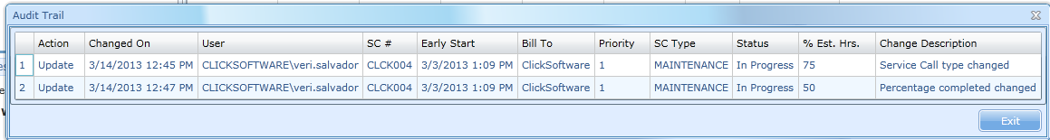

## Purging

The user can see the Tasks up to 21 days (Configurable) following their closing time. Beyond that time the Tasks are purged from the ClickSchedule database. Note that incompleted tasks are only deemed closed once the incompletion workflow has also been completed.

# Click Mobile

## Overview

ClickMobile is a ClickSoftware application designed to enable service organizations to better manage and optimize utilization of their engineers in the field. ClickMobile enables field resources (FSE’s) to have the critical information they need at their fingertips, increasing their efficiency and productivity. The application supports the full range of field activities from sending and receiving real-time situation updates, managing work orders as well as speeding up manual administrative work through automated processes.

### Users

The number of Field Service Engineers, including trainees and named contractors, is understood to be approximately 1200 within the full EMEA roll-out.

### Devices

ClickMobile Touch (the Smartphone variant of the product) is to be deployed on Apple ipad devices in this solution.

### Connectivity

Where the device has no or poor connectivity the user can continue to update the mobile device with their progress. As soon as connectivity has been restored the mobile application automatically synchronizes with ClickSchedule. This feature, known as “offline mode”, allows users to continue accessing and entering work related data while disconnected from any network ( minimum 3G on the devices)

### Data Availability

The FSE will have access to all of their non-availabilities and assigned tasks (in statuses described in section 13.2) for the previous three days, the current day and 6 months ahead. Note that, since tasks are typically only dispatched the day before, only non-availabilities (and manually dispatched tasks) will be visible beyond one day ahead.

## Workflow

The following statuses are applicable to ClickMobile and form a sub-set of the complete view of the task status flow shown in the Status Diagram in Section 4.2.

### Tentative

This status represents a task that has been tentatively assigned to a given FSE at a specific date and time. Tasks with this status are only sent to an FSE’s device if the FSE’s region has this feature enabled. Such tasks are visible, when enabled, for the next 5 working days (configurable) and are always fully read-only on the device.

### Assigned

This status represents a task that has been sent from ClickSchedule to ClickMobile and is the first status that the FSE sees. The number of tasks visible will depend on the relevant “dispatch policy”, as described in section 9.1.

### Acknowledged

This status indicates that the FSE has reviewed the task’s details and planned timings and is prepared to execute it as planned (the FSE explicitly acknowledges acceptance).

### Rejected by FSE

This status indicates that the engineer cannot execute the task as planned.

This status will be enabled from ClickSchedule only on the first (UK and Ireland) regional roll-out (i.e. it will not be available on the mobile device). In later regional roll-outs the ability to reject from the device is to be based on specific user permissions. *Note: The latter is a customization.*

### En Route

The engineer updates the task status to ‘En Route’ in order to confirm that they have started travelling to the task’s site. The time of this update is captured for auditing purposes.

### On Site

When the engineer reaches the task’s site (e.g. the hospital parking lot), ready to start executing the task, s/he SIEBEL update the task status to ‘On Site’. The assignment start time will be updated automatically, to capture the end of travel and start of administrative and working time for auditing purposes.

### Suspended

The method for handling MDT’s is to use the OOTB MDT mechanism. When a Multi-Day Task (MDT) is still in progress at the end of a working day the engineer SIEBEL update the status to ‘Suspended’. The task remains in ‘Suspended’ state until the next working day. At the beginning of the next working day the engineer updates the status first to ‘En Route’ and subsequently to ‘On Site’ upon on arrival at the site. This allows for accurate capture of travel and working time for auditing purposes.

### Completed

When the task is completed successfully, the engineer changes the task status to ‘Completed’. The assignment finish time is updated accordingly, thereby enabling audit of working time.

Work debrief is filed by the engineer quite separately on his/her laptop, outside of ClickMobile.

### Incomplete

When the task cannot be completed successfully, for whatever reason, the engineer SIEBEL change the task status to ‘Incomplete’.

In addition to the status change, the engineer provides the following details:

* The reason, from a fixed (though configurable) set of options.
* An accompanying comment that can provide further details related to the incompletion.
* Estimation of how long a follow-on task might be (a follow-on may be required to complete the task, for example once another part has been obtained).
* Indication that the engineer would like to perform the follow-on task.
* Indication as to whether the engineer has left the system operational or inoperative.

The assignment finish time is updated accordingly.

## Main Screens

The screens covered in the following sections reflect the configuration at initial go-live. It is quite straight-forward to restructure many of the forms, using the same underlying data, and as such it is recognized that the screens with continue to be modified over time.

### Logon

The engineer is prompted to enter their GE SSO credentials if necessary (the following screenshot shows the GE SSO login page):

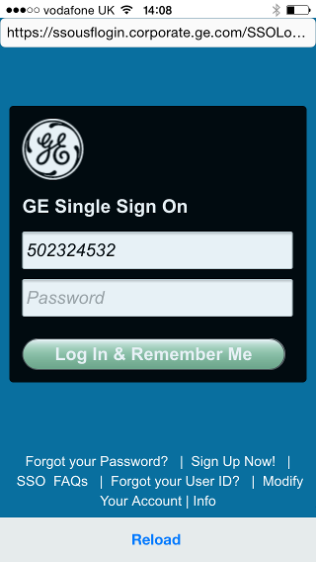

Once successfully logged in via the GE SSO mechanism, the engineer’s login will be kept active for up to 7 days. On explicit logout or after the mobile credentials time out the engineer SIEBEL again login via the GE SSO mechanism.

### Home Page

The home page, being the first page shown after successful login, provides access to the various specific views available within the client. Access is provided via a grid of labelled icons. These views are also accessible through options on the app’s menu. The following illustrates the appearance of the home page.

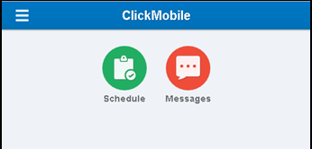

The views that are included in this solution are:

* Schedule

This provides access to a list of the engineer’s assignments on a given day.

* Messages

A list of received messages is shown and allows the engineer to send new messages.

* “My Details” (Engineer View)

Shows details related to the logged in engineer, including contact information for their manager. Note that this is only accessible from the menu.

* Find my Friends

Provides access to Apple’s external, standard Find My Friends mobile app.

These views are covered in more detail, where necessary, in the following sections.

### Schedule Main Tasks View

The Schedule view displays a list of the engineer’s assignment tasks and non-availabilities for a given day (the day can be selected from those stated in Section 13.1.4).

The following information is presented at the ‘first glance view’ of the schedule. Note that labels can be applied to clarify the meaning of the various values.

| Object | Value | Note |
| --- | --- | --- |
| Assignment | Assignment Start  Assignment Finish  Status | Specially presented as a header line. |
| Safety |  |
| Job Number |  |
| Job Type |  |
| System ID |  |
| System Name |  |
| Modality |  |
| Site Name |  |
| Street |  |
| Postcode |  |
| City |  |
| Non-Availability | Start Time  Finish Time | Specially presented as a header line. |
| Non-Availability Type |  |
| Street |  |
| Postcode |  |
| City |  |
| Country |  |
| Comment |  |

The following illustrates the general look and feel for this view.

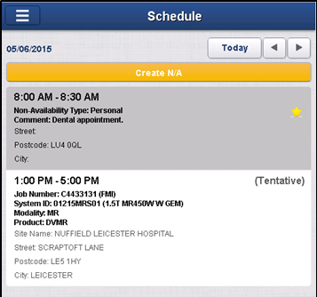

When looked at in the context of the iPhone device the assignment list will appear similar to the following.

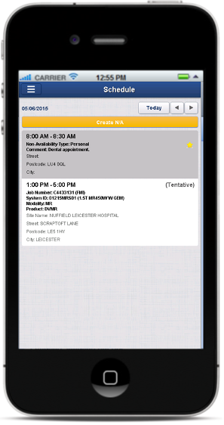

Non-Availabilities are created using a button in this view using a mobile App.

### Assignment Form

Touching (clicking) an assignment in the Schedule view’s assignment list opens the Assignment view. This includes all the information that the engineer needs in order to reach the site, record start time, identify the work to be done and record completion time, with a completion code. In order to ergonomically group the information and de-clutter the screen, the assignment form uses multiple tabs. Up to three of the tabs are shown in a tab bar just below the view title. Touching a tab’s label in the tab bar displays that tab’s associated information (and may change the selection of tabs shown).

The following tabs and properties are indicative examples of the type of forms displayed. The exact format, tabs and properties will be defined during the Detailed Design phase.

The following is only intended to illustrate the general look and feel for this view, not the actual content.

#### General Tab

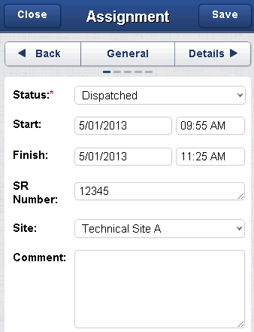

The read-only[13] properties requested for inclusion on this tab are:

* Status (editable, drop list)
* Assignment Start (date/time)
* Assignment Finish (date/time)
* Job Number (string)
* Job Type
* System ID (string)
* System Name
* Site ID (string)
* Site Name
* Site Address

This tab also permits the engineer to extend the assignment finish time, using Extend Assignment mobile App. The engineer should do this, when realizing that the task will take longer than anticipated, in order to give the dispatchers and any in-day optimization more time to respond to and remedy such a case (re-scheduling later work etc.).

The Site Address may have been overwritten to show a mobile site’s current address or the part pickup address depending on the type of task.

#### Incomplete Tab

This second tab is set to appear when the engineer changes the status for the task to Incomplete on the General tab.

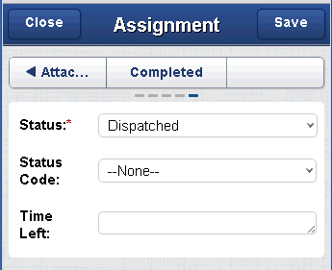

The editable11 properties included on this tab are:

* Job Number (read-only, string)
* System ID (read-only, string)
* Incompletion Reason (selection)
* Comment (free text)
* Prefer me for follow-on (boolean)
* Proposed follow-on duration
* System Status (selection)

These values are required when the engineer cannot complete his work for some reason.

#### Details Tab

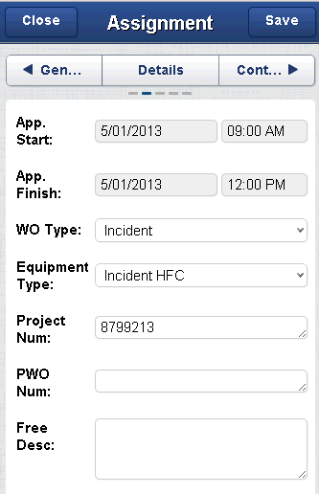

The read-only properties requested for inclusion on this tab are:

* Job Number (string)
* Job Type (selection)
* Safety (boolean)
* Job Sub Type (selection, covers FMI type when necessary)
* System Name (string, from the System)
* System ID (string, from the System)
* Product ID (string, from the System)
* Product Name (string, from the System)
* Modality (string, from the System)
* Skill Level (number)
* Task Note
* FMI Number (string, only applicable for FMI)
* FMI Recall (boolean, only applicable for FMI)
* PM Schedule (string, only applicable for PM)
* CTC Debrief (string)
* Link to full job comments (embedded business object)
* Part Delivery Method (Dictionary)
* Earliest Arrival On Site (date/time)
* Latest Arrival On Site (date/time)

There is a ClickMobile app that permits related assignment information to be viewed on the device. This can be used to view the FSEs in related assignments (when an activity requires multiple FSEs the SIEBEL macro will create multiple tasks, one per FSE, with some form of dependency such as start to start).

#### Contact Tab

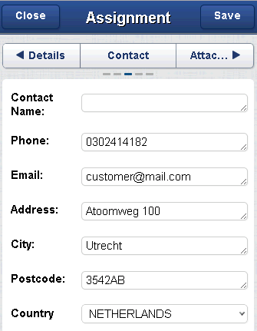

The read-only properties requested for inclusion on this tab are:

* Job Number (string)
* System ID (string, from the System)
* System Name (string, from the System)
* Modality (string, from the System)
* Site ID (string, from the Site)
* Site Name (string, from the Site)
* Site Address (string, repetition of the “Site Address” from the General Tab)
* Customer Contact Name (string)
* Contact Phone Number (string)
* Contact E-mail Address (string)
* Site Note (string, from the Site Comments)
* System Note (string, from the System Comments)

Options are provided on this tab to allow the FSE to call, text or e-mail the contact when the necessary values are available.

### Non-Availability Form

The Non-Availability form presents the absence information created by the dispatch centre or, as for all mobile users, by the engineer via functionality on their mobile device. The form shows the following editable properties (mandatory fields are marked with *):

* Start (Date/Time)*
* Finish (Date/Time)*
* Non-Availability Type* (Dropdown allowing a potentially filtered choice, as described in ‎5.7.6)
* Comment*
* Street
* City
* State
* Postcode
* Country (dropdown allowing selection from all available choices, defaulting to the Engineer’s home base country)

### Messages Form

The messaging feature allows engineers to send messages to and receive messages from other engineers and the dispatcher(s) for their district (the dispatchers who have access to the alert view and the district). A dispatcher can action the message in whatever way is required and then delete it.

Touching the ‘Messages’ icon on the home page displays the engineer’s message conversations.

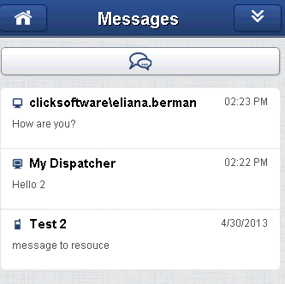

By touching a message in the list the entire conversation can be displayed.

A new message can be composed and sent to a set of required recipients.

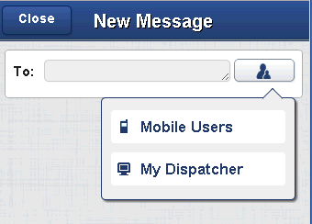

The list of the ‘Mobile Users’ loaded can be configured.

A message sent to the dispatcher is displayed in the ‘Messages View’ panel in ClickSchedule User Interface.

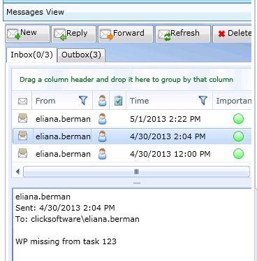

The above feature can be disabled by configuring the user templates( ASEAN requirement).

## Alerts

ClickMobile can provide alerts to engineers in specific situations. These alerts appear in an alert panel at the top of the screen. It is also possible to have an audible alert every time the visual alert appears.

ClickMobile alerts users for the following defined situations:

* New assignments on the current day’s schedule
* Updated assignments on the current day’s schedule
* Deleted assignments from the current day’s schedule
* New incoming message
* Next Assignment start in one hour (configurable)

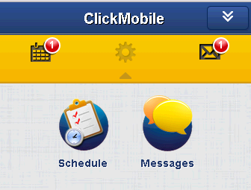

## Purging Policy

The Purge Agent is a process that is set to execute on a periodic basis in order to remove data from ClickMobile that is no longer relevant to the engineer. As ClickMobile is not a record repository, irrelevant data is purged in order to enable ClickMobile to operate at maximum performance and efficiency. The purge process is configured to run nightly and purges:

* Assignments that are more than 7 days old – subject to tuning during later stages in the implementation, based on performance.
* Messages that are more than 3 days old.

# Appendix A: Data Structure

***Source Reference: SDT - Interface - v1.3.pptx***

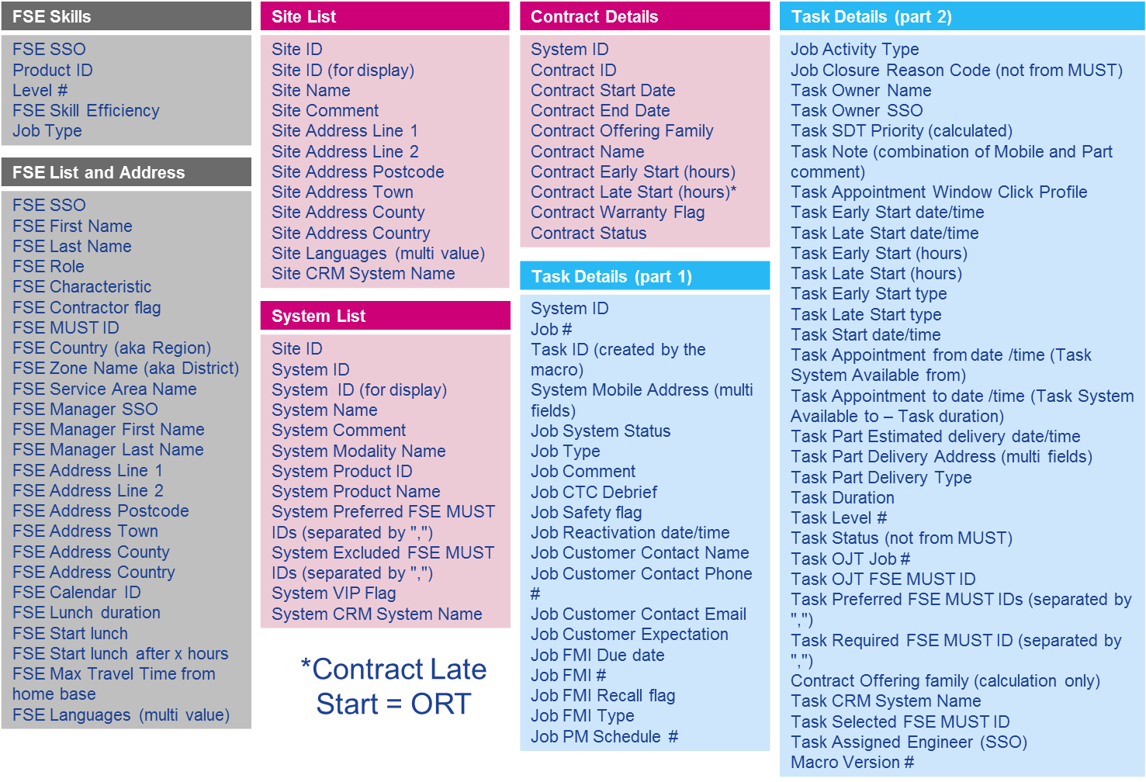

# Appendix B: Approvals

Approval of this BSS (version TODO dated TODO) indicates that the GE Healthcare and ClickSoftware Project Managers are in agreement as to GE Healthcare’s business requirements at this stage of the project. If additional requirements are identified later in the project, ClickSoftware’s Project Change Control process will be followed, as required, to outline any additional scope and effort required.

|  |  |
| --- | --- |
| **GE Healthcare** |  |
| Name: |  |
| Title: |  |
| Signature: |  |
| Date: |  |
|  |  |
|  |  |
|  |  |
| **ClickSoftware**  Name: |  |
| Title |  |
| Signature: |  |
| Date: |  |

Please fax a signed copy of this page of the document to your ClickSoftware Project Manager.

ClickSoftware Europe Ltd.

1. ClickSchedule leverages a single Street line when specifying an address OOTB.
2. This will vary by type of user. It is provided as general guidance only.
3. This will vary by type of user. It is provided as general guidance only.
4. ClickSchedule uses a single, combined name property OOTB instead of separate first and last names.
5. For those engineers that are in SIEBEL.
6. This is essentially the opposite of a “Contractor” indicator and provides OOTB access to the same data.
7. As with all name storage in ClickSchedule, this is a composite of first and last names.
8. As the FSE is expected to contact their manager in some scenarios, it might be helpful to have this value so that it can be displayed on the mobile device under the Engineer View app. This will be removed if GEHC cannot supply this value.
9. This will vary by type of user. It is provided as general guidance only.
10. Permits Dispatchers to filter their task list to show only tasks created by themselves, or managers to find tasks created by specific Dispatcher(s).
11. This may happen, for example, when inherited by tasks.
12. It is recommended that all resources who can only perform a sub-set of task types are also listed as able to undertake part pickup tasks.
13. Unless otherwise stated.